**AGREEMENT BETWEEN**

Grand River Environmental Network **AND** Franz Hartmann

**Terms and Conditions**

**ARTICLE 1: RETAINER & DUTIES OF THE CONSULTANT**

* 1. Services. Franz Hartmann (the Consultant) shall be responsible for providing consulting services to Grand River Environmental Network (the Client) in connection with the duties described in Attachment 1 – Scope of Work. The Consultant shall perform the services required under this Agreement in an efficient manner, acting always in the best interests of the Client and in accordance with and subject to all laws, rules and regulations which are applicable to the performance of its obligations hereunder. The Consultant shall report to an individual designated in writing by the Client, and shall carry out his duties in accordance with this agreement or in accordance with changes in the agreement as may be approved through consultation with such individual.
  2. Indemnity. Grand River Environmental Network shall not be liable for any damages, injury or any loss of use or profit of the Recipient arising out of, or in any way related to the Consultant’s operations. The Consultant shall indemnify Grand River Environmental Network against all costs, damages and expenses incurred as a result of a claim or proceedings related to the Consultants’ operations, unless such costs, damages or expenses arise from the negligence or willful act of an officer, employee or agent of Grand River Environmental Network.
  3. No Partnership. The Client and the Consultant are not partners or joint venturers with each other and nothing herein shall be construed so as to make them partners or joint venturers or impose any liability as such on either of them. The Consultant shall perform their duties hereunder as an independent Consultant. It is understood and agreed that the Consultant is free to perform work for third parties.
  4. Confidential Information. The Consultant acknowledges in any position the Consultant may hold, in and as a result of the contract with the Client, the Consultant will, or may, be making use of, acquiring or adding to information about certain matters and things which are confidential to the Client and which information is the exclusive property of the Client. Confidential Information will not include information that:
* is generally known in the industry of the Client;
* is now or subsequently becomes generally available to the public through no wrongful act of the Consultant;
* the Consultant rightfully had in its possession prior to the disclosure to Consultant by the Client;
* is independently created by the Consultant without direct or indirect use of the Confidential Information; or
* the Consultant rightfully obtains from a third party who has the right to transfer or disclose it.

The Consultant agrees that a material term of the Consultant's contract with the Client is to keep all Confidential Information absolutely confidential and protect its release from the public. The Consultant agrees not to divulge, reveal, report or use, for any purpose, any of the Confidential Information which the Consultant has obtained or which was disclosed to the Consultant by the Client as a result of the Consultant's contract with the Client. The Consultant agrees that if there is any question as to such disclosure then the Consultant will seek out senior management of the Client prior to making any disclosure of the Client's information that may be covered by this Contract.

The Consultant may disclose any of the Confidential Information:

1. to a third party where Client has consented in writing to such disclosure; and
2. to the extent required by law or by the request or requirement of any judicial, legislative, administrative or other governmental body, however, the Consultant will first have given prompt notice to the Client of any possible or prospective order (or proceeding pursuant to which any order may result), and the Client will have been afforded a reasonable opportunity to prevent or limit any disclosure.

**ARTICLE 2: REMUNERATION**

* 1. Fee. In consideration of the Services provided by the Consultant pursuant to this Agreement, the Consultant shall be entitled to the sum of $62.50 per hour + HST for the completion of the work described in Attachment 1: Scope of Work. Both parties agree the Consultant will complete the work by June 30, 2022.
  2. Payment of Fee. The Consultant shall email an invoice to the Client on a monthly basis**.** The Client shall pay such invoices upon receipt of same within 7 days.

2.3 Disbursements. It is understood that prior to incurring any disbursement related costs, the Consultant shall seek the approval of the Client.

**ARTICLE 3: MODIFICATION OF AGREEMENT**

3.1 Modification of Agreement. Any amendment or modification of this Contract or additional obligation assumed by either party in connection with this Contract will only be binding if evidenced in writing signed by each party or an authorized representative of each party.

**ARTICLE 4: TERMINATION OF AGREEMENT**

4.1 Termination. The parties agree that the Agreement shall continue in full force and effect until the end of the Term, subject to the following:

* 1. Either the Consultant or the Client may terminate the Agreement at any time during the Term or any renewal with 5 days notice in writing to the other party;
  2. In the event of a breach by the Consultant of any provision of this Agreement, which breach is not remedied within 5 days of the Client providing written notice of the breach to the Consultant, then the Client may terminate the Agreement by notice in writing to the Consultant; and
  3. In the event of a breach by the Client of any provision of this Agreement, which breach is not remedied within 5 days of the Consultant providing written notice of the breach to the Client, then the Consultant may terminate the Agreement by notice in writing to the Client.

4.2 In the event of the termination of the Agreement as set out in article 4.1 above, the parties shall forthwith adjust for any amounts owing by the Client to the Consultant, or by the Consultant to the Client, as the case may be, for Services rendered, or prepayments by the Client for Services not yet rendered on the date of termination, and mutually agreed out-of-pocket expenses incurred by the Consultant to the date of termination of the Agreement.

**Article 5: NOTICES**

5.1 Notices: All notices, requests, demands or other communications required or permitted by the terms of this Contract will be given in writing and either served personally or sent by facsimile or e-mail. The address for any notice to be delivered to any of the parties to this Contract is as follows:

1. Kevin Thomason, Grand River Environmental Network,c/o 1115 Cedar Grove Road, Waterloo N2J 3Z4, 519-888-0519; kevin@gren.ca
2. Franz Hartmann, 160 Bartlett Ave, Toronto, ON M6H 3G1; 416-606-8881; fhartmann160@gmail.com

or to such other address as to which any Party may from time to time notify the other.

Signed:

Kevin Thomason, Grand River Environmental Network Date

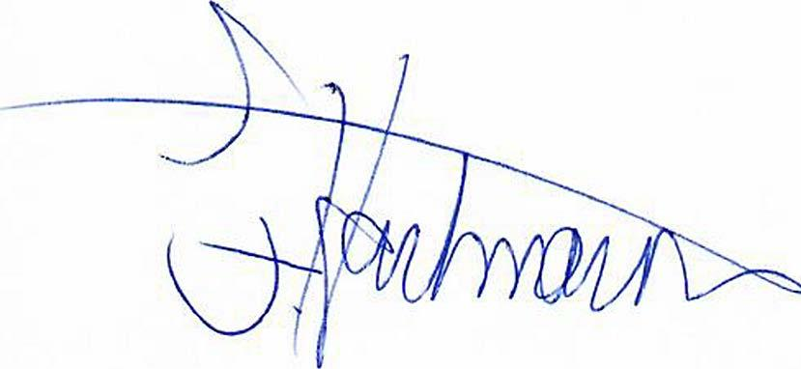 November 17, 2021

Franz Hartmann Date

**Attachment 1: Scope of Work**

The Consultant agrees to perform the following activities to be completed by June 30, 2022:

-Provide ongoing advice and assistance to GREN for the completion of the activities outlined in the 2021 GREN contract with the Greenbelt Foundation.

The Consultant shall report to and take direction from Kevin Thomason. Both parties will meet regularly to review the hours worked by the Consultant and discuss future workload.