February 2021

Grand River Environmental Network

c/o John Jackson

17 Major Street

Kitchener, ON N2H 4R1

To: [RegionalOfficialPlanReview@regionofwaterloo.ca](mailto:RegionalOfficialPlanReview@regionofwaterloo.ca)

**Re: Climate Change Policy Direction Paper – 5 Year Review**

Thank you for the opportunity for the Grand River Environmental Network to comment on the above paper.

**Policy Direction Generally Sound**

With less than one percent of the Region’s greenhouse gas emissions so far due to regional efforts—the rest being attributable to the province shutting down the coal plants—we need to up our game.

Overall, within the Region’s described capacity of “providing leadership; coordinating among stakeholders; developing and monitoring a clear and consistent policy framework; setting region-wide standards; and facilitating regional and local action,” the policy directions are generally sound.

**C40 Mayor’s Agenda**

Although Waterloo Region isn’t one of the international C40 Cities collaborating to address climate change, the paper generally aligns with the [C40 Mayor’s agenda](https://c40.my.salesforce.com/sfc/p/#36000001Enhz/a/1Q000000kVoY/kuR1PLHMGR2K9eEbo8aivV.xPegZVTqwt.EjX.4a.hk) of:

* Building retrofits
* Renewable energy
* Nature-based solutions (parks, green roofs, green walls, blue infrastructure, permeable pavements)
* Circular economy strategies
* Sustainable transport, and
* Low carbon clean infrastructure that will also create green jobs

The Region’s plan, based on C40 Cities recommendations, should also include advocacy to both national and provincial governments for the following:

* The only stimulus should be green stimulus.
* Commit to an equitable and inclusive recovery.
* Protect and champion mass transit.
* Prioritize and invest in clean energy.
* Invest in resilient cities as the engines of the recovery.
* End all public investments in fossil fuels.

**Overarching Comments from Grand River Environmental Network**

1. Based on the mantra of “managing what we measure”, the Region needs to set smaller, incremental targets before 2050 to have a substantive impact. i.e. reduce GHGs 30 to 40 percent by 2030, 60 to 80 percent by 2050 and 100 percent after that.
2. The 15 minute city is a good model. The C40 Cities refers to this as “giving streets back to people.”
3. Language is important. To keep in line with Federal government’s Bill C-12, we should be talking net-zero or carbon-neutral, not low-carbon.
4. Set higher goal for urban tree cover. The 2018 Environmental Commissioner of Ontario’s [report](http://docs.assets.eco.on.ca/reports/environmental-protection/2018/Back-to-Basics-Volume4-Ch2.pdf) on Southern Ontario’s Disappearing Forests advises that 30 percent tree cover is the minimal amount to, “ensure marginally functional ecosystems.”

**Comments Specific to the Paper**

**How We Move**

* Greenhouse gas emissions from transportation have increased from 40 to 49 percent of the total in the region since the [2013 Action Plan](http://www.climateactionwr.ca/wp-content/uploads/2015/10/ClimateActionPlanWaterlooRegion_Full_Nov2013.pdf) report. We all know that getting people out of their personal ICE vehicles is the biggest challenge. It has never been solved because driving your own car is a conflux of emotion, marketing, freedom, convenience, status, pride, rite-of-passage and necessity, and now personal safety with COVID-19. Everything in this section addresses the physical infrastructure necessary to optimize active transportation. However, a social marketing campaign must be in place to address these “soft” aspects. What are the barriers? What are the incentives?
* Planning for the 15-minute city is good, but that has to include the suburbs. Adjunct urban design professor at the University of British Columbia, Scot Hein, proposes that a [5 minute walk](https://thetyee.ca/Opinion/2018/10/17/Five-Minute-City-Better-Vancouver/) is more in line with what people will actually do, and offers a design of 5-minute catchment areas for walkability. Within these hyper-local neighbourhoods, connected to public transit, are all the amenities needed to live. How we live and work is essentially how we move. Williamsburg in Kitchener, with a central commercial hub, is a step in the right direction, but still missing the key element of 5-minute walk.

**How We Live and Work**

***12. Identify, protect and maintain a robust network of greenspaces within urban and rural areas.***

**Recommendations:**

* Waterloo Region planners advocate a target of 30% treed and natural areas in the rural parts of the Region.  Unfortunately, only 13% of the Region is presently forest-covered.  As well as providing shade ad evaporative cooling, growing trees act as a carbon-sink. Our current rural landscapes, when viewed from an ecological perspective, are termed “fragmented”. This not desirable.
* We need an ambitious, **large-scale and comprehensive program** to reforest areas other than our most productive agricultural areas. Planning for this must be on a landscape-scale basis with due regard to the longer time-frames of forest growth and development. This means that up-front expenditures to establish necessary infrastructure for propagating nursery stock and organizing and undertaking annual planting should be viewed as investments and not as costs -- and be taken undertaken quickly.
* Adjustments will also be needed in legislation. For example, Waterloo Region has one of the highest concentrations of aggregate development in Canada, particularly in North Dumfries township. Existing regulatory legislation has not resulted in adequate land rehabilitation of exhausted gravel pits and many remain derelict. The present provincial regulations are based on the sole objective of “restoration to agriculture”. Yet there is little monitoring of the success of restoration and no specification of productivity standards for restored pits. It is likely that a better alternative for many pits would be to reforest the exhausted pits – and thus contribute to advancing the percentage of the landscape that is treed and happily busy absorbing carbon dioxide -- rather than attempt transformation to an impossible tilled-agriculture alternative.
* Reforestation programs must be solidly based on the science of restoration ecology and intimate knowledge of local conditions. Carefully planned design objectives would improve our presently fragmented rural landscapes by establishing linkages, corridors and buffers that work to build interconnections among presently isolated natural areas. Of course, well-grounded, scientifically-based projections of the effects of climate change on our native ecosystems must also be considered for species selection and structuring of ecologically restored land. Considerable resources in restoration ecology exist at our area universities.
  + Ensure that all city dwellers have access to greenspace within easy walking distance of their homes. They should not have to use cars or transit to experience nature every day.
* Work with the townships to plan the creation of greenspace to ensure interconnectedness within the townships and between all the municipalities.
* Provide incentives for the reforestation of non arable or marginal lands.

***13. Integrate green infrastructure into infrastructure planning, asset management, and site development, to both accompany and replace engineered infrastructure.***

**Recommendations:** To make these very important and doable greening activities actually happen, especially in the townships, the Region needs to be clear, specific, insistent and supportive. The cities have knowledgeable planning staff devoted to environmental issues and generally have the capability to plan and implement greening projects. In contrast, with limited finances and resources, the townships do not have such staff, and certainly not at the level of senior management. Most greening activities in the townships are initiated and implemented by volunteers funded largely by grants and donations. Getting any necessary approvals or permissions from township government can be a long process, as there is a “conservative” culture among staff, even when councils have endorsed the project. For example, Woolwich now has a 20-year greening plan that was initiated by community volunteers, funded by the Region, and endorsed by council. Implementation has, however, been sluggish and is fraught with concerns about any additional maintenance costs.

**Here are some suggestions for how the Region can assist the townships to meet the Region’s climate change goals:**

* + Require the townships to develop a plan to carry out Big Moves 12 and 13, with timelines, check points, and a senior staff person designated to oversee. Develop a template to guide them.
  + Encourage townships to share staff resources for which they do not have full time resources, such as an arborist or an environmental planner.
  + Keep township staff updated about funding opportunities for these projects from the province, the federal government and any other funding organizations.
  + Provide training for township staff involved. There is little expertise and few opportunities to obtain it.
  + Maximize the return on investment by increasing support for the growing number of volunteer groups doing greening projects and pushing the climate agenda in the townships.

**Suggestions for the cities and townships:**

* Require leading-edge green infrastructure in new developments (residential, institutional, commercial and industrial as well as rehabilitation in existing developments).
* In parking lots (in malls, churches, community centres, etc.) require at least 1 tree per 5 parking spaces, to help mitigate the heat island effect and reduce storm water run-off.
* Stop cutting down mature trees, or shortening their lives by cutting off their roots, to make way for roads and road repair. Trees mitigate the pollution from traffic, provide cooling for pedestrians, and also help the road surface last longer.
* Increase the funding to REEP and other non-profits that work with the Region on greening and climate change improvements.
* Maximize the return on investment by increasing support for the growing number of volunteer groups doing greening projects and pushing the climate agenda in the townships and cities. People love trees and are particularly willing to join volunteer projects to plant and beautify their streets and neighbourhoods.  In addition, there are many successful volunteer initiatives to restore damaged parts of the countryside.  Programs must be developed to assist such volunteer efforts.  The two “before and after” photos below show the wonderful results of a volunteer initiative in Woolwich to rehabilitate a damaged watercourse.  All work was done by volunteers, guided by expert advice from the GRCA.  There is strength in our communities: they only need some material assistance and cooperative guidance from experts.  We urge you to launch a bold, area-wide program to combat climate change through citizen-assisted ecological restoration in our rural areas as well as on our city streets, in our parks, on vacant and underused land.

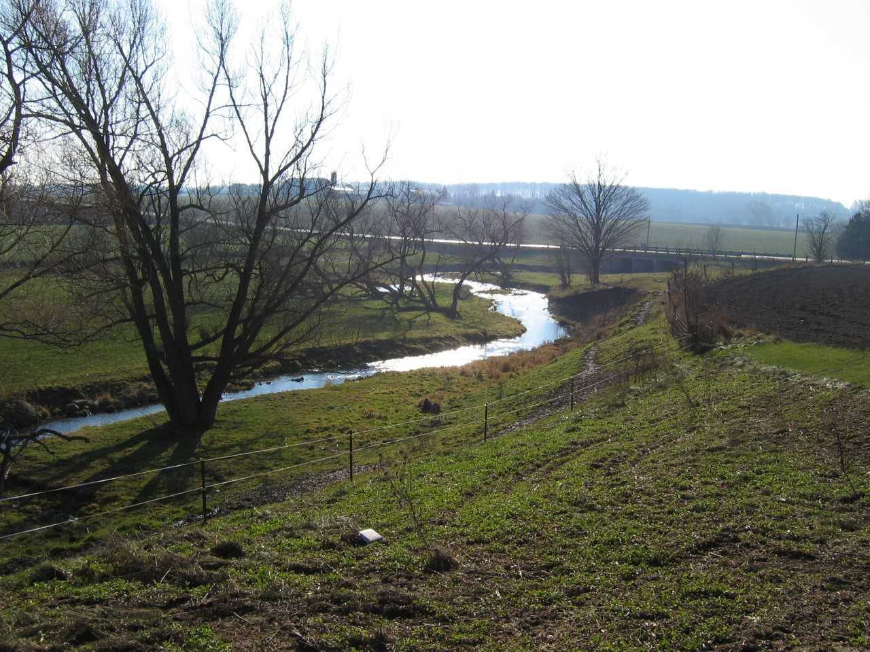

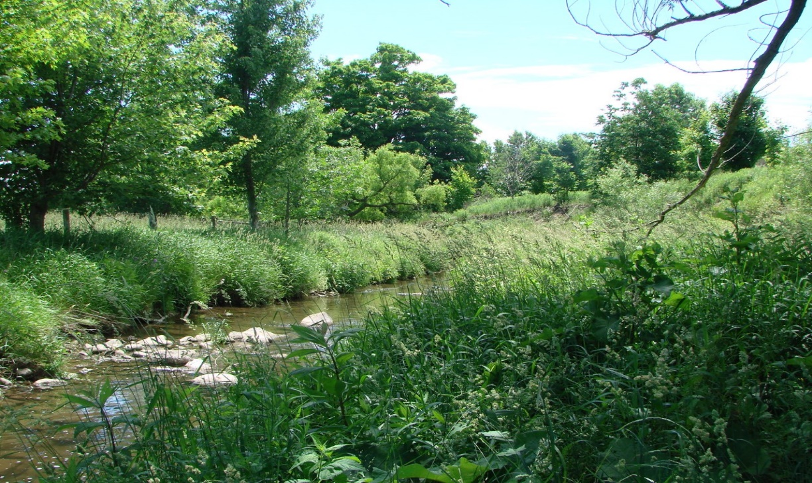

Photographs courtesy of GREN member Susan Bryant

***14. Maintain and build a robust agricultural system, to protect and enable maximal use of agricultural lands, ensure the agricultural industry has all the services and processing facilities needed to grow and distribute food, and improve local food security.***

**Recommendation:**  That much more attention be paid in the ROP and climate change policy to the agricultural sector. There is a distinctly urban emphasis to goals and solutions. Significantly more land is devoted to agriculture in the Region than to any other sector or activity. That huge land base offers many and varied opportunities to reduce greenhouse gases and to sequester carbon while also growing food and running a prosperous farm. And there is significant research and innovation being done on how farms and farmland can make substantial contributions to climate change issues. Best practices can not only reduce the carbon footprint of farm activities but also provide a host of climate-related services. **However, this aspect of farmland is not even mentioned in the policy paper.**

The Region essentially delegates responsibility for the agricultural sector to the townships. Yet township governments are too poorly resourced to provide much support. Farmers don’t always have the time to keep up with the latest research and technology, available subsidies and funding opportunities, even when they are committed to environmental stewardship on their land. They depend on the GRCA and other farm-related organizations for information and support rather than municipal governments. The result is a rather haphazard flow of information. If, however, the Region is to meet its climate change goals, it must involve the agricultural community—to “enable maximum use of agricultural lands.”

**Here are some ways the Region might help the farm community to better provide the environmental services their land base can offer:**

* Strengthen and guarantee the Region’s support to the GRCA, the Ontario Soil and Crop Improvement Association as well as other farm organizations. These groups have the knowledge and expertise to address climate change issues through administering the Environmental Farm Plan, the Rural Water Quality Program, and other initiatives.
* Take advantage of the policy directions and solutions offered by Farmers for Climate Solutions, a national alliance of farmers.
* Create a working group with farm experts and set clear, measurable goals and for collaborating on initiatives to reduce farm footprints and help farmers sequester carbon through cover crops, no-till cropping, woodlot management and many other opportunities to address climate change.
* Provide farmers with information on best practices as well as incentives and subsidies to invest in new technology (e.g. low-till machinery).
* Maintaining the hard countryside line is currently the Region’s key contribution to preserving farmland. As the policy report states, only some parts of the line have the protection required to remain permanent. **Do whatever is required to make that entire boundary permanent.**

**How We Build**   
  
**The Energy Lens**

The focus is creating clean energy, and creating and reducing the need for energy, specifically referencing the 2016 [Canadian Passive House, EnerPHit and PHI Low Energy Building Standard](https://passiv.de/downloads/03_building_criteria_en.pdf) used for homes, barns, and commercial buildings.

With increased biking/walking, workplaces can add amenities such as bicycle lockers and showers as well as vehicle charging.

The region should benefit economically from keeping local energy dollars in the local community, in the Ontario economy, instead of being traded out for fossil fuels from other regions and countries. Funding models include Halifax Solar City, [PACE Loan](https://www.homeownering.com/blog/2017/01/13/what-you-need-to-know-about-pace-energy-loans/), [Our Action Starts at Home (Federal)](https://www.nrcan.gc.ca/science-and-data/funding-partnerships/funding-opportunities/funding-grants-incentives/our-action-starts-home-home-energy-retrofit-initiative/23230), [Energy-Efficient Housing Program](https://www.cmhc-schl.gc.ca/en/finance-and-investing/mortgage-loan-insurance/mortgage-loan-insurance-homeownership-programs/energy-efficient-housing-made-more-affordable-with-mortgage-loan-insurance).  
  
**The Resiliency Lens**  
Our single most important priority must be to ensure that our dwellings will maintain livable conditions in the event of extended power outages or interruptions in heating fuel.  
  
The resiliency lens should go beyond energy use and include measures addressing issues of extreme heat, wind and precipitation and flooding, lockdowns due to future viruses, and agricultural protections.   
  
For example, a typical 1950s Duluth, MN home would take eight hours to drop below 40 F in a power failure, while a code-compliant home would take 45 hours, and a Passive House would take 152 hours. A net-zero-ready home lasted 61 hours. The opposite is true of a building overheating during heat waves. As electricity and gas supply grids become less reliable, resiliency is not only for comfort but also for safety. For Ontario examples, see <https://www.passivehousecanada.com/projects/>  
  
**Big Moves**

***15. Build new buildings to be net zero carbon and have an adaptable design.***

* Include the Passive House Standard for new net-zero buildings, as well as other design techniques, and the use of local materials which substantially reduce embedded carbon and heating/cooling energy requirements.

Thinking extreme heat:

* Measures must be taken to cool our cities as much as possible as the climate heats up.  Some cities in California have bylaws that require that all roofs be light-coloured to reflect heat rather than absorb it, and that streets and particularly parking lot surfaces be both light-coloured and shaded as much as possible by trees.  Average summer urban temperatures in Sacramento were reduced by about 4 degrees by the uptake of such measures, and electrical demand for air conditioning was consequently reduced as well. Such measures should be taken in Waterloo Region, starting immediately with ones that are uncomplicated and cost-free, such as simply regulating the colour of shingles. The Region should also pressure the Canadian government to invest in private-sector research to develop radically more energy-efficient air conditioners. These would enormously benefit control of carbon emissions – and save residents’ money.
* All buildings with higher ceilings with higher operable windows, apartments with operable windows with awnings, and big apartment balconies on two sides, will reduce energy requirements and increase comfort.
* There are examples in Waterloo of buildings that have passive cooling by using tubes that bring air cooled from below ground and hot air eliminated above ground.

Thinking extreme wind:

* New bylaws concerning roofing materials and installation practices will prevent wind damage.

Thinking extreme precipitation:

* Cistern options in new subdivisions and water catchment in large buildings could prevent flooding, reduce demand on community water resources, recharge aquifers, provide local employment, reduce homeowner costs.

Thinking materials and building techniques:

* Defining situations suitable for use of locally available materials/techniques (straw bale, rammed earth, Earthship architecture) would shift building costs from embedded carbon materials to local labour, reduce heating/cooling energy use, and increase structural resiliency.

Thinking Covid

* Mall shops would benefit from exterior doors for curb side pick up. Apartments will require green spaces to accommodate residents/children during stay-at-home restrictions of highly contagious periods.

***16. Retrofit existing buildings to eliminate emissions.***As in Big Move 15, it would be wise to include passive design techniques that reduce our

dependency upon machines and that use local materials which increase structural resiliency.

To reduce energy requirements, use straw bale retrofit on square buildings, and require operable windows, high and low, to facilitate air flow (for cooling and infection prevention).

***17. Facilitate and plan for renewable energy generation and storage at appropriate locations and scales, particularly for wind solar and energy from waste organics.***

***18. Design communities to facilitate/require community energy considerations.***

* Extreme weather considerations and lockdown recreation might also be included.
* Community design might be wise to include parks and parkettes that become rain gardens during extreme precipitation, thus accommodating localized flooding.
* Shaded local parks are needed during summer heat waves (Woolwich Township had no cooling centres during last summer’s heat wave as folks were afraid to gather during Covid.) Provide benches in parks so people of all ages and abilities can enjoy them.
* Institutions/stores/apartments will require bicycle lockers.

***19:  Adaptively reuse a high percentage of existing buildings by conserving heritage buildings, reducing incentives to demolish buildings, and salvaging materials for reuse.***

* Pass bylaws that prevent landlords from leaving salvageable buildings vacant until they deteriorate beyond reasonable repair.