• Measures must be taken to cool our cities as much as possible as the climate heats up.  Some cities in California have bylaws that require that all roofs be light-coloured to reflect heat rather than absorb it, and that streets and particularly parking lot surfaces be both light-coloured and shaded as much as possible by trees.  Average summer urban temperatures in Sacramento were reduced by about 4 degrees by the uptake of such measures, and electrical demand for air conditioning was consequently reduced as well. Such measures should be taken in Waterloo Region, starting immediately with ones that are uncomplicated and cost-free, such as simply regulating the colour of shingles. The Region should also pressure the Canadian government to invest in private-sector research to develop radically more energy-efficient air conditioners. These would enormously benefit control of carbon emissions – and save residents’ money.

• Waterloo Region planners advocate a target of 30% treed and natural areas in the rural parts of the Region.  Unfortunately, only 13% of the Region is presently forest-covered.  As well as providing shade ad evaporative cooling, growing trees act as a carbon-sink. Our current rural landscapes, when viewed from an ecological perspective, are termed “fragmented”. This not desirable.

We need anambitious, **large-scale and comprehensive program** to reforest areas other than our most productive agricultural areas. Planning for this must be on a landscape-scale basis with due regard to the longer time-frames of forest growth and development. This means that up-front expenditures to establish necessary infrastructure for propagating nursery stock and organizing and undertaking annual planting should be viewed as investments and not as costs -- and be taken undertaken quickly.

Adjustments will also be needed in legislation. For example, Waterloo Region has one of the highest concentrations of aggregate development in Canada, particularly in North Dumfries township. Existing regulatory legislation has not resulted in adequate land rehabilitation of exhausted gravel pits and many remain derelict. The present provincial regulations are based on the sole objective of “restoration to agriculture”. Yet there is little monitoring of the success of restoration and no specification of productivity standards for restored pits. It is likely that a better alternative for many pits would be to reforest the exhausted pits – and thus contribute to advancing the percentage of the landscape that is treed and happily busy absorbing carbon dioxide -- rather than attempt transformation to an impossible tilled-agriculture alternative.

This would also mean that reforestation programs must be solidly based on the science of restoration ecology and intimate knowledge of local conditions. It would require carefully planned design objectives to improve our presently fragmented rural landscapes by establishing linkages, corridors and buffers that work to build interconnections among presently isolated natural areas. Of course, well-grounded, scientifically-based projections of the effects of climate change on our native ecosystems must also be considered for species selection and structuring of ecologically restored land. Considerable resources in restoration ecology exist at our area universities.

•  People love trees and are particularly willing to join volunteer projects to plant and beautify their streets and neighbourhoods.  In addition there are many successful volunteer initiatives to restore damaged parts of the countryside.  Programs must be developed to assist such volunteer efforts.  The two “before and after” photos below show the wonderful results of a volunteer initiative in Wellington County to rehabilitate a damaged watercourse.  All work was done by volunteers, many from Waterloo Region, guided by expert advice from the GRCA.  There is strength in our communities: they only need some material assistance and cooperative guidance from experts.  We urge you to launch a bold, area-wide program to combat climate change through citizen-assisted ecological restoration in our rural areas as well as on our city streets, in our parks, on vacant and underused urban land. 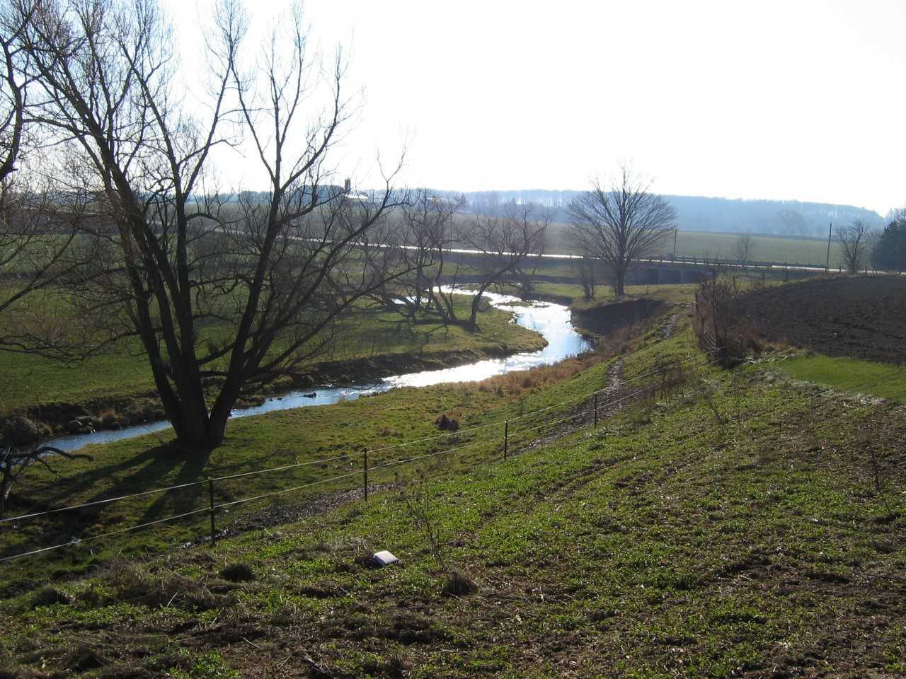

Photographs courtesy of GREN member Susan Bryant

