

INVOICE

To: Environment Hamilton

Date: December 11, 2020

RE: OGA Greenbelt Foundation Grant

This is our invoice for $10,000 for the contract with Environment Hamilton for GREN’s share of the Greenbelt Foundation grant. In the new year we will send you a summary of our activities under this grant, which will provide detail on our activities under this grant.

Please make the cheque out to “Grand River Environmental Network” and mail it to our treasurer Greg Michalenko at 53 Menno Street, Waterloo N2L 2A6.

We have appreciated the support to help us work on these matters.

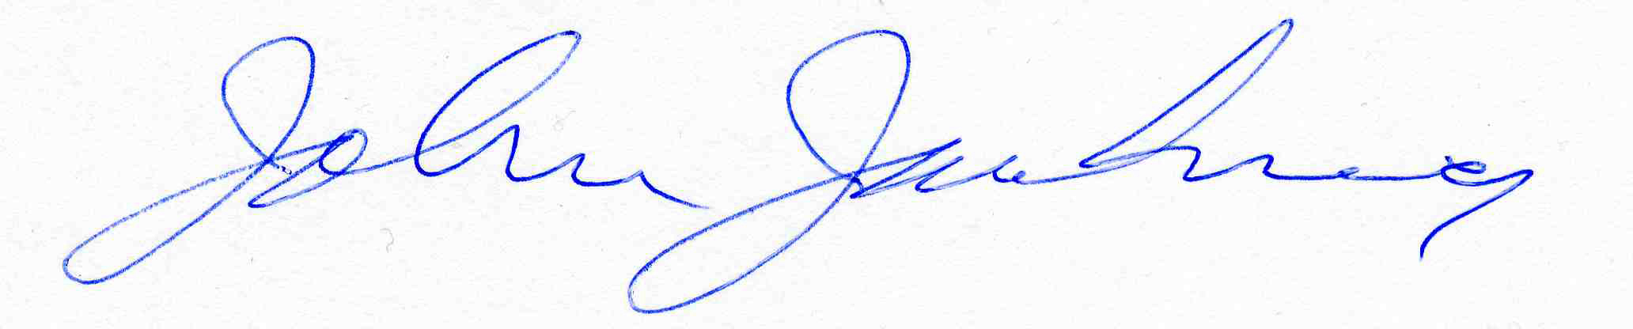

John Jackson

GREN Executive

519-744-7503