 April 12, 2013

The Grand River Environmental Network is a strong supporter of the Waterloo Regional Official Plan. We contributed over a number of years to its creation, adoption, and implementation. In 2011, this Plan was approved by the Province of Ontario following extensive engagement with the residents and the Region, and reflects our shared vision for our community. Therefore we are extremely disappointed by the recent Ontario Municipal Board’s decision against the Waterloo ROP and the subsequent refusal to rehear the case.

In particular, we are concerned with the adjudicators' interpretation of the Planning Act, the Provincial Policy Statement, the Places to Grow Act, and the Growth Plan that will force unnecessary urban sprawl, destroy irreplaceable farmland and natural areas, and threaten the viability of the integrated aspects of this Official Plan such as infrastructure efficiency and effective public transportation.

We support the Region’s filing of the appeal to the Divisional Court of Ontario and hope that the Province of Ontario will join with the Region of Waterloo on this essential appeal.

We also hope that the Province will join with the Region and declare a provincial interest to participate in the third phase of the OMB Regional Official Plan hearing expected later this year.
The Grand River Environmental Network is optimistic that with the assistance of the Province and by continuing to work together, we can ensure the success of our local planning efforts and a more progressive and sustainable future.
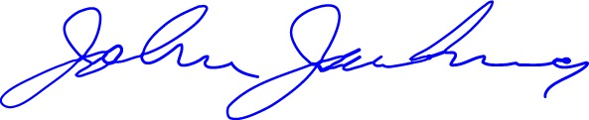

John Jackson,
Chair, Grand River Environmental Network
jjackson@web.ca
519-744-7503

