Toronto River Run 2012
Take action with Grassy Narrows Asubpeeschoseewagong Anishinabek

Join us & continue a tradition of community lead action for justice—for our people, and for the protection of the water, air, and forests
that give life to us all.
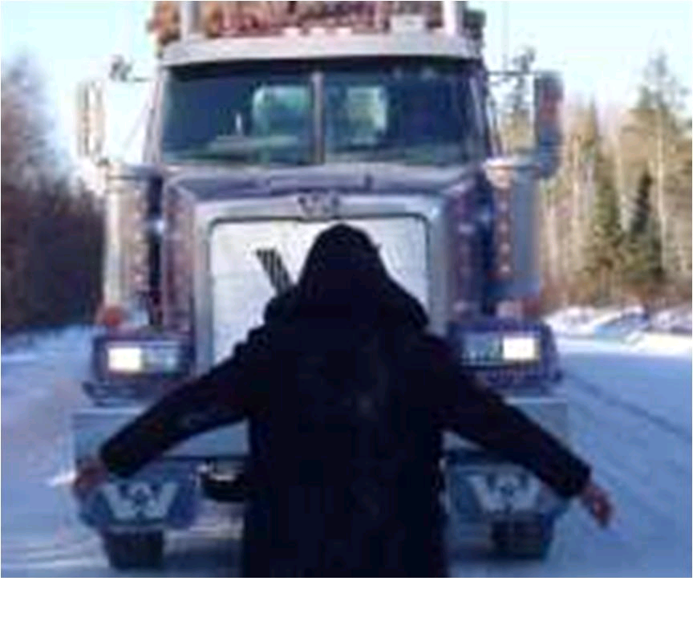

SPEAKING EVENT WITH JUDY DA SILVA
Tuesday June 5, 6:30 p.m., Steelworker’s Hall

FISH FRY
Wednesday June 6th, Noon. Queen's Park south lawn.

MARCH AND RALLY WITH GRASSY NARROWS
Friday June 8, Noon. Grange Park (behind the Art Gallery of Ontario on Beverly)

more info: FreeGrassy.org

Toronto River Run 2012
Take action with Grassy Narrows Asubpeeschoseewagong Anishinabek

Join us & continue a tradition of community lead action for justice—for our people, and for the protection of the water, air, and forests
that give life to us all.

SPEAKING EVENT WITH JUDY DA SILVA
Tuesday June 5, 6:30 p.m., Steelworker’s Hall

FISH FRY
Wednesday June 6th, Noon. Queen's Park south lawn.

MARCH AND RALLY WITH GRASSY NARROWS
Friday June 8, Noon. Grange Park (behind the Art Gallery of Ontario on Beverly)

more info: FreeGrassy.org
In April 2010, we marched together as one wild river flowing onto the steps of Queen’s Park to deliver our demands on World Health Day. We ask that you join us again this year to make clear to those at Queen’s Park that we’re as strong as ever, and will continue to demand justice for our people and protection for our environment.

To endorse, donate, support, or for more information contact us at: 2012riverrun@gmail.com

Over 40 years ago our people were poisoned by mercury from a paper mill that contaminated our river upstream. Our people are demanding justice because we are still dealing with the ongoing health impacts of this avoidable disaster. It’s an inescapable truth that this poison will affect everyone if we don’t stand together to protect our water.

For decades the GNAA community members have been on the front lines of the movement to defend the earth and to uphold Indigenous self-determination, culture and spirituality. We have kicked out logging giant Abitibi for now, but there is still much work to be done.

Joining in River Run 2012 is a great opportunity to show your support and to join us in the fight to protect Indigenous rights and the water, air, land, and creatures that we all depend on.

Migwetch

more info: FreeGrassy.org
In April 2010, we marched together as one wild river flowing onto the steps of Queen’s Park to deliver our demands on World Health Day. We ask that you join us again this year to make clear to those at Queen’s Park that we’re as strong as ever, and will continue to demand justice for our people and protection for our environment.

To endorse, donate, support, or for more information contact us at: 2012riverrun@gmail.com

Over 40 years ago our people were poisoned by mercury from a paper mill that contaminated our river upstream. Our people are demanding justice because we are still dealing with the ongoing health impacts of this avoidable disaster. It’s an inescapable truth that this poison will affect everyone if we don’t stand together to protect our water.

For decades the GNAA community members have been on the front lines of the movement to defend the earth and to uphold Indigenous self-determination, culture and spirituality. We have kicked out logging giant Abitibi for now, but there is still much work to be done.

Joining in River Run 2012 is a great opportunity to show your support and to join us in the fight to protect Indigenous rights and the water, air, land, and creatures that we all depend on.

Migwetch

more info: FreeGrassy.org

