Grand River Established: 2008
Environmental Network (GREN)

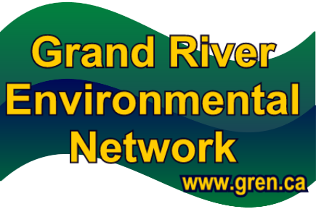
Membership Size: 25+ members

Contact: John Jackson (chair)
Address: 619 Forest Hill Drive,
Kitchener, Ontario N2N 1A1
Phone: 519-744-7503
Email: info@gren.ca
Website: www.gren.ca

Goals/Mission/Background
The Grand River Environmental Network (GREN) is a proactive voice for the environment in the Grand River watershed. Members of GREN are activists, watchdogs, guardians, stewards and concerned citizens. They support each other by sharing information and expertise. Together GREN members foster environmental awareness and literacy and promote respect for the natural environment and humans as part of the ecosystem.
GREN promotes a set of guiding principles. The overarching belief of GREN is that “we are near the carrying capacity of the essentials for life—water, air, energy, greenspace, aggregate, agricultural land and wetlands—in our communities.” GREN draws from the knowledge and expertise of people in Grand River watershed communities by finding innovative ways to live better with less, working together to promote initiatives that restore, maintain and enhance the livability of watershed communities, and including all life forms, for current and future generations.
GREN achieves the above by:
- implementing aggressive water conservation and reusable programs instead of planning on outside water sources, such as through a pipeline from Lake Erie to Waterloo Region.
- preserving natural and groundwater recharge areas such as Hidden Valley; Kitchener, the Waterloo Moraine and the Guelph-Amabel Aquifer.
- moving Grand River communities to adopt the precautionary approach and principles of sustainability in all decision making.
- measurably improve air quality.
- reducing private car use by improving infrastructure to support human-powered (walk/bike) and public transportation.
- increasing production, availability and purchase of local and organic food.
- reducing toxics use and toxic and climate-changing emissions (land, water and air).
- instituting waste avoidance, reuse and recycling and composting programs to avoid disposing of garbage either through landfill or incineration.
- eliminating urban sprawl.
- creating and establishing other goals as new environmental issues arise.

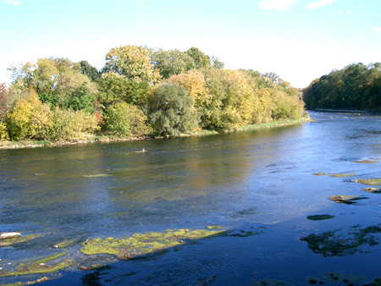
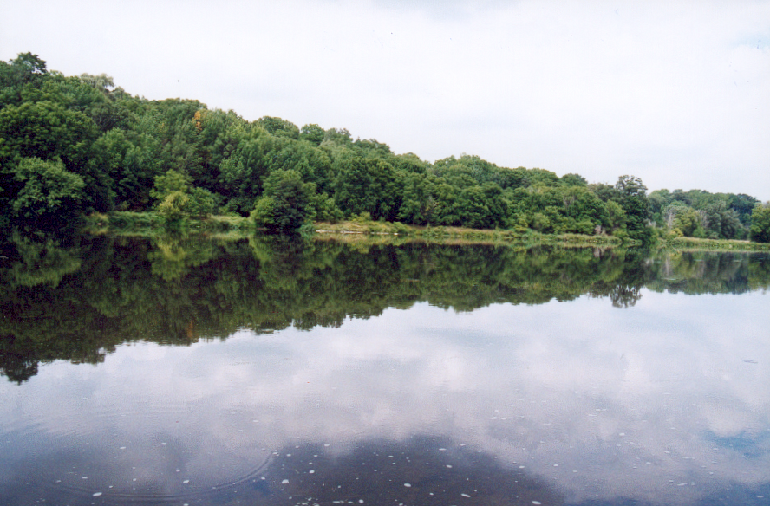

A Voice for the Grand River –Concerned citizens a part of GREN, advocate on behalf of the fragile ecosystem.

Events/Activities/Actions (2010)
In 2010, GREN participated in the following activities:
- hosting public information displays about climate change at the Waterloo Memorial Recreation Complex, Waterloo.
- lobbying provincial and federal governments to support biodiversity, water protection, and climate change action via petitions and letters e.g., GREN included in open letter to the Prime Minister with the Climate Action Network Canada, a coalition of organizations committed to preventing dangerous levels of human interference with the global climate system, protecting environmental sustainability and public health, while upholding principles of just transition, equity and social justice.
- participating in forums on environmental issues re: genetically-modified crops, the Grand River Watershed Water Forum, source protection issues, and sharing the information with other members.
- providing minor monetary donations towards the efforts of concerned citizens’ groups working to protect the environment.
- networking with other groups to assist with public participation processes regarding environmental concerns.
- informing municipal leaders about environmental issues of concern in our community and provided suggestions on ways more sustainable solutions can be fostered.
- hosting a “meet and greet” with municipal election candidates and GREN members.
- drafting and submitting position papers on proposed Light Rail Transit (LRT), Source Water Protection documents for the Grand River watershed, and the protection of Hidden Valley, an environmentally sensitive area in Kitchener.
- holding regular monthly membership meetings, as well as sub-committee meetings.
Number of Volunteers  Age Range
Approximately 25 volunteers  25-70 years of age
Sponsors/Partners/Supporters
GREN is funded through membership fees and infrequent fundraising events.
Media Coverage

- CTV Southwestern Ontario, television
- 570 News, radio
- Waterloo Region Record, newspaper
- Kitchener Citizen, West and East Editions, newspaper
- Waterloo Chronicle, newspaper

Future Activities Planned
The activities undertaken by GREN are based on the interests of its members in addressing on-going and emerging environmental concerns. In 2011, members will continue to undertake activities to protect the Hidden Valley, an Environmentally Sensitive Area in Kitchener, advocate for Light Rail Transit (LRT) in Waterloo Region and improve public transit, lobby against the Highland Companies quarry proposed in the Township of Melancthon because it is believed that this immense undertaking would directly impact the headwaters of the Grand River, and undertake stewardship activities within the Grand River watershed. GREN will continue to hold monthly membership meetings. New members are always welcome.
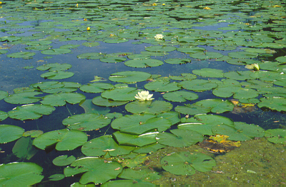

Stewards of the Grand – GREN is a proactive voice for the Grand River watershed.

