Grand River Environmental Network

Membership Size: 25+

Contact: John Jackson (chair)
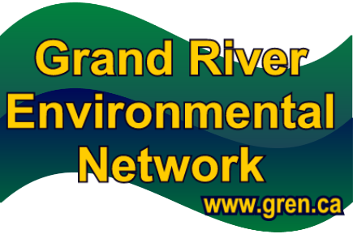
Address: c/o 619 Forest Hill Dr., Kit, ON N2N 1A1
Phone: 519-744-7503
Fax:
Email: info@gren.ca
Website: www.gren.ca

Goals/Mission/Background
GREN is the proactive voice for the environment in the Grand River watershed

GREN members:
- are activists, watchdogs, guardians, stewards and concerned citizens
- support each other by sharing information and expertise
- foster environmental awareness and literacy, and

promote respect for our natural world and our place in it.

GREN Guiding Principles
Our Belief
We are near the carrying capacity of the essentials for life—water, air, energy, greenspace, aggregate, agricultural land and wetlands—in our communities.
Our Commitment
GREN will draw from the well of creative people in our communities to:
- find innovative ways to live better with less
- work cooperatively to promote initiatives that restore, maintain and enhance the livability of our communities
- do so for all lifeforms, for current and future generations

Our Goals
- Implement aggressive water conservation and reuse programs instead of planning on outside water sources, such as through a pipeline from Lake Erie to Waterloo Region
- Preserve natural and groundwater recharge areas such as Hidden Valley, the Waterloo Moraine and the Guelph-Amabel Aquifer
- Move our communities to adopt the precautionary approach and principles of sustainability in all decision making
- Measurably improve air quality
- Reduce private car use by improving infrastructure to support human-powered (walk/bike) and public transportation
- Increase production, availability and purchase of local and organic food
- Measurably reduce toxics use and toxic and climate-changing emissions (land, water and air)
- Institute waste avoidance, reuse and recycling and composting programs to avoid disposing of garbage either through landfill or incineration
- Eliminate urban sprawl
- Other goals as issues arise
Events/Activities/Actions (2010)

- Organized public workshop regarding issues of air pollution in Sarnia in partnership with the First United Church Outreach Committee and members of Aamjiwnaang First Nation.

- Hosted public information displays about Climate Change at the Waterloo Memorial Recreation Complex
- Lobbied provincial and federal governments to support biodiversity, water protection and climate change action via petitions and letters eg: GREN included in open letter to the PM with Climate Change Action Network
- Members participated in forums on environmental issues re: GM crops, the GRCA watershed forum, source protection issues and shared the information with other members.
- Provided minor monetary donations towards the efforts of concerned citizens groups working to protect the environment
- Networked with other groups to assist with public participation processes regarding environmental concerns.
- Kept municipal leaders informed about environmental issues of concern in our community and provided suggestions on ways we can foster more sustainable solutions.
- Hosted “meet and greet” with municipal candidates and GREN members
- Drafted and submitted position papers on proposed LRT, GRCA Source Water Protection document, protection of Hidden Valley

Number of Volunteers  Age Range  Volunteer Hours  Value ($)
All members are volunteers ranging in age from 25 to well past retirement age. We do not log volunteer hours nor dollar value.
Sponsors/Partners/Supporters  Contributions
Wholly funded on membership fees and infrequent fundraising events
Media Coverage
Most GREN members have been active in their respective interests for many years, so coverage from local media such as CTV Southwestern Ontario, 570 News, The Record, Kitchener Citizen West and East, Waterloo Chronicle etc. is generally reactive rather than proactive. Eg: seeking comment from GREN members on issues as they arise.
Future Activities Planned
Activities are based on the interests of our membership in addressing ongoing and new environmental concerns as they arise. As of early May 2011, that includes Saving Hidden Valley, advocating for an LRT and improved public transit, advocating against the proposed Highlands Quarry as it would directly impact the headwaters of the Grand River.

Please send pictures and logo as attachments. Any additional information which could help in filling in the required information (e.g., annual reports, write-ups, brochures) can also be sent as attachments.
Email: grandactionsregistry@grandriver.ca

