April 14, 2011

Ontario Ministry of Natural Resources
2284 Nursery Road
Midhurst, Ontario
LOL 1X0, and

The Highland Companies
P.O. Box 377, Shelburne, ON
L0N 1S0

RE: The Highland Companies’ Proposed Melancthon Quarry

Representing the many inhabitants of the Grand River watershed concerned with protecting the health of our ecosystem, The Grand River Environment Network (GREN) is opposed to the Highland Company’s proposal for a massive open-pit limestone mining operation, below the water table, in Melancthon Township.

Located in the headwaters of the Grand River, as well as other river systems, this quarry puts at serious risk the quantity and quality of water in the Grand River and in the aquifers in our watershed. The technical studies in support of the application are based on outdated and inadequate information and fail to prove that there will not be permanent adverse effects on the downstream water systems. Tampering with this water could affect over a million people downstream.

The Region of Waterloo and other downstream communities have spent and will continue to spend multiple millions of tax dollars to protect our river and groundwater supplies. The health of our agricultural sector, industry, people and ecosystem all depend on a reliable water supply. In spite of these efforts, the Grand River remains a highly stressed system, with multiple contaminants and constant threats to water volumes. To permit yet more stress in the headwaters of an already stressed system is simply irresponsible and unacceptable.

Equally unacceptable is the massive loss of high-quality agricultural land that will result from this mining operation. With climate change and other pressures, food security is fast becoming a major concern everywhere in the world. When the mining is finished and the substrate removed, this land can never be rehabilitated to decent farmland. The loss is permanent.

We ask that you say no to this proposal, as it poses unacceptable risks to the water and food resources essential to millions of Ontarians.

Sincerely,

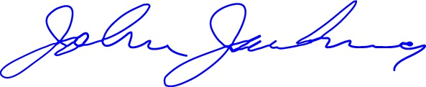

John Jackson
Chairperson

