Project Description
On Conservation
Despite the profound impact innovative conservation programs can have on Great Lakes (G.L.) health, the regulatory framework for protecting the Great Lakes, including the Great Lakes Water Quality Agreement, the Great Lakes Regional Collaboration, the Canada-Ontario Agreement respecting the G.L.; the Clean Water Act (US) and the Source Water Protection Act (Ontario) are all silent on the benefits of conservation in pursuit of their objectives. Only the Great Lakes Sustainable Waters Compact and International Agreement refer to conservation and even those Agreements delayed attention to conservation. This lack of focus on conservation takes place in the very jurisdictions that top global per capita water consumption according to the Organization for Economic Cooperation and the Great Lakes Commission.

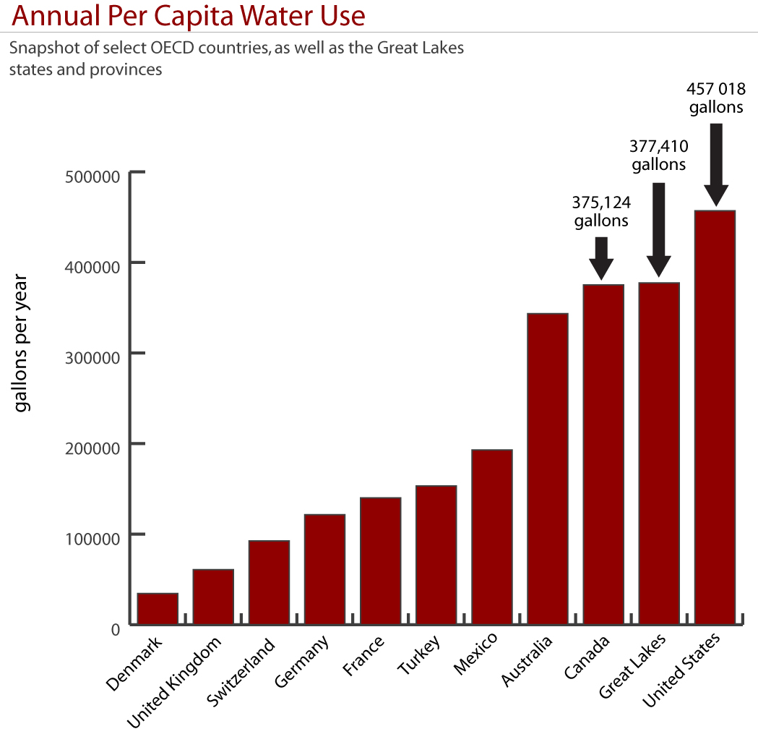
With 24 billion gallons of untreated sewage overflows into the Lakes and St Lawrence River annually (www.ecojustice.org), a stronger conservation ethic with reductions in per capita water use will ease pressure on overburdened infrastructure and reduce overflows. The benefits of conservation to GLRI priorities, commensurate with reductions in sewage overflows are evident, including improvements to Nearshore Health and Habitat Protection. In addition, EPA’s strategic interest in developing policy on Managing Peak Flows at sewage treatment plants will benefit from increased public understanding of the problem, the benefits of conservation and through informed municipal conservation programs that reduce those peak flows.

The benefits of per capita reductions in water use are not, however, limited to peak flows at treatment plants and overflows. Pumping and treating water is also the single largest cost – often 30% or more of a municipal budget, and typically accounts for 10% of municipal greenhouse gas emissions. The benefits that innovative conservation planning provide to environmental managers are exponential. A strong communications effort, proposed here and identified in the GLRC as a need, must, when focussed on per capita water use, target municipal decision makers as well as end users (i.e. the public).

By expanding on what is already the most comprehensive Great Lakes public opinion research ever conducted, Great Lakes United and our partners will challenge the myth of abundance in public opinion, help municipalities in the development of conservation programs and progressive water pricing schemes, and contribute to forums where municipal dependence on water bills and the capital investments in infrastructure needed to deliver that water are one and the same conversation.
The Great Lakes United Conservation Initiative
The Conservation Initiative follows two pathways to conservation. The first provides expert research to decision makers for the development of conservation programs and the second delivers the conservation message to millions – activating public awareness and creating space for the necessary behavior change to come. Pathway one is discussed here.

(a) Informing Decisions for Environmental Managers: Model Communities
Recognizing that water charges are the single largest source of revenue for most cities, the Conservation Initiative will demonstrate that progressive, committed, and timely action to conserve water can allow for community growth while staying within the sustainable water budget of the area. Our research will analyze individuals’ water use behaviors and identify strategies for individuals to lower their water use and improve their own efficiency while activating latent values toward source water and Great Lakes protection.

Through our Model Communities pathway we will work closely with three Great Lakes communities in each of Canada and the U.S. – that are experiencing significant current or projected future water availability problems. As these communities face growing populations and/or dwindling water supplies, we will work with them to show how conservation practices and policies can lead to positive population growth within their existing or reduced water budget. Typically these are growth communities where the current trend is toward pipelines to and from neighboring municipalities, falling water tables, and high infrastructure and pumping costs. Our plan includes:

- A local policy-building program that works with the municipalities, businesses, citizen’s groups and other stakeholders to put in place the regulatory initiatives and business practices that will bring water conservation practices; and

- A focused social marketing campaign that researches how individuals in that community use and understand water and a program that uses this insight to improve wasteful water practices.

(i) Organizing the Community for Conservation
The Conservation Initiative will hire a Community Organizer to work with the researchers studying individual motivations as well as with local officials, business groups and non-government organizations to identify, develop, and implement a campaign to address water quantity needs and attitudes within the municipality.

Development of the campaign will involve the following aspects:
- Identification of barriers in by-laws/ordinances, building codes, municipal master plans, etc., to the adoption and implementation of the model conservation plan in Pillar 1;
- Identification and engagement of existing and potential allies in the community;
- Identification of potential opponents within the community;
- Identification of potential technical and political arguments against adoption and implementation of the model conservation plan and determination of best way to address those concerns and barriers; and,
- Modifying the Model Conservation Plan to meet local conditions and needs.

(ii) Community Based Social Marketing Strategy
The first stage of this campaign will identify how individuals perceive water availability and think about their water use. By understanding the barriers to conservation action and outlining the benefits of conservation, it is possible to shift action away from wasteful practices to more sustainable actions.

The second stage of this campaign uses the knowledge gained to create incentives for users to change their behavior. In some cases, this is as simple as asking for an individual to commit to a certain action (e.g., not leaving the tap on when brushing their teeth) and following up on that commitment with more significant actions (e.g., reducing lawn-watering, installing rain-barrels, or replacing inefficient toilets or showerheads). It could also involve creating financial or other incentives for sustainable action, or simply reminding individuals to do certain things.

Recycling and waste-reduction programs have seen tremendous success with community-based social marketing campaigns because they confront barriers to action and create alternative routes for sustainable action.

Schedule
Year 1  September 2009  to September 2010 | Year 2  September 2010  to September 2011 | Year 3  September 2011  to September 2012
- Identify Canadian and U.S. pilot community  Organizing for Conservation  - Hire Community Organizer  - Build community conservation plan  - Outreach to local stakeholders  Social Marketing  - Hire/Identify firm or university  - Research water use behaviour among individuals | Organizing for Conservation  - Community organizer coordinates campaign  Social Marketing  - Launch behaviour change campaign | - Evaluate program and identify potential new pilot communities  Organizing for Conservation  - Complete campaign  - Assess results  Social Marketing  - Based on evaluation of first campaign, launch follow-up campaign

Cost Effectiveness
(a) Informing Decisions for Environmental Managers: Model Communities
Great Lakes water users draw more than three times as much water as Germany and six times as much as the UK. Coupled with the fact that very few conservation efforts are underway in the region, preliminary reductions in per capita water use are “low hanging fruit”. A public willingness to purchase more environmentally friendly appliances that are only modestly more expensive is already documented. Water efficient dishwashers, toilets and washing machines can cut per capita water use by half. By funding social marketing research designed for applicability across the basin and distributed by Great Lakes United to our bi-national coalition of 170 members groups as well as through municipal stakeholders, the GLRI provides a breadth of useful information through a “one stop shop”. The alternative involves hundreds of municipalities, foundations and NGOs independently pursuing social marketing data on conservation that will prove disjointed. (See also Expected Results / G.L. Ecosystem Health / Education).

Education & Outreach Plan to Stakeholders
As a bi-national leader in Great Lakes stewardship, Great Lakes United believes it is our duty to promote and facilitate continued stewardship by others in the community. The Conservation Initiative inherently depends on communicating results between stakeholders that respectively lead various aspects of the work (e.g. Alliance for Water Efficiency and the G.L.S.L.R. Cities Initiative as the messenger to municipalities, local state and provincial NGOs to lead efforts in the respective jurisdictions, and the sharing of best practices by all). Upon completion of the project analysis, we will publish a whitepaper outlining the Conservation Initiative, including the inputs, activities, outputs and measured outcomes. We will discuss unexpected challenges, external factors, unintended outcomes, and present recommendations to stakeholders for improving conservation.

We will also compare what was adopted in state conservation plans (i.e. Compact implementation) to the Model Conservation Plan prepared by Polis Project on Ecological Governance, Great Lakes United and other advisors thereby identifying continuing and newly revealed opportunities for future stewardship activities related to conservation and reductions in per capita water use. (See Collaboration, below)

To reach the potential of our outreach goals it will be critical to communicate the conservation message repeatedly and strategically. All of the educational material, the public service announcements and the documentary will be made available for distribution by community groups that join the festival as well as to organizations leading state and provincial conservation plan implementation and to the community organizers in the pilot communities. In addition, preliminary results will be presented in our 2010 Annual Report.

Great Lakes United has a dependable history of sharing findings broadly and internationally on a cost-free basis. (See Programmatic Capability and Past Performance).

Outcomes, Outputs & Expected Results

The Great Lakes United Water Conservation Initiative is an innovative approach that offers a suite of benefits that tie directly to the priorities identified in the request for proposals in addition to other environmental gains. Expected results include the Protection of Near-shore Health and Habitat Protection as well as publication to Scientific Journals and contribution to graduate and post-graduate research. Outcomes for the Conservation Initiative include Strengthening Environmental Management Decisions and Providing Input Mechanisms for G.L. stakeholders to citizens and government. Among the important outputs are the increased Opportunities for Collaboration, Planning, Data Access and Accountability as well as an Increase in Outreach and Education Efforts and Curricula Revision.

Expected Results
Protecting Near Shore Health and Habitat Protection
While Canada and the U.S. are the world’s most profligate water users, communities across the continent are demonstrating that water conservation program are dramatically reducing water use, deferring expensive capital projects, and easing the strain on wastewater systems.

Aggressive cuts in net waste water will reduce the sewage overflows that threaten near-shore health and habitat. In Goleta, California, for example, conservation programs successfully reduced water use by 30% in the district, and delayed a wastewater treatment plant expansion. In Santa Monica, California conservation programs reduced water use by 14% and wastewater flow by 21% due in large part to a toilet retrofit that resulted in a 1.9 mgd reduction, and savings of $9.5 million from 1990-95. In Barrie, Ontario, conservation programs reduced per capita water use by 14.5 gallons and the commensurate wastewater flow reduction allowed the city to defer an expensive capital expansion project. A leak management program for the town of Gallitzin, Pennsylvania, brought a system loss in excess of 70% down to 9% in just four years.

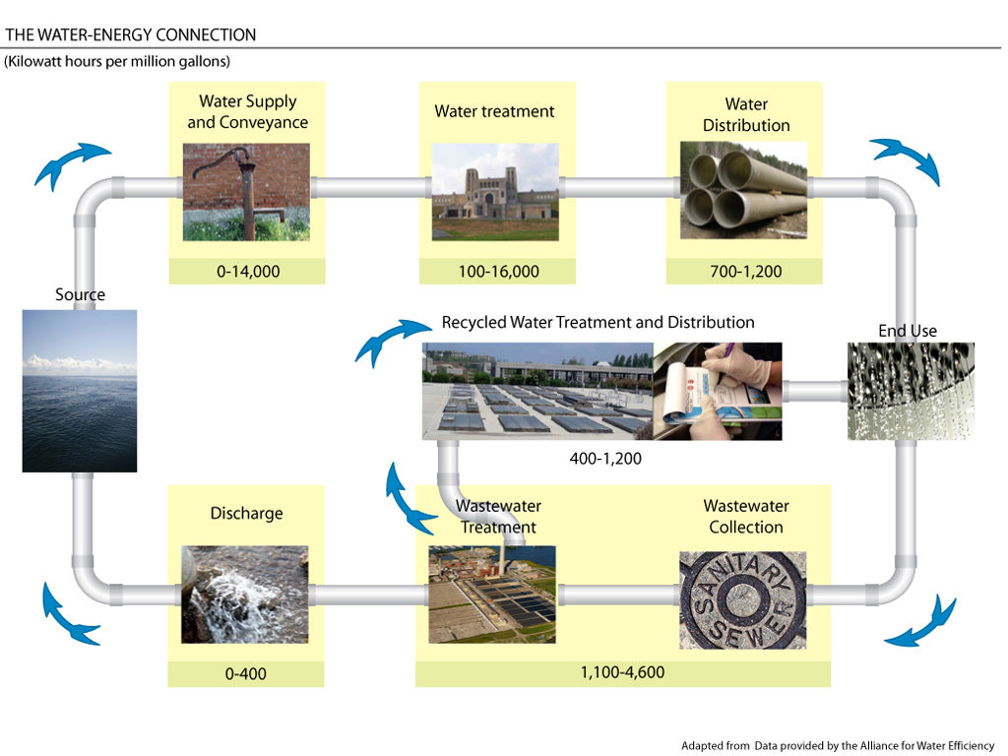
Above are just a few examples of how multi-pronged conservation programs targeting various stakeholders and sectors can lead to dramatic water, energy, and financial savings. This ultimately protects the water resources of thousands and even millions of people and the plants, animals and fish that depend on them.

In many Great Lakes communities, however, the public is insufficiently sensitized to water source, delivery and treatment challenges, so our Model Communities (social marketing research) and Public Outreach efforts (the Great Lakes United Tall Ships Challenge 2010) create the necessary space in public dialogue and understanding regarding the merits of conservation.

Outcomes
Environmental Management Decisions
The return on investment for conservation is staggering. Reducing consumption cuts pumping, treatment and heating costs. According to the Polis Institute “In a month, the energy we use moving and treating water could power from 314,000 to 1,500,000+ homes. That’s $17-$82 million spent every month pumping and treating water in the Great Lakes region. Tens of millions more is spent heating water.” In addition, research by the Alliance for Water Efficiency already shows that deferred and/or avoided capital expenditures in infrastructure exceed the immediate fiscal benefits of increased water use to municipal coffers. Capital investments in delivery and treatment infrastructure can reach hundreds of millions of dollars.

Moving further into the future (+5 yrs), we will be monitoring changes in per capita water use, population projections, actual and projected municipal spending on water infrastructure and electricity, local bylaw implementation and whether communities adopt quantitative targets and guidelines in their programming. As public knowledge and opinion plays a critical role in the success of this project, Great Lakes United prepared itself to trend these changes. In 2007, we concluded public opinion research built upon existing U.S. data sets, designed to compare and contrast earlier American polling work performed in 2004 by Belden, Russonello & Stewart. This data will be used to measure changes to public consciousness on the issue of water conservation – funding permitting.

We will share our information and the data set with municipal governments in the development of conservation programs and with the state and provincial governments in their assessments of the conservation plans mandated by the Great Lakes Compact and International Agreement.

Opportunities for Collaboration, Planning, Data Access and Accountability via Internet
An advisor to our Model Communities work, the Alliance for Water Efficiency recently launched its Water Conservation Tracking Tool, free of charge to members in good standing. Not only can the tool be used to evaluate the water savings, costs, and benefits of water conservation programs, it can propose strategies for specific communities/municipalities based on local information provided by the user. Our social marketing research (Model Communities) will advise updates to the tool

Additionally, The Alliance for Water Efficiency and Great Lakes United can host webinars for municipal stakeholders wherein the data and other results of our conservation work are shared, and support is provided for using the online tool. This work will also be of interest to the Federation of Canadian Municipalities.
Economic Outcomes
Tangential to our water conservation goals, we will also report on the economic benefits of the Great Lakes United TALL SHIPS CHALLENGE 2010 to the Great Lakes economy. The last Tall Ships festival, according to ASTA, generated $126M in Chicago alone! Cumulatively the Great Lakes United Tall Ships Challenge 2010 series will generate hundreds of millions of much needed dollars for the regional economy.

Collaboration, Partnerships and Overarching Plans
Great Lakes United helped craft the Great Lakes Compact as an Advisory Committee member to the Council of Great Lakes Governors, and Ontario’s Annex Advisory Committee. Our advisory roles to those bodies are on-going. With the Great Lakes Water Resources Compact & International Agreement coming into force, the Great Lakes states and provinces have until December 2010 to present conservation plans. Working with the POLIS Project on Ecological Governance at the University of Victoria, a Model Conservation Plan was developed to identify progressive, achievable, and timely goals that will help the region adopt world-leading conservation standards. This proposal aims to inform, through social marketing research and public outreach efforts, the conservation programs intended to meet those world-leading standards.

Of course local priorities, challenges and opportunities for conservation will differ between the jurisdictions so our collaborative effort includes, in addition to the Polis Project on Ecological Governance, the Alliance for Water Efficiency (U.S.) and Environmental Defence (CA) to help in the development of selection criteria for Model Communities in ways that capture local priorities. The Great Lakes Cities Initiative is also advising selection criteria as is Georgian Bay Forever.

(a) Model Communities Research & Communication to Environmental Managers
Our results will advise municipalities in the development of effective conservation programs. Research will be undertaken by expert contractors with regular advice from Initiative advisors. The Great Lakes St Lawrence Cities Initiative and the Alliance for Water Efficiency will help engage and deliver results to municipal stakeholders. Our goal is to design programs that showcase positive population growth within the existing water budgets of participating communities. Possible pilot communities, with whom we would like to partner, include York Region (ON); Waterloo (ON); Niagara (ON); Sarnia (ON); Windsor (ON); Green Bay (WI), Bay City (MI), Cleveland (OH), and Duluth (MN). We invite the nomination of other prospective Great Lakes communities.

In late 2010 we will launch our Model Communities Research for which the Ontario Trillium Foundation has requested we expand the scope to include at least 3 Ontario communities. Trillium has invited a March 2010 proposal and has suggested support in the range of $400-$500K. With a substantial commitment from the Trillium Foundation (results expected in April 2010), and the interest of several charitable foundations and municipal stakeholders from both sides of the Canada-US border, the value of research that identifies individual barriers to actions that conserve water is far reaching.

Support to ensure coordination between the overarching Compact work and the research and public outreach objectives in this proposal is provided by the W.D. Gordon Foundation ($27.5K, 2011, with approval of year two (i.e. $27.5K) contingent on progress/success) and the Salamander Foundation ($11K, 2011). A further 13.3K is under consideration by the McLean Foundation. Water quantity and regulation of large scale users is a core element of GLU work that will continue beyond 2011 with a focus on conservation.

Programmatic Capability & Past Performance
Incorporated in both Canada and the United States, Great Lakes United has over 27 years of cross-border expertise in the delivery of bi-national programs. With a coalition that is 170 member-groups strong, a Board of Directors with presence in each Great Lakes state and province, and offices in Buffalo, Montreal and Ottawa, Great Lakes United is uniquely positioned to realize a truly basin-wide Conservation Initiative. We have: engaged in extensive public opinion research, scoping values and attitudes toward the Great Lakes; a broad, bi-national network of partners and allies across the region to draw on for support; and professional, effective staff capable of running a summer long public awareness and outreach campaign.

Great Lakes United has a solid history of reporting and accounting for EPA grants – mostly related to the Bi-national Toxics Strategy (BTS) and other Water Quality Agreement work. Our current EPA grant is for $100K and includes a collaborative component, though it is not directly related to conservation. Prior to 2009, Great Lakes United was awarded $45K from EPA for BTS work.

Directly related to our current proposal, in 2006-08, we undertook extensive public opinion research that spanned 3 years, more than $500K in work (funded primarily by the Joyce Foundation) and involved more than a dozen partners all of whom benefited from the results identifying the values and pathways that individuals can be introduced to in promotion of better Great Lakes stewardship.

The results were so successful that in 2008, we provided Great Lakes message training to those provincial departments most responsible for Great Lakes programming in Ontario including the Ontario Ministry of the Environment, the Ontario Ministry of Natural Resources and the Ontario Ministry of Agriculture, Food and Rural Affairs (under contracts totaling $60K). Great Lakes United also presented “topline” public opinion results to the COA Communications Group (provincial and federal officials responsible for Water Quality Agreement implementation in Ontario via the Canada Ontario Agreement).

Following that effort, Ontario’s Trillium Foundation (a government funding agency) awarded Great Lakes United a grant of $204,000 to help Ontario’s public advisory committees strategically plan and more effectively communicate their priorities (i.e. based on the public opinion data).

All of those grants are closed and none was subject to auditing concerns, troubles with reporting, or failures in collaboration. We pride ourselves on a history of solid financial management that routinely has funders request we administer or partner in projects that involve less established groups. We are a nimble team capable of running both a multi-year initiative and a focused summer-long, basin wide public outreach campaign.

We have deep expertise on the legislative and regulatory tools adopted in Canada and the United States as it pertains to water quality and water use. This is reflected in our presence on several advisory panels, including:
- The Lake Superior Forum;
- The Bi-National Toxics Strategy of EPA and Environment Canada;
- The Annex Advisory Committee to the Council of Great Lakes Governors;
- Canada’s National Pollutant Release Inventory;
- Montreal’s Waste Water Committee;
- The International Joint Commission’s Upper Lakes Levels Study; and,
- The Great Lakes Ships Initiative.

Great Lakes United is also a formal observer of the Great Lakes Commission, the Bi-national Executive Committee, Policy Chair of the Great Lakes Nuisance Species Panel, official advisors to the Great Lakes Fishery Commission, and a Steering Committee member for the U.S. Healing Our Waters campaign and the Great Lakes Wind Collaborative.

