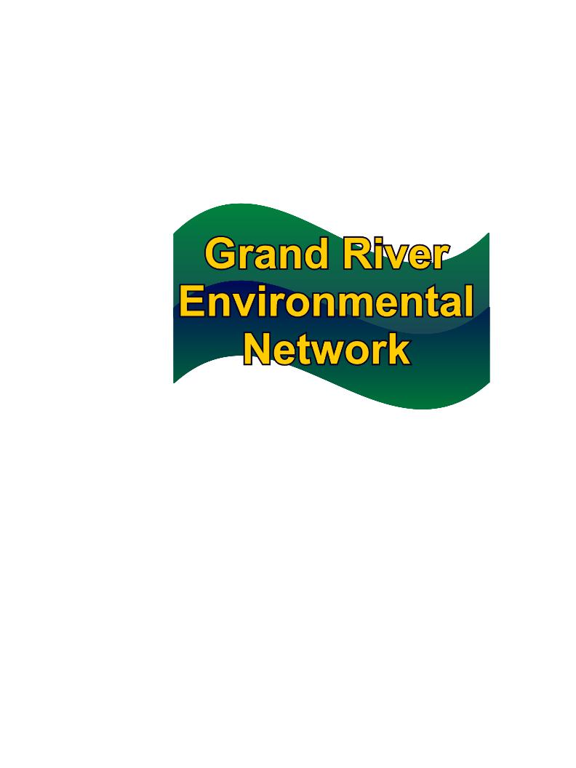
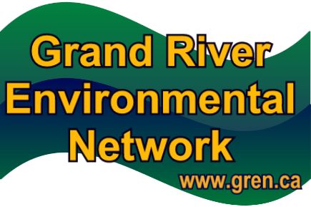
February 26, 2010
619 Forest Hill Drive
Kitchener, Ontario
N2N 1A1
info@gren.ca
519-744-7503
The proactive voice for the environment in the Grand River watershed
To Whom It May Concern:
The Grand River Environmental Network (GREN) offers its full support to Great Lakes United’s application to the Trillium Foundation for funding its Model Communities pathway to conservation. Specifically, we believe Waterloo Region would be an ideal pilot community for the proposed Conservation Initiative, and GREN would be delighted to work with Great Lakes United in helping to implement this project.
Background on GREN
Organized in 2008, The Grand River Environmental Network is a network of about 40 environment groups and environmentally concerned individuals in the Grand River watershed. The groups and individuals represented in GREN have been working on a wide variety of local environmental issues for many years, and GREN was formed to help coordinate these efforts. Following are GREN’s statement of principles:
Mission Statement: GREN is the proactive voice for the environment in the Grand River watershed. Members of GREN are activists, watchdogs, guardians, stewards and concerned citizens; support each other by sharing information and expertise; foster environmental awareness and literacy; and promote respect for our natural world and our place in it.
Our Belief: We are near the carrying capacity of the essentials for life—water, air, energy, greenspace, aggregate, agricultural land and wetlands—in our communities.
Our Commitment: GREN will draw from the well of creative people in our communities to find innovative ways to live better with less; work cooperatively to promote initiatives that restore, maintain and enhance the livability of our community; do so for all lifeforms, for current and future generations.
Our founding document then lists nine goals, with water conservation the first on the list: Implement aggressive water conservation and reuse programs instead of planning on outside water sources, such as a pipeline from Lake Erie to Waterloo Region. As this first goal illustrates, water conservation is a primary aspiration for GREN. Having Waterloo Region, by far the largest water-user in the Grand River watershed, as a pilot community for water conservation research and action would fit perfectly with one of GREN’s primary goals.
In our view, Waterloo Region is a prime candidate for this project. It is the largest urban community in Canada that uses groundwater as its main water source (only about 25% of the supply is from the Grand River). The Region also has one of the fastest growing populations in Ontario. The current population is about 525,000 and projections anticipate a population of about 712,000 by the year 2029---a 35% increase. The Regional Municipality of Waterloo’s Long-Term Water Supply Strategy (2000) recommends constructing a displacement pipeline from Lake Erie in 2035 to meet the water requirements of this growing population.
An assumption made in planning a pipeline was that per capita water use would remain essentially the same in 2035 as in 2000. The efficiencies possible from water conservation strategies were hardly considered in the Supply Strategy.
However, experience in recent years, where Waterloo Region has seen water demand flat line and even decrease, has prompted interest in re-evaluating the water conservation possibilities. The massive expense of building a 100-kilometre long pipeline from Lake Erie to Waterloo Region, as well as the costs of pumping and treating that water, is also a powerful motivator for a serious analysis of the possibility of staying within our local water budget.
Finally, Waterloo Region is well endowed with the expertise to support the campaign envisioned for a pilot community. Water professionals at the Regional Municipality of Waterloo have been at the leading edge of water protection policy in the province of Ontario. Waterloo Region is home to two universities and a community college, all with strong water/environment programs. The high-tech business sector attracts innovative people, and there is a keen interest in and knowledge about water issues in the community at large.
For these reasons, GREN wholeheartedly supports the Great Lakes United Water Conservation Initiative and its proposal that Waterloo Region be one of the pilot model communities. We would be honoured to participate in this project.

Susan Bryant
Chair of the Pipeline Committee
Grand River Environmental Network

