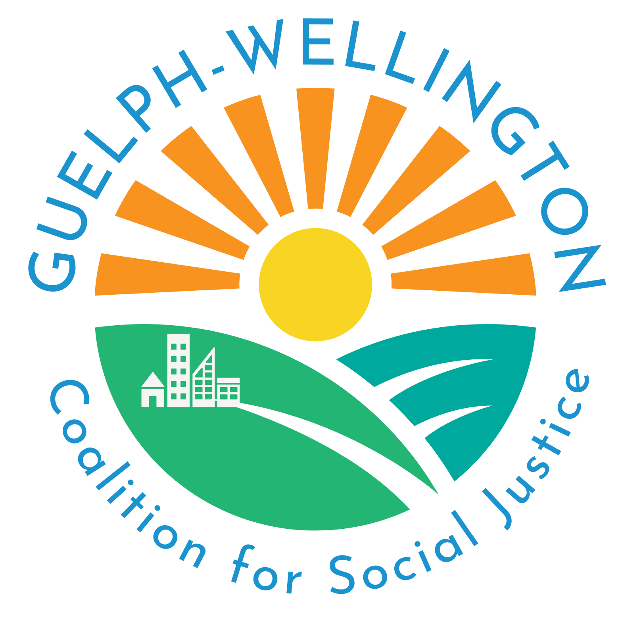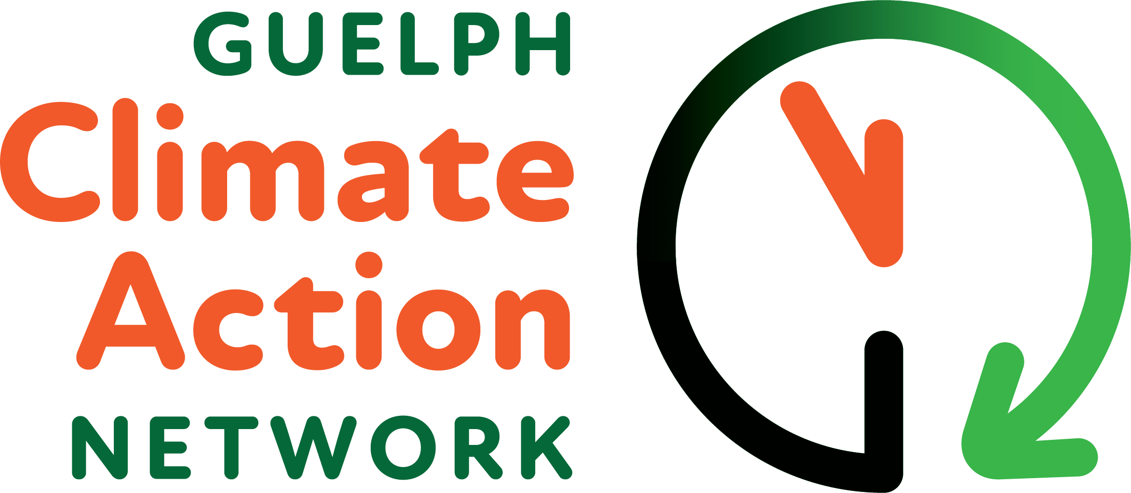

Media Release
April 25, 2024
Community Unites To Take
Climate Action

WHO: The Guelph Climate Action Network (GCAN ) and the Guelph Wellington
Coalition for Social Justice (GWCSJ) are partnering to host a Community
Climate Forum and launch our brand new Carbon Conversations program.
We are non-partisan, independent, and volunteer run groups and together we
represent 20 organizations and over 5000 affiliated members.
Co-Sponsors; OPIRG, Lind Design, The Bookshelf, Guelph Family Health Team,
Canadian Federation of University Women, Retired Teachers of Ontario.

WHAT: Community Climate Forum and launch of Carbon Conversations Program

WHERE: Italian Canadian Club
135 Ferguson St., Guelph

WHEN: Saturday, May 4, 2024
1 - 4 pm

WHY: The IPCC has issued a Code Red for humanity and a report from March 2023
concluded that we’re not doing enough to bring down emissions. We are the last
generation to have the opportunity to make the deep, rapid and sustained reductions in
greenhouse-gas emissions that are required. We must address the emergency at the
scale it demands to ensure a successful energy transition, lower emissions, and carbon
drawdown. We call on Guelph to step up, get involved and TAKE ACTION.

DETAILS: Bring a friend. All ages welcome. Doors open at 12:40

CONTACT: For more information: Donna Jennison - guelphclimateactionnetwork@gmail.com

Guelph Climate Action Network | Guelph Wellington Coalition for Social Justice
guelphclimateactionnetwork@gmail.com  https://guelphclimateactionnetwork  .carrd.co  https://www.facebook.com/groups/937133917737557/?paipv=0&eav=AfYLolSq9x5U57wNVoLtXAtqVMyQ3J7w_rWiDYuyUoE02FArbN-3v4P8qlpxkppwqa0&_rdr | guelphwellington.csj@gmail.com  https://www.gwsocialjustice.com

