**Posting for Board of Directors, Reep Green Solutions**

Posting open between January 3 to 31, 2024

**Award-winning* environmental charity seeks board member** from the Region of Waterloo and surrounding watershed, and from diverse ages, backgrounds and sectors.

*You care about our community and helping people live sustainably. You are concerned about climate change, the availability of clean water, air quality, and the integrity of our ecosystems.*

*You want to support an ambitious goal that recognizes the urgency of climate action now:* ***By 2030, people impacted by Reep Green Solutions have taken 10,000 meaningful actions to collectively shift our community to a resilient, low carbon future.***

Reep Green Solutions is looking for board members who share our vision and passion, and who recognize the opportunities and importance of this unique challenge.

**The organization:** Reep Green Solutions is an environmental charity that has been helping people reduce their impact and adapt to climate change for 25 years, through home energy efficiency, healthy yards, water conservation and waste reduction**.** We believe that by acting today, we can leave our children a community that is more resilient, vibrant, caring and sustainable.

**Our culture** is “trusting, productive, and happy at work”, as one staffer put it. There is great joy in working on issues we feel passionately about! One of our departing board members says “It has been wonderful working with such a competent and diverse board with an open communication and focused output-based decision-making.”

**One Board Position currently open:** We welcome applications from people with diverse perspectives across the Region and surrounding watershed, and are particularly looking for the following to add to our Board:

* **Connections with Cambridge, North Dumfries, Wellesley, Wilmot or Woolwich;**
* **Experience in one or more of fundraising, skilled trades, affordable housing, communications.**

Interested individuals contact Sarah Smouter, Office and HR Coordinator, [office@reepgreen.ca](mailto:office@reepgreen.ca).

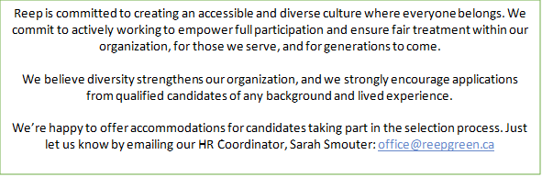

Reep Green Solutions has been making a difference since 1999:

* 22,000 homes evaluated for energy efficiency - 45,000 tonnes of CO2 reduced, cumulatively
* $61,000,000 in retrofit activity stimulated - 110,000 litres of stormwater capacity built

*2018, Social Venture Partners Waterloo Region [Perfect Pitch](https://www.youtube.com/watch?v=Cq3mIbS_Iek&feature=emb_title)

*2019, Green Community of the Year, Green Communities Canada

2017, 2018, 2019, 2020 Outstanding Board Member Awards, Green Communities Canada

*2011 Award Winner, Minister’s Award for Environmental Excellence, Ontario Environment Ministry