[**Aa**](https://observerxtra.com/2022/12/01/hes-made-a-career-of-covering-the-local-environment/?fbclid=IwAR04qmGD9aeH22mQgstYTz1qoBIxUwikSZLMHyx-srUXwMw0xXjQNQMqd7s)

READING:He’s made a career of covering the local environment

Share

[**OBSERVER**](https://observerxtra.com/)**>**[**Blog**](https://observerxtra.com/blog/)**>**[**Living Here**](https://observerxtra.com/category/livinghere/)**> He’s made a career of covering the local environment**

[LIVING HERE](https://observerxtra.com/category/livinghere/)

**He’s made a career of covering the local environment**

Last updated: 2022/12/01 at 9:04 AM

*By*[Leah Gerber](https://observerxtra.com/author/lgerber/)Published December 1, 2022

Share

6 Min Read

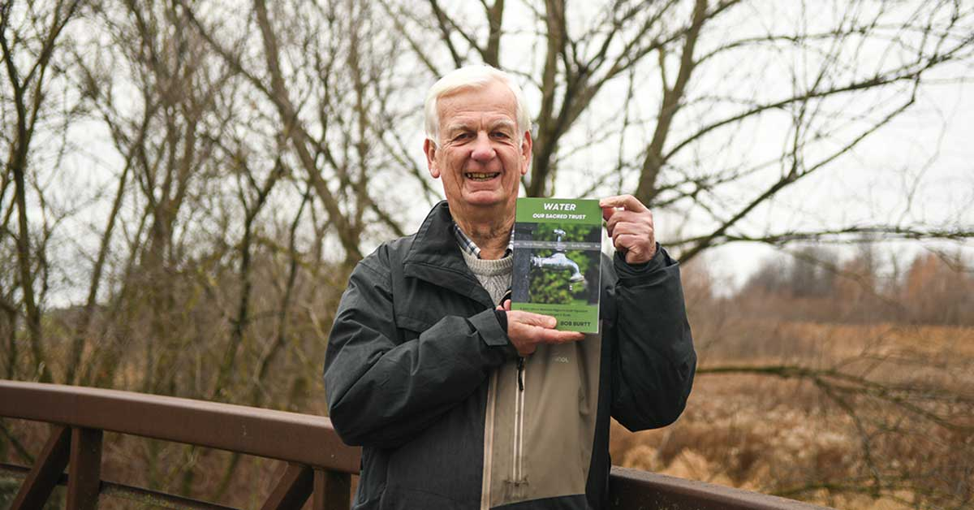

Bob Burtt stands near the Canagagigue Creek with his latest book, Water, Our Sacred Trust, which details cautionary tales of what happens when water is taken for granted, the sources of water in the region, and the history of water here. [Leah Gerber]

SHARE

Bob Burtt knows a thing or two about water – and the issues surrounding its use and abuse – from his years working as a Waterloo Region Record reporter covering environmental issues.

Water is the subject of this third book, Water, Our Sacred Trust.

“Water, it’s the source of all life, and if it’s abused or ignored, it can also be the cause of death or serious illness,” Burtt said.

Burtt worked in the newspaper industry for 50 years, with much of that time spent at the Waterloo Region Record. He was inspired to write this book after spending years covering water issues in the region, especially in Elmira.

His first book, No Guardians at The Gate, was in fact about the discovery more than 30 years ago that Elmira’s aquifers were full of chemical contaminants, the cleanup of which continues to this day. The second is rare Moments in Time about the work being done at rare Charitable Research Reserve in Cambridge.

The newest book has three parts. First, he looks at cautionary tales of what happens when water is abused or taken for granted. He covers the stories of the Walkerton and Elmira water crises, among other stories.

In Elmira, “all their wells were contaminated because of lack of over site by government and lack of care by the company,” said Burtt.

Second, the book takes a look at the sources of water available in Waterloo Region, including groundwater, the Grand River and conservation. Burtt says he considers conservation, that is, using less water, as a third source because, “if you don’t use it, you don’t need to produce it.”

He is also concered about major threats to the region’s water sources, particularly road salt.

“Salt is a real dilemma,” he said. The region is targeted for thousands more people, but “more growth [means] more roads, more salt, and this is having a real negative effect on the well water in the region. That’s going to be a real challenge.”

The third part of the book looks at the history of water, beginning all the way back to water-moving structures in ancient Roman times, and following this to the installation of the first wells in the region, current-day management and plans for the future.

All together, Burtt estimates he wrote the book on and off over three years. Sometimes he needed to take a break to get his focus back, he said.

“I always believed there was a really good story there. I just had to find a way to tell it.”

All his books  required a great deal of research, “lots of time in the archives, and lots of reading,” he said. But ultimately he feels it’s very rewarding work.

“I loved newspaper work, but here you get a chance with a book to really focus on one thing and learn about it as much as you can,” he said.

Burtt has spent much of his life writing about the Grand River and the region’s groundwater. He speaks about the ups and downs the river has had. At times, it’s been extremely polluted and running nearly dry in summer or flooding recklessly in the spring or fall.

“We’ve always expected so much of [the Grand],” he says. “We wait for it to break, but it really never has.”

He also spends time speculating about the future of water in Waterloo Region and around the world.

“A lot of rivers in the States are just drying up. Aquifers are drying up,” he said. Burtt believes a large percentage of the world is going to be short water in the next 20 or 30 years.

In Waterloo Region, Regional staff are “reasonably confident that we can go ahead with growth and still protect the river,” he said.

The challenges will include protecting the recharge of the river and groundwater, and ultimately managing water wisely in order to avoid building a pipeline to one of the Great Lakes for more water if the region’s supply runs out.

“Some of [the book] tends to be dark,” he said, “but I meant this to be a hopeful book.”  He hopes the book will engage readers and, “get [them] interested in where their water’s coming from, how it’s protected and where it’s coming from in the future,” he said.

“Be engaged. That would be the simple message, I think.”

The book will be available for purchase by mid-December at Wordsworth Books and Bowman Home Hardware in Preston. Those interested can also email Burtt directly at: [bobburtt@gmail.com](mailto:bobburtt@gmail.com).

Bottom of Form