<https://www.therecord.com/news/waterloo-region/2022/12/03/ontario-greenbelt-focus-of-cambridge-rally.html>

**Ontario Greenbelt focus of local rallies**

Residents urged to contact Conservative MPPs

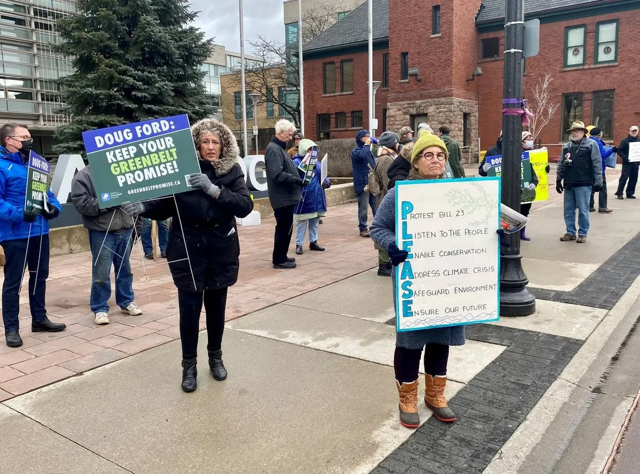

Photo: Mark Bryson Waterloo Region Record

By Waterloo Region Record Sat., Dec. 3, 2022timer2 min. read Article was updated 19 hrs ago

WATERLOO REGION — The recorded voice coming out of the speaker belonged to Doug Ford, and his words were clear: “We won’t touch the Greenbelt.”

Waterloo resident Kae Elgie wants Ontario’s premier to keep his 2020 promise, and repeal Bill 23: More Homes Built Faster Act, 2022.

The bill, passed by the Ontario government on Nov. 28, is to assist in constructing 1.5 million new homes in the province by 2031.

Elgie and about 30 others attended a rally at Cambridge City Hall on Saturday to express concern about how the new law could negatively impact the Greenbelt and possibly lead to the destruction of heritage properties. Many of the same people attended another rally Sunday in Kitchener that attracted about 100 people, at the corner of Alpine Road and Homer Watson Boulevard.

Elgie, past chair of Architectural Conservancy Ontario, is calling on Waterloo Region residents to contact their Conservative MPPs — Brian Riddell in Cambridge and Jess Dixon in Kitchener South-Hespeler.

“We want them to put pressure on Doug Ford, the environment minister (David Piccini) and Steve Clark, the housing minister, and say: ‘Look, if you want a Conservative seat in the next election, you better do something about this bill,’” said Elgie.

“People are pretty upset about this, and Ford needs to hear about it.”

The Ontario government is opening up about 7,400 acres of the Greenbelt for development under Bill 23. The government plans it to be part of a land swap, with 9,400 acres in other areas to be added to the two-million-acre swath of farmland and wetlands.

Bill 23 also gives cities two years to review heritage properties to determine if they should be designated, or removed from the registrar.

Saturday’s rally lasted about an hour, with those in attendance making their way through the streets of downtown Galt to spread the word.

“This is important to me because I see long-term threats to water, the environment and farmland,” said Waterloo resident Colleen Cooper, a retired public health nurse.

“I’m a grandmother, and I want to have a good world for my grandchildren to grow up in. And that’s really what it’s all about for me.”

Rallies were held across the province, including Sunday in Guelph.