**Neil E. Taylor**

**1016A Wilson Avenue**

**Kitchener, Ontario**

**N2C 1J3**

**TEL. (519) 893-6469**

November 23, 2020

Albert Hovingh,

Principle Planner, Stewardship Planning

Region of Waterloo

Planning Department and Legislative Services

150 Frederick St., 8th Floor

Kitchener, ON N2G 473

**Re. Marking and Logging in Hidden Valley Natural Heritage Site**

Albert

I am in receipt of your email November 20th, 2020.

I was disappointed in your response. We have worked together and known each other too many years for you to engage in obfuscation to my queries in my Nov. 18th, 2020 email.

Because of my about 46 years of interest in the area, I receive many reports, sometimes accompanied by photos that keep me aware of a variety of sightings and observations.

Natural Heritage designation has become incredibly significant to me. In the most recent Official Plan, the Region attempted to designate our residential property as Natural Heritage. It has taken us years to have it corrected which included a site visit by you and others. In the case of Hidden Valley, I had been given assurances that the Natural Heritage designation by the Region of Waterloo and the City of Kitchener would offer absolute protection.

With response to the question of new or old markings, the most recent report included the deciduous upland forest along and adjacent to the eskers and not just where the logging took place near Highway 7/8 earlier this year.

With this basis, we both know that since Hidden Valley has been designated as a Natural Heritage Site in Kitchener, any activity perceived to possibly lead to disturbance must be evaluated by either the Region’s and/or Kitchener's Ecological and Environmental Advisory Committee (EEAC). In this matter, the identification of the activity is proposed tree removal and thereby requires evaluation by EEAC. By default, since Hidden Valley holds status as a Natural Heritage Site, it is probable you provided guidance on the initial proposal by the owner to remove trees. Then this process is to require someone like yourself to explain that this activity has been proposed to EEAC, and then EEAC independently assesses the activity for possible disturbance to a Natural Heritage Site.

As a Forester, it is likely you know any proposal to remove trees is completed within a forest management plan, likely approved by the Ministry of Natural Resources and Forestry (MNFR). With the completion of an MNRF forest management plan, it implies the plan has explicitly considered possible impacts on a suite of factors, including Species At Risk (SAR), drainage, erosion, plant diseases as well as possible presence of significant wildlife habitat among an array of other considerations. When you responded to my note, you stated a plan had been prepared by a qualified person. With this comment, it is implied it was approved by an Arborist or Forester and then reviewed by MNRF. Your response did not identify if this plan was reviewed by EEAC. If EEAC completed a review and approved the proposed activity, it implies that it is unlikely to cause disturbance to, for example, SAR or known significant wildlife habitat evident in Hidden Valley. Further, as you likely know, large trees provide habitat to SAR myotis like Endangered Little Brown Bat (*Myotis lucifugus*). Hence, the haphazard removal of large trees or even trees with DBH > 10 cm can disturb or harm bats and is thereby prohibited within Ontario's Endangered Species Act and federal Species At Risk Act. With our relationship, you know I have been observing many bat and bird species in this area for decades. With all of this, given your commitment to the environmental sustainability of Kitchener, it is very probable you or EEAC have assessed possible risk to sensitive features such as SAR bats in Hidden Valley and other environmental features. I look forward to reviewing the risk analysis within the forest management plan completed for this important Natural Heritage Site.

For Hidden Valley, when you send along the risk assessment for the proposed tree harvest, I also look forward to reading the recommendation provided by EEAC to the Council for the Region of Waterloo and/or Kitchener City Council regarding this matter. For example, it would not surprise me to learn that EEAC has applied a high degree of analysis to this matter concomitant with additional environmental management recommendations to accompany the tree removal exercise. Maybe it would be easier for you to send the document likely prepared by EEAC for Council on this matter?

Respectfully submitted,

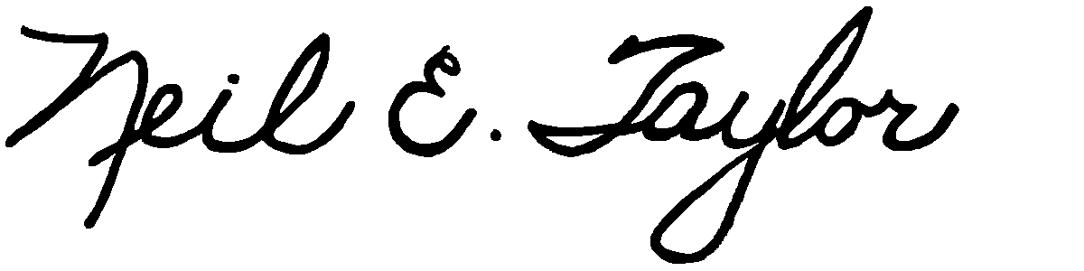

Neil E. Taylor

Cc. Karen Redman

Bruce Lauckner

Kate Hagerman

John Jackson

Interested parties