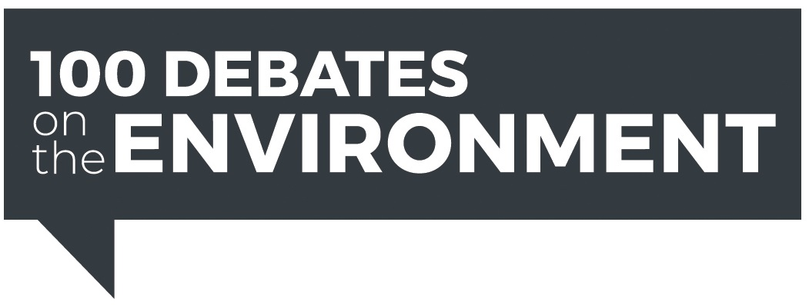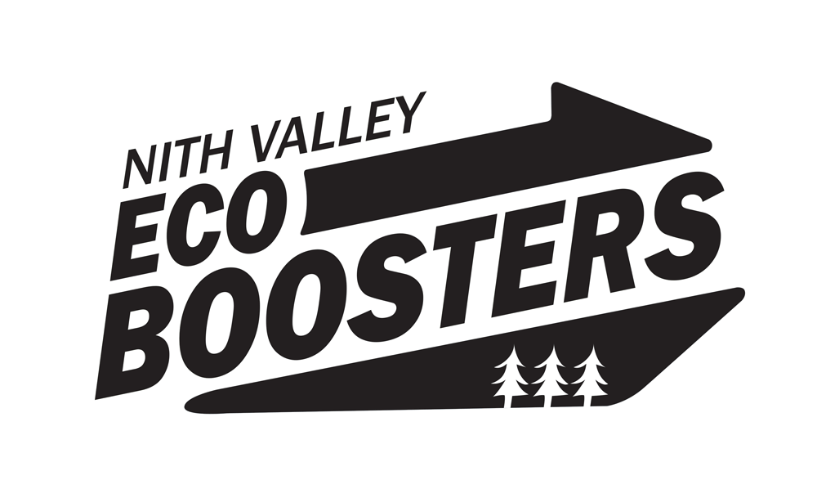

***You are invited to the Kitchener-Conestoga riding’s debate on the environment!***

Most of the scientists and citizens of our world recognize that we are in a climate emergency. As the IPCC has warned us, we only have 11 years to take drastic action to reduce greenhouse gases - if we want to avoid the most damaging effects of climate change.

Recent polls show that climate change and protecting the environment are top of mind for most Canadians as we head into the federal election. It’s never been more important for us to elect MPs who will take bold action to fight climate change and protect our environment – for the sake of future generations and Earth itself.

The 100 Debates project (<https://www.100debates.ca>) is spearheading over 115 non-partisan environmental debates that will be taking place in federal ridings across Canada. This unprecedented debate focus on the environment is what is needed to help us all face the serious challenges that are ahead.

Come to the Kitchener-Conestoga Debate on **Wednesday, October 9th from 7 to 9 p.m. at the New Dundee Community Centre, 1028 Queen St., New Dundee**.

To register for this free event go to <http://nvecoboosters.com>

For other ridings in Waterloo Region, register at Eventbrite “100 Debates on the Environment + *the name of your riding*”

With hope for our future!

*Nith Valley Ecoboosters*