**Neil E. Taylor**

**1016 Wilson Avenue**

**Kitchener, Ontario**

**N2C 1J3**

**TEL. (519) 893-6469**

August 1, 2018

**Brandon Sloan,** Manager, Long Range & Policy Planning, Planning Division

City of Kitchener, 200 King Street West, Kitchener, ON N2G 4G7

Dear Mr. Sloan

(Via e-mail)

**Re. Hidden Valley**

I am in receipt of your email dated June 28th, 2018.

I do not understand nor accept that the regulated area delineated by the OMNR should not be zoned Natural Heritage Conservation given that the area was regulated in order to protect habitat for a species listed in SARA. Natural Heritage Conservation zoning is absolutely appropriate for this area. I suggest that failure to do this would be an abrogation of duty by the City and may result in appeals.

Perhaps you are already considering some of my concerns below, but please note I have not abandoned them.

* Please see my June 23, 2016, to Nancy Gross on the subject area. Please address this to my understanding. See the OMNR regulated area. I suggest that the area surrounding this regulated area should be permitted and encouraged to be naturalized.
* I note that you mentioned in the presentation that the Region had conducted exhaustive studies re. environmental issues. To my certain knowledge, the 2-year study re. Jefferson Salamander did not include the southern portion, the quarry area or the sloping area north and west of the largest PSW. This is a significant gap in data collection.
* I am concerned that the tenant farmer has already encroached into the Natural Heritage Conservation in several locations.
* Serious consideration must be undertaken to provide for more recreation in the area as opposed to any further development that may impact traffic and the environment.

Respectfully submitted,

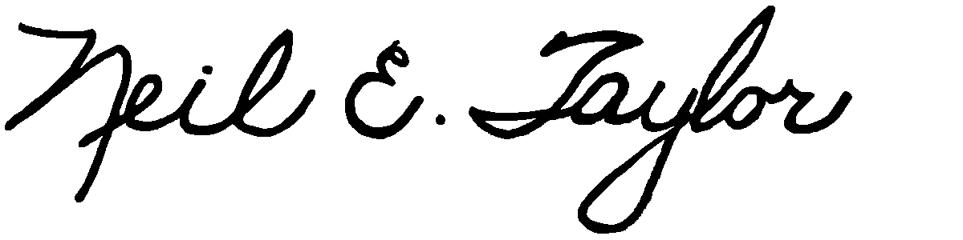

Neil E. Taylor

Cc. Councillor John Gazzola

Councillor Yvonne Fernandes

Interested parties