June 23rd, 2016

**Attention:**

**Natalie Goss,** MA, MCIP, RPP  
  
Senior Planner | Planning Division | City of Kitchener  
519-741-2200 x7067 | TTY 1-866-969-9994 | [crozby@kitchener.ca](mailto:crozby@kitchener.ca)

**Response to Notice of a Comprehensive Review if the Zoning By-law (CRoZBy)**

I note that on the City of Kitchener Web Site re. the above subject as found at:

<http://www.kitchener.ca/en/insidecityhall/crozby-component-a---first-draft.asp>

no mention is made of OMNR regulated areas. This should have been included as Appendix I just as the one, Appendix H - Grand River Conservation Authority Regulated Area. Further I find no reference to such regulated areas anywhere further in any of the documents referenced on city web site links.

There are 2 such regulated areas that I am aware of. The one is in Doon south and was part of a determination through the Ontario Municipal Board. The second is in Hidden Valley and was firmly established at least by 2013. Please see the attached map below.



There are numerous documents to support my assertions re. these two regulated areas. How many more might there be?

In remitting this concern, I ask for acknowledgement of receipt of this document and a response as to how this information will be incorporated into the **Comprehensive Review if the Zoning By-law (CRoZBy)**

Respectfully submitted,

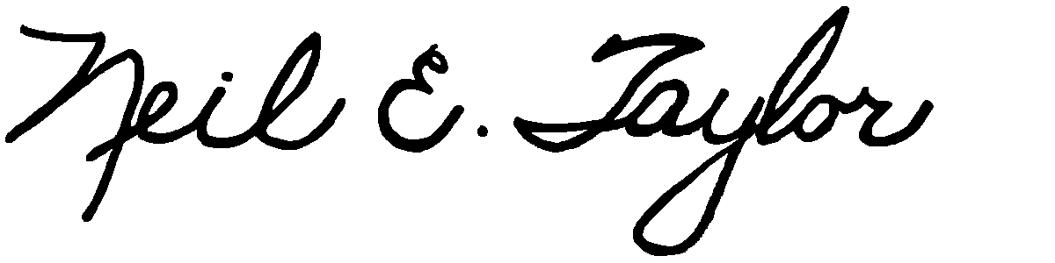

Neil E. Taylor

CC. Interested parties