**Neil E. Taylor**

**1016 Wilson Avenue**

**Kitchener, Ontario**

**N2C 1J3**

**TEL. (519) 893-6469**

June 28, 2018

**Brandon Sloan,** Manager, Long Range & Policy Planning, Planning Division

City of Kitchener

200 King Street West, Kitchener

ON N2G 4G7

Dear Mr. Sloan

(Via e-mail)

**Re. Hidden Valley**

First Brandon, I compliment you on the approach you have taken to this important planning issue. It is refreshing to see a municipality approaching residents in advance of times required by provincial statutes.

I was also so pleased to hear you echo my oft used word “jewel” re. Hidden Valley. For about 40 years, I have referred to this special area as a “gem”, “jewel”, an “emerald gem” or “emerald jewel”. Let it gleam and sparkle for future generations.

At this time, I am only able to provide a few concerns as follows.

* Please see my June 23, 2016, to Nancy Gross on the subject area. Please address this to my understanding. See the OMNR regulated area. I suggest that the area surrounding this regulated area should be permitted and encouraged to be naturalized.
* I note that you mentioned in the presentation that the Region had conducted exhaustive studies re. environmental issues. To my certain knowledge, the 2-year study re. Jefferson Salamander did not include the southern portion, the quarry area or the sloping area north and west of the largest PSW. This is a significant gap in data collection.
* I am concerned that the tenant farmer has already encroached into the Natural Heritage Conservation in several locations.
* Serious consideration must be undertaken to provide for more recreation in the area as opposed to any further development that may impact traffic and the environment.

Respectfully submitted,

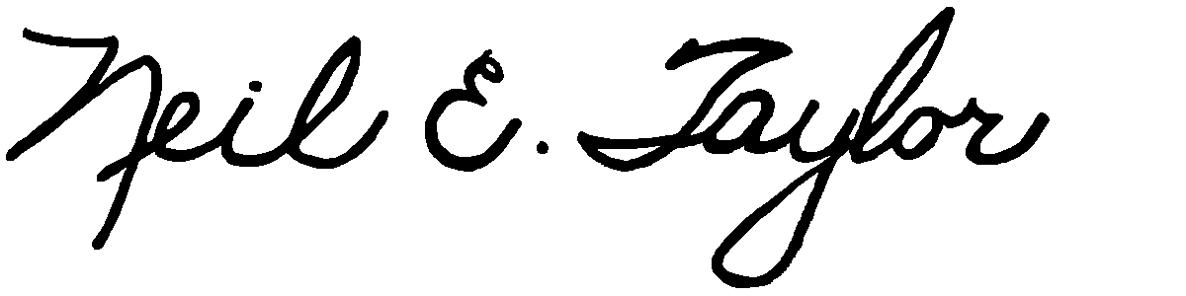

Neil E. Taylor

Cc. Councillor John Gazzola

Councillor Yvonne Fernandes

Interested parties

Attachment June 23, 2016