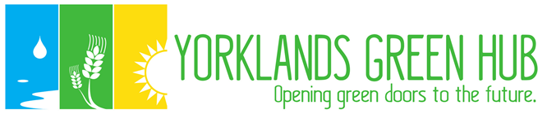

**Yorklands Green Hub** (YGH)

is an incorporated non-profit group that is working to establish an interactive environmental learning and nature centre for strengthening sustainable communities on part of the heritage site of the closed Guelph Correctional Centre.

**Our Mission:**

To be a centre for urban sustainability initiatives through innovating, educating and collaborating to open green doors to the future.

By repurposing 70 acres and 1 building of this former Ontario Reformatory, we can inspire stewardship and resilience on food, water and energy use at this heritage and culture-rich landscape of meadows, wetlands, streams, ponds and trails.

**The Yorklands Green Hub Will Be:**

a centre for sustainable food production, wise water use, wetland restoration, biodiversity and energy conservation and technologies.

* a site for citizen engagement in building strong, healthy and inclusive communities through education, research and recreation.
* an historic exhibition centre that reflects the groundbreaking past of early 20th century skill-building on this site plus the earlier indigenous history of the area.
* A collaborative cluster of community organizations building resilient municipalities and stewardship of nature, our culture and heritage.

**What we are doing right now:**

* Fundraising for an executive director and operational expenses .
* Designing and implementing a capital fundraising campaign to purchase the land, to retrofit one building and start our programming.
* Collaborating with water, energy, food and heritage organizations, institutions and individuals supporting a resilient future.
* Exploring the possibility of YGH becoming a land trust that will be protected in perpetuity as community shared space for these goals.

**We ask you to help the Yorklands Green Hub become:**

**An educational resource for living and working in a resilient future, an environmental exhibition centre, an eco-tourism destination, a community hub of best sustainability practices and a preserved heritage site.**

**For details, to join or to donate please visit**

<http://www.yorklandsgreenhub.ca> Email: [info@yorklandsgreenhub.ca](mailto:Info@yorklandsgreenhub.ca) Aug. 2017