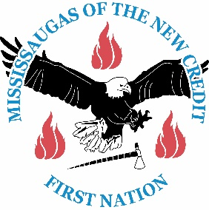Mississaugas of the New Credit and

The Grand River Conservation Authority Present:

HISTORICAL GATHERING

&

HERITAGE DAY WORKSHOP

Wednesday, February 15 – Thursday, February 16 – Friday, February 17

2017

Registration form – must register by Wednesday February 8, 2017

Name: _____________________________________________________________

Organization: _______________________________________________________

Address: ___________________________________________________________

City/Town: ________________ Province: __________ Postal Code: ___________

Phone Number: _________________________ Fax Number: _________________

Email: _____________________________________________________________

Please note – Lunch is provided, but if you have any strict dietary restrictions, it is advised that you bring a bagged lunch.

Participants are encouraged to bring their own utensils/plate/bowl/cup to be entered in a draw to win a prize.

Please return completed form(s) by **email**: [delainie.king@newcreditfirstnation.com](mailto:delainie.king@newcreditfirstnation.com)

Please check all that apply:

Participant/Guest Presenter Volunteer Sponsor

Please check which day(s) you will attend.

February 15 February 16 February 17

Or by **fax** 905-768-7311. You may also **register by calling** 905-768-0100, or **mail** completed forms to Historical Gathering 468 New Credit Rd. Hagersville, ON N0A 1H0