

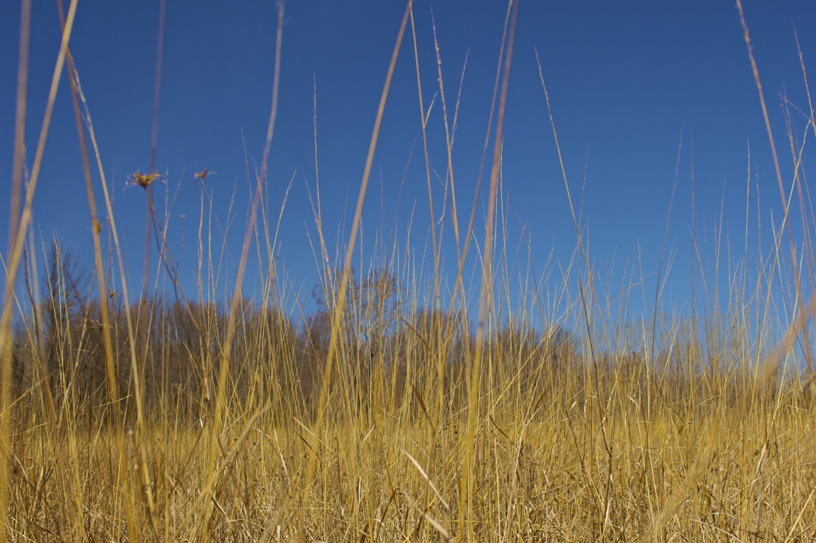

**SAVE THE DATE!**

**The ALUS Norfolk 9th Annual Tour**

“Nature’s Benefits on the Farm”

**Wednesday August 27, 2014**

**9:30-3:30**

At this year’s Annual Tour we will be visiting and exploring 4 unique properties that highlight the diversity of ALUS projects on the eastern edge of Norfolk County. Each stop will include greetings from our host-landowner, a guest speaker and a walk-about to get a good look at our work on the land. Highlighted projects will include Riparian Restoration, Marginal Farm Land Restoration, Agricultural Operation Enhancement and Wetland Creation.

Remember to bring your best field footwear!

*Registration* ***8:30 – 9:30***

*Departure* ***9:30***

*Lunch & Presentations* ***11:30***

*(Bonnieheath Estate Lavender & Winery)*

*Return* ***3:30***

**Invitation with more details to follow...**