Neil E. Taylor

1016 Wilson Avenue

Kitchener, Ontario

N2C 1J3

519-893-6469

November 26th, 2013

(Via e-mail)

Without Prejudice

**Urgent Attention**:

Wayne Cheater, P. Eng., Senior Project Manager

Regional Municipality of Waterloo, 150 Frederick Street,

Kitchener, Ontario, N2G 4J3.

Re. South Kitchener Transportation Corridor,

**AKA River Road Extension,**

Bleams Rd. Extension, and

River Road Extension Class EA

Dear Mr. Cheater,

I acknowledge receipt of you email November 25, 2013.

Mr. Cheater, I have stated several times in communications that you seem to have a predisposition to indulge in obfuscation. Perhaps I have been too kind since you continually repeat the error. Permit me to define the word for your edification. Simply said, to obfuscate means to obscure or be deliberately ambiguous. One of my friends would probably cite your style as an example of ‘plausible deniability’.

You claim to have addressed my concerns in # 64 in the Public Consultation Centre #3 Comment / Response Summary, October 1, 2013.

Mr. Cheater, you do me and regional staff a gross disservice by responding as you do. You have picked and chosen and disregarded various concerns in a manner that I might only describe as being whimsical. That sir is not good enough in 2013. No longer will “business as usual” be accepted.

I have reviewed the comments that staff have made to various citizens. Invariably, the response is, “concerns and comments are acknowledged and have either been, or are again being considered”, “at the detailed design stage”. It appears that much needs to be done “at the detailed design stage”. I say it must be now.

I am both shocked and disappointed that no summary was made re. those in favor of the costs associated with the project vs. those that have concerns and those that don’t. **It would seem that only one person supports the project, no matter what the design may be.** This was in spite of the loaded headings in the comment sheet.

As for my own comments, I drafted a serious 4 page response to the October 1st PIC in which I outlined 10 concerns specifically dealing with the current design. Further I raised several concerns re. the EA Study and the Endangered Species Act.

You did not address my request to receive a copy of the letter seeking specific permission from provincial ministries for the acceptance of such a new ingress/egress design in a Provincially Significant Wetland (PSW). I also asked to receive a copy of the granting of such specific permission at this time from the Provincial Government.

**You were silent on this request. I am prepared to seek the assistance of the Freedom of Information and Privacy Commissioner as well as the Environmental Commissioner in the event that you fail to provide me these documents forthwith.**

You ignored my # 5 completely which sought the precise cost for the “S” curve ingress/egress. This is unacceptable. You asked for comments and then ignored them.

With respect to the “S” curve ingress/egress, you cite the requirements of the City of Kitchener for access. I suggested an access via ingress only which would not require the intrusion into the PSW. Once again you ignored this. I expect a response forthwith.

With respect to Species at Risk and mitigation, you are now on the record as stating that “consideration”, “consultation”, and “as necessary’ will be the *modus operandi*. What an admission! Once again you failed to provide concrete methods of mitigation.

Then you became expansive and responded to my 2 pages re. the **EA Study and the Endangered Species Act** in 8 sentences which seemed to indicate that in spite of the region stating originally that no species at risk existed in the project area, there may be up to 46 species. You also seem to admit that there are gaps in data. What is most amazing is that the region has not been able to determine accurately the list of species at risk even at this date.

Mr. Cheater, you completely ignored the following concern. “**It goes without saying it is not feasible to claim this EA and EIA are complete when all of these SAR are excluded from analysis of effects and these SAR permits have not been identified or discussed with the public.** **Given the absence of any discussion on these permits that are also likely required for the proposed road, there also has been no identification of the cost and time to obtain these permits.”** I request an estimate of these costs by return email.

Finally, please understand that only a few of these concerns apply only to Alternate Route 5. Most of these apply to every single design proposed by regional staff over several years.

Respectfully submitted,

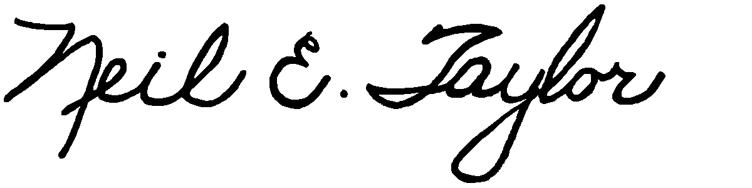

Neil E. Taylor

C.c.

Mrs. Jean Haalboom, Councillor, Region of Waterloo and Project Team Member

Mr. John Gazzola, Councillor, City of Kitchener and Project Team Member

Mr. Barry Vrbanovic, City of Kitchener and Project Team Member

Ms. Claudette Millar, Councillor, Region of Waterloo

Ms. Jane Mitchell, Councillor, Region of Waterloo

Mr. Les Armstrong, Councillor, Region of Waterloo

Mr. Jim Wideman, Councillor, Region of Waterloo

Mr. Carl Zehr, Councillor, Region of Waterloo

Mr. Geoff Lorentz, Councillor, Region of Waterloo

Mr. Doug Craig, Councillor, Region of Waterloo

Mr. Sean Strickland, Councillor, Region of Waterloo

Mr. Rob Deutschmann, Councillor, Region of Waterloo

Mr. Ross Kelterborn, Councillor, Region of Waterloo

Mr. Tom Galloway, Councillor, Region of Waterloo

Ms. Brenda Halloran, Councillor, Region of Waterloo

Mr. Ken Seiling, Chair, Region of Waterloo

Ms. Jane Brewer, Councillor, Region of Waterloo

Mr. Todd Cowan, Councillor, Region of Waterloo

Hon. Hon Kathleen O. Wynne, Premier of Ontario,

## Hon Michael Gravelle, MPP, Minister of Natural Resources

## Hon James J. Bradley , MPP, Minister of the Environment

Mr. Michael Harris, MPP

Hon. John Milloy, MPP

Mr. Ken Seiling, Regional Chair

Ms. Virginia West, Deputy Minister

Mr. Gord Miller, *Environmental Commissioner* of Ontario

Mr. André Marin: The Ombudsman

Dr. Ann Cavoukian, Information and Privacy Commissioner of Ontario

Mr. Howard Hampton, MPP, Critic, Natural Resources

Mr. Jerry J. Ouellette, MPP, Critic, Natural Resources

Other interested and concerned citizens.