04/05/14

Concerns of the Costco Project by Erbsville Road
As submitted by Louisette Lanteigne, 700 Star Flower Ave. Waterloo.

Issue #1: Collisions

In 2012, The Ira Needles and Erbsville roundabout and the Ira Needles and Highland roundabout in Kitchener both had 33 collisions. The University and Ira Needles roundabout in Waterloo had 21.

Total collisions involving all roundabouts on Ira Needles in 2012 = 87 collisions.
View Attachment 1 for details.

We already have a significant number of collision issues regarding the design of existing area roundabouts. It is likely that increased traffic flow heading to and from Costco will result in further collisions in an already high problem area of Erbsville Road. It is not reasonable for us to proceed to increase traffic until we reasonably design a better way to mitigate the existing traffic issues in the area. Lives depend on it.

In Kitchener, they are considering the approval of the River Road Extension as a means to reduce traffic congestion on Fairway Drive which will cost 72 million dollars. How many millions of dollars more will it cost Waterloo Taxpayers in the future to remedy the high congestion of traffic flow along Ira Needles and Erbsville Road? The placement of this proposal in my view, does not reflect sound planning principals.

The high volumes of traffic along Ira Needles as it stands currently is unsafe for biking and pedestrians. There is too much traffic and not enough alternative roadways in the vicinity to offset the flow. There are too many natural constraints to allow for further roadway alternatives. It’s not an appropriate location.

How long is the emergency response time along Erb Street during the 5 o’clock traffic hour, heading west of the Ira Needles turn around? What is the anticipated response time after Costco is built?

Six people hurt in chain-reaction crash on Ira Needles Blvd in Kitchener
Waterloo Region Record Sept. 20 2013
KITCHENER — Six people were taken to the hospital after a multi-vehicle crash on Ira Needles Boulevard in Kitchener late Friday morning.
Multiple people were hurt Friday in a crash on Ira Needles Boulevard.An injured person is carried to an ambulance past the wrecked vehicles involved in a four-vehicle collision on Ira Needles Bloulevard near Highland Road, Friday.Multiple people were hurt Friday in a crash on Ira Needles Boulevard.An ambulance attendant carries a child through the scene of a four-vehicle collision on Ira Needles Bloulevard near Highland Road, Friday.
The crash was reported to rescue crews at 11:32 a.m., near the entrance to the Shoppers Drug Mart about 100 metres north of the Highland Road roundabout.
It looks like the chain-reaction collision started with a northbound car trying to turn into the shopping plaza, said Const. Gary Russell of Waterloo Regional Police.
"As it did that it went into the path of another car. As a result of that it spun out, went across the median and got hit by another car," he said.
Chris Zografos was driving a Waste Management recycling truck northward through the roundabout and heard a bang. Then he saw smashed cars in front of him, injured people on the ground, and stopped to help.
"I grabbed what I could from my emergency kit, like blankets for them, and tried to help keep the people calm. I tried to keep their necks still, but they kept moving around," he said.
He said it looked like multiple generations of a family were in the minivan: a man and two women, and two children. A woman was hurt in the car that collided head on with the van. Another damaged car was in the southbound lanes
Four ambulance carried people to hospital.
Ira Needles was closed about two hours as police traffic investigators took measurements and photos at the crash scene.
The investigation continues.
Around the same time, police were called to other crashes nearby. Two were along Highland Road near Belmont Avenue. There was another fender-bender along Highland at Fischer-Hallman Road.

Issue #2: Salt
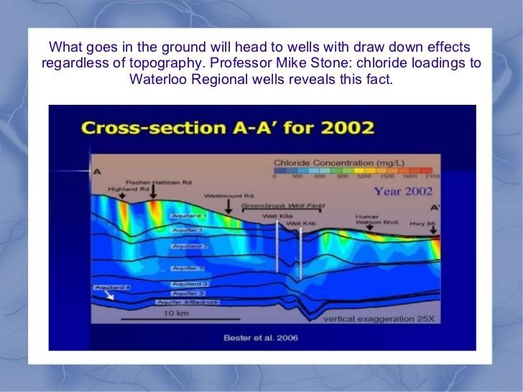

Most wells in Watelroo Region already have high salt levels and show increasing trends. The highest levels show up in the urban core where road density is high. Levels that are very high (several thousand mg/L) have been found in snow pipes removed from by the Region of Waterloo and in shallow groundwater adjacent to the roadways. Approximately 10% of Regional wells are exceeding 250mg/L as mandated by the Ontario Drinking Water Standards. See Attachment 2 for details.

The Waterloo Region health department has issued warnings about our tap water for people on salt restricted diets. The Heart and Stroke foundation states, ”If you are on a low-sodium diet and are drinking water with high levels of sodium it would be a good idea to choose another supply of water.” This is noted in Attachment 3.

Salt levels are rising in almost all wells and in the Grand River. We are spending millions to address the risks and the GRCA has flagged high chloride levels in the Grand River as a concern. The more people, the more road salt. Canadian Environmental Protection Act lists salt as “Toxic”. See Attachment 4.

How will the additional salt loadings from this project interact with the contents and chemicals found within the dump? Will it degrade the biota needed to break down componants? Will it increase risk of toxicity issues?

Vinyl Chloride leaking at the Erb Street dump that threatens our water supply. There is the possibility of using in situ bioremediation using enzymes that will eventually neutralize the toxicity but issues such as road salt may kill off the beneficial enzymes needed to make that happen. Further data is needed to understand what if any relationship the salt loadings have on the contents of the dump.

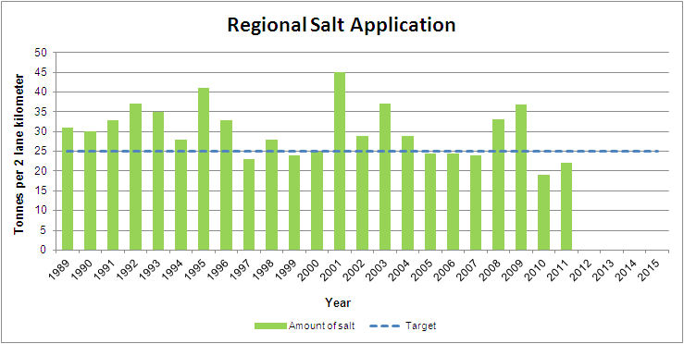

The annual target for road salt applications in the Region of Waterloo is 25 tonnes per 2 lane kilometre of road (established in 2003/2004).

How much salt will the Costco project require on an annual basis?

What will the long term impacts be on our existing well systems?

What is the thresh hold for salt in receiving waters before we see deleterious impacts on aquatic communities? (Without an actual values given, there is no reasonable baseline data to work with!)

The West Side Lands had a zero thresh hold for exceeding MOE salt limits. What will the impact of this project be on the Greenbrook wells?

Could we see future well closures as a result of this proposal? If so how many years will that take to manifest?

Is this project putting at risk future wells fields?

The International Joint Commission’s report, “A Balanced Diet for Lake Erie: Reducing Phosphorus Loadings and Harmful Algal Blooms,” recommends the Canadian province of Ontario and the states of Ohio, Michigan, New York, Pennsylvania and Indiana ban applying manure, biosolids and fertilizer to frozen ground or ground covered by snow to stop harmful algal blooms in Lake Erie.

There is concern about the use of Beetroot as a de-icer because it is known for it's acute nitrate levels. See Attachment 14. Applying it directly onto roadways in the winter may introduce nitrates directly into our local waterways. It will end up in storm drains leading to the Grand River then to Lake Erie. We must be cautious with alternatives like this.

The need is there to secure the establishment of appropriate runoff criteria grounded in the assimilative capacity of these waters. For example, the EA process is intended to identify, assess and mitigate potential environmental impacts during the planning stages of a project. The proponents cannot assess and mitigate what they have not identified. The City and Regions’ failure to carry out an appropriate baseline receiving water study along with a clear mitigation strategy would be a violation of various MOE policies and guidelines including Water Management Policies, Guidelines & Provincial Water Quality Objectives, July 1994.

Supporting policies: Regional Official Plan, as approved, with modifications on Dec. 22, 2010

Source Water Protection
Waterloo Region is unique in Ontario in that it is the largest urban municipality to rely almost exclusively on groundwater supplies for it's drinking-water. Approximately three quarters of all the region's drinking-water comes from over one hundred municipal wells, many of which tap into rich aquifers sustained by the Waterloo Moraine.
The remaining quarter of the region's drinking-water is drawn from the Grand River. Protecting these valuable water resources from contamination and from land uses that could hinder groundwater recharge is essential to maintaining human health, economic prosperity and a high quality of life in the Region.

CHAPTER 8
Overall Goal – Protect, maintain and wherever feasible, enhance surface water and groundwater resources to ensure that a municipal drinking-water supply system continues to provide a sufficient quantity and quality of drinking-water.

Objectives:
8.1 Protect existing and future sources of drinking water from incompatible land uses.
8.2 Maintain and, wherever feasible, enhance the quantity and quality of water infiltration and recharge to groundwater aquifers.
8.3 Minimize the potential for contamination, including potential contamination from de-icing salts, on sources of municipal drinking-water.
8.4 Promote informed stewardship of Source Water Protection Areas in collaboration with the Province, Area Municpalities and Grand River Conservation Authority.

NOTE: With incomplete hydrological assessment, lack of salt mitigation strategy, lack of noise reduction strategy or storm water management plan, it is premature for us to assume this project can be built in compliance with the existing policies including 150/06 of the Conservation Authorities Act, the Clean Water Act, Federal Fisheries Act etc.

The technical requirements for the proposed road expansion should be finally determined only after these steps so the final design can take the studies fully into account in order to reasonably mitigate risks and costs.

Issue #3: Illness costs of smog & human fatalities

In a document distributed by Waterloo Region Healthy Communities Coalition, one third of the members of our Region are vulnerable to smog. They include children, seniors and those with cardiovascular and respiratory conditions. It also notes the following:

In 2005 in Waterloo Region, it is estimated that air pollution resulted in:
• 200 premature deaths
• 660 hospital admissions
• 2250 emergency room visits
• 1.24 million minor illness days
• $19.9 million in health care costs
• $16.01 million in lost productivity
• Total dollar costs to the community of $36 million

Considering predicted population growth in this area, these premature deaths are expected to grow to 350 in 20 years if there are no improvements in air quality. (Ontario Medical Association, Illness Cost of Air Pollution Report, June 2005.) See Attachment 5.

According to revised data from the Ontario Medical Association's Illness Cost of Air Pollution report 2008, the premature death rates for Waterloo Region have since increased to 348 moralities per year. See Attachment 6.

Waterloo Region's air quality is influenced by the high number of quarry pits and ongoing construction in the area. Currently we have over 80 active pits and there is a lack of data regarding the cumulative impacts of silica particulates and diesel emissions related to these various projects. We also have manufacturing sectors and the University of Waterloo with 7 coal burning plants in use. We are under pressure by the Province to grow yet the City and Region are not changing behaviour patterns in planning. People are still looking at building more roads as a means to “reduce traffic congestion” and they are still fostering auto dependency to access facilities like this.

Human fatalities from poor air quality is evidence to show that we are already exceeding human health limits in regards to issues of localized particulates and the need is there to make human health a higher priority in the shaping of our municipal planning because the current status quo is already killing people.

In light of these issues, how can we reduce adverse impacts of this project in terms of particulates and emissions?

Can we integrate renewable energy options on site ie; Solar or wind power to offset local carbon emissions?

Can we demand the placement of x number of trees or the purchase of new green spaces or placement of a green roof as a means to secure carbon offsets for the long term?

Can we bump up public transit connections and establish electric car charging stations at this location to foster less use of fossil fuel cars?

Can we restrict construction activities during times of smog alerts to help protect the health of our citizens as a top priority?

Supporting Policies

The Region of Waterloo’s Environmental Sustainability Strategy
The focus of the Environmental Sustainability area is primarily on ensuring a healthy natural environment - clean air, water and land as well as the protection of green spaces and sensitive environmental features. This in turn overlaps and supports other Focus Areas such as Infrastructure and Growth Management and Healthy and Safe Communities. The need for a balanced interrelationship among all six elements is recognized in this plan as well as an integrated approach to achieve its Vision and related Strategic Objectives.

Region of Waterloo Past and Present Environmental Initiatives (May 2008)
2.6.1 Community Development
iv. Healthy Growth Initiative (Community)
As part of the robust collaboration between the Planning Housing and Community Services and Public Health departments associated with the RGMS, the Region is promoting a wider understanding of the ways in which the built environment can affect health. In 2007, Public Health released “Healthy Growth: Health and the Built Environment”, a report which describes the ways in which elements of community planning (i.e.: urban design, reurbanization, transportation, housing and rural land use) interact with the socio-economic environment to support community health. This initiative looks at the integrative links between urban design and transportation infrastructure improvements for example, and potential air quality, fitness and local food systems benefits to be realized.

Issue #4 Impervious Surfaces/Heat Islands.

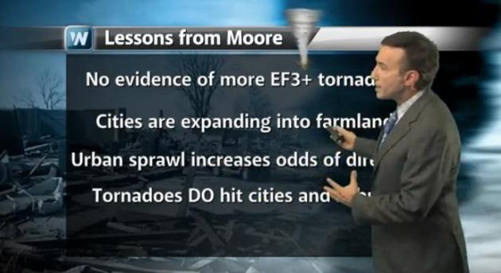

The moraine, farmlands and forests to the West of Waterloo provides cool moist air and the natural absorption of solar radiation.

Paved areas generates heat and deflects radiation up at a faster rate than natural terrain. This creates heat thermals that rise upwards.

As storm fronts enter from the west, it hits the paved heat islands, the contrasting temperatures creates a stronger thermal shift that sends hot air up, and cool air downwards increasing the intensity of wind, storms and risk of tornadoes. See Attachment 7.

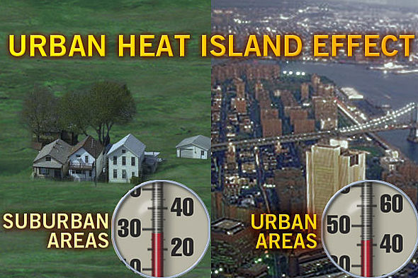

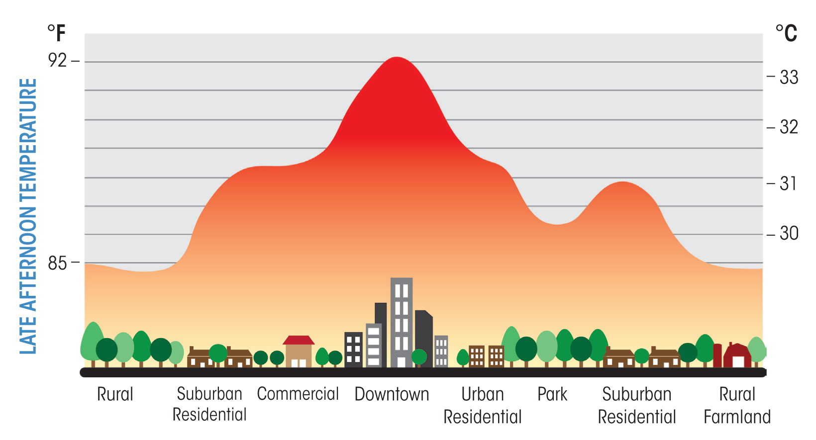

Are there ways we can reduce heat island impacts associated with ths project?

Can we impliment the use of shade trees, green roofs or other methods to reduce heat island impacts?

Can we consider placing such projects to the East rather than to the West of the city?

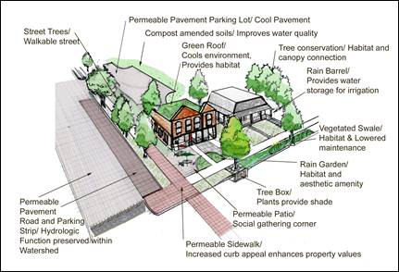

THERE ARE WAYS WE CAN INCORPORATE SOLUTIONS.

But are they willing?

Costco, however, lags behind its global industry peers on sustainability reporting, especially regarding key issues such as environmental stewardship and climate change. In a recent report authored by RiskMetrics, the company received the second lowest score of big-box retailers in terms of climate change governance practices. See Attachment 8

Are they co-operative?

Opponents of a proposed Ukiah Costco have filed a lawsuit, contending the city of Ukiah and Costco
failed to adequately consider the massive store’s environmental impacts.
“We don’t believe the environmental impact report is adequate and we don’t believe the city complied with
state planning and zoning laws,” said attorney William Kopper of Davis, who filed the lawsuit earlier this
month on behalf of Ukiah Citizens for Safety First. No court dates have been set, he said.
It’s the second attack on the Ukiah Planning Commission’s January approval of the project’s permit.
Another group has appealed that decision to the Ukiah City Council.
Costco officials hope to open the store in 2015. Before that can happen, the city must make an estimated $4

million in Highway 101 interchange improvements to accommodate extra traffic. See Attachment 9.

Are they reasonably law abiding?

Attachment 10
The Costco Wholesale Corporation agreed to a civil penalty of $60,000 after a New York State Department of Environmental Conservation (DEC) investigation revealed the company sold pesticides that are banned on Long Island, DEC Commissioner Joe Martens announced today. DEC also ordered the company to remove the pesticides from all its stores throughout the region and to issue a recall notice to its members.
"Long Island's sole source aquifer is especially vulnerable to contamination, and DEC takes its responsibility to enforce environmental laws very seriously," DEC Commissioner Martens said. "DEC followed up on a tip and found Costco violated a ban on certain pesticides. DEC is vigilant in pursuing offenders that ignore these vital safeguards for Long Island's drinking water.

Evidence

(1)This process is flawed

(2) No evidence supplied by Costco

(1)This process is flawed for the following reasons.

There has been no substantive evidence either scientific or engineering evidence produced to
show that any burden of proof has been met for safety or integrity by the applicant.

The responsibility for the burden of proof for the safety of this application and the overall

integrity of the application and all the physical parts and systems and subsystems which

shall cover at a minimum all the edicts of reliability engineering health and safety

engineering and environmental studies and assessments (the environmental assessment
shall contain current information and also long term projections taking into account long
term effects and considerations of global warming and atmospheric instability and
assessments based on unfettered scientific research) this responsibility is the responsibility
solely of the applicant Costco.

A parallel example. A vehicle cannot be built and driven on a highway until certain design
and safety requirements have been met.

Neither the government or the people have to prove the vehicle is not safe to be on the

highway. The burden of proof is on the company who is applying to drive the vehicle on the
road, they have to prove that he vehicle meets the required standards.
This principle in this example applies and must apply to this applcation.

It is not possible for any person, or group of people or society at large to prove the integrity
or non-integrity of the application and it physical manifestations as all the documentation
for this process is controlled by the applicant.

As the propject has the potential to kill people by way of polluting air, land and water ways and by way of increasing traffic risks, there must be
evidence produced to show and prove all reliability engineering requirements have been met
also that all other aspects of concern must be addressed by scientific and engineering
protocols and principals. Statements that are part of a marketing plan shall not be
admissible.

This application is being lost in all rhetoric and political interference placing profit and jobs
in front of safety and people’s lives and the health of the environment.
Therefore this application must be dismissed outright as there is no
evidence substantive or otherwise being produced by the applicant (Costco) that proves
any integrity or safety of the project in any sustainable format.

