Discover the connection between heritage and climate change
Learn how to make our communities livable and sustainable

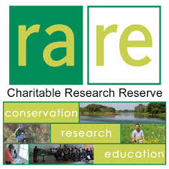 | Heritage is Green  with Kae Elgie  President, North Waterloo Region Branch  Architectural Conservancy of Ontario  Tuesday April 8, 2014  7 pm  rare ECO Centre, 768 Blair Road, Cambridge | 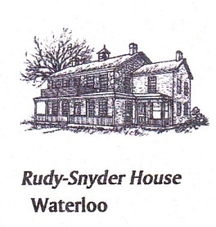  NORTH WATERLOO REGION BRANCH  ARCHITECTURAL CONSERVANCY OF ONTARIO
Presented by rare charitable research reserve
$8, or $3 with discount card.
Register online at www.raresites.org/events or call 519-650-9336

An illustrated talk for environmentalists, heritage advocates, and people who like to expand their minds

