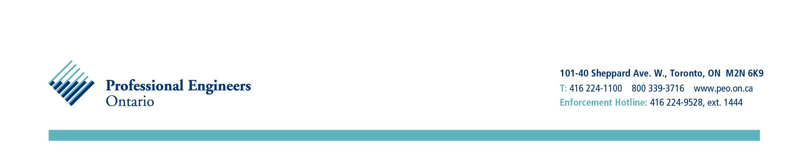
March 25, 2014 Via Email: butterflybluelu@rogers.com
Dear Ms Lanteigne:
Thank you again for your email of March 12. You are correct when you state that there are limitations regarding Professional Engineers Ontario’s (PEO’s) jurisdiction in matters like the Enbridge Line 9 debate. Under the Professional Engineers Act, PEO governs its members and regulates the professional engineering practice of its licence and certificate of authorization (C of A) holders. As the practice of no particular licence holder has been questioned and Enbridge does not hold a C of A, PEO does not have jurisdiction to take on this issue officially.
That said, it is a public policy issue relating to engineering and technical standards and likely of interest to many of our licensees as individuals. Perhaps you might consider writing an article or asking the engineers you are corresponding with to write an article for the Policy Engagement section of Engineering Dimensions, PEO’s bimonthly magazine. The Policy Engagement section, managed by PEO’s Ontario Centre for Engineering and Public Policy (OCEPP), aims to air diverse viewpoints on public policy issues of a technical nature to further debate and increase engagement of PEO licensees in public policy. Should you wish to pursue this option, you should contact Catherine Shearer-Kudel, OCEPP’s business manager, at cshearerkudel@ocepp.ca.
Might I also suggest that you contact the Ontario Society of Professional Engineers (OSPE), the Ontario engineering profession’s member advocacy and services group (like the Ontario Medical Association for doctors). OSPE has a number of working groups on various technical public policy issues, including energy, and might consider developing a position on Line 9 should it think the issue sufficiently broad in its implications.
I hope that I have been of some assistance in advising you where you might go next in raising awareness of your issue among engineers. I trust you understand why PEO cannot take on the issue itself.
Best regards,
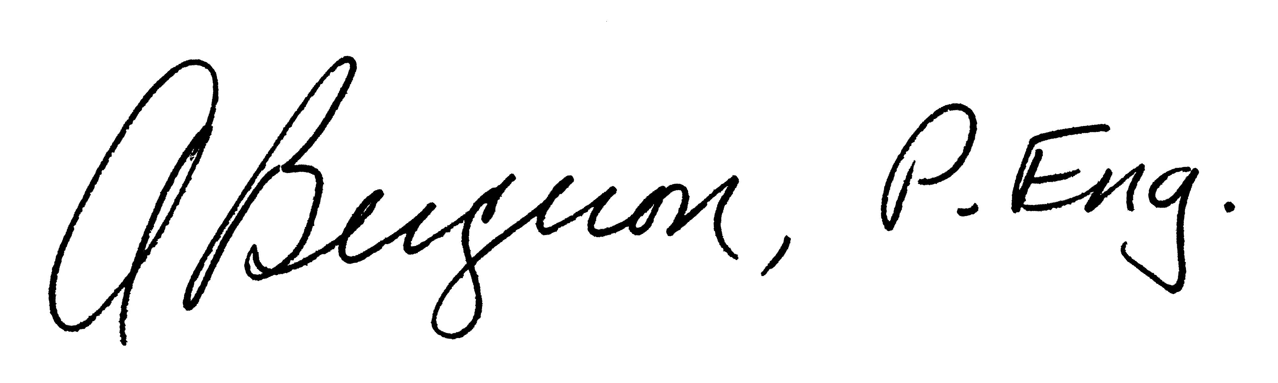
Annette Bergeron, P.Eng., MBA, FEC
President

AB/b

Cc: Paul Acchione, P.Eng., - Chair, OSPE

