Neil E. Taylor
1016 Wilson Avenue

Kitchener, Ontario

N2C 1J3

519-893-6469

November 5th, 2013

(Via e-mail)

Without Prejudice

Urgent Attention:

Wayne Cheater, P. Eng., Senior Project Manager
Regional Municipality of Waterloo, 150 Frederick Street,
Kitchener, Ontario, N2G 4J3.

Re. South Kitchener Transportation Corridor,
AKA River Road Extension,
Bleams Rd. Extension, and
River Road Extension Class EA

Dear Mr. Cheater,

This letter is to list my concerns and issues that have previously been presented to you, but remain either unacknowledged or unanswered. Please confirm the following and respond to me re.:
- The existence of documents seeking permission from provincial ministries the intent to build new roads into Provincially Significant Wetlands.
- The existence of documents granting permission from provincial ministries for the intent of the region to build new roads into Provincially Significant Wetlands.
- A complete list of Species At Risk in the subject area.
- That at the very least the following 14 Species At Risk have been recorded to be in the subject area: Red-headed Woodpecker (Sp. C), Common Nighthawk (Sp. C.), Chimney Swift (Threatened), Eastern Meadowlark (Threatened), Barn Swallow (Threatened), Milk Snake (Sp. C.), Louisiana Waterthrush (Sp. C.), Acadian Flycatcher, Butternut (Endangered), Bobolink (Threatened), Cerulean Warbler (Threatened), Jefferson Salamander (Endangered), Henslow's Sparrow (Endangered), and Loggerhead Shrike (Endangered).
- That 13 of 14 of the above species and their habitat have not been subject to an Environmental Impact Analysis (EIA). That is, only Jefferson Salamander has received special consideration.
- The costs and time period associated with the studies and permits associated the EIA pursuant to the Endangered Species Act, 2007, ONTARIO REGULATION 242/08.
- The reduction in costs by having sidewalks and trails limited to one side of the proposed 4 lane highway and bridges.
- The reduction in costs by removing the “S” curve into the Provincially Significant Wetlands and thus limiting the ingress to Hidden Valley by using the existing Hidden Valley Road.
- The increase in traffic in the area resulting from the development that Mr. Peter Benninger of Pearl Valley was proposing at the committee meeting on December 3, 2013.

Respectfully submitted,
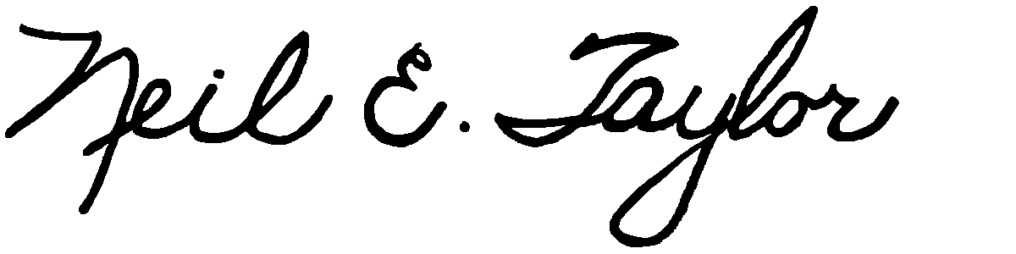
Neil E. Taylor

C.c.
Mrs. Jean Haalboom, Councillor, Region of Waterloo and Project Team Member
Mr. John Gazzola, Councillor, City of Kitchener and Project Team Member
Mr. Barry Vrbanovic, City of Kitchener and Project Team Member
Ms. Claudette Millar, Councillor, Region of Waterloo
Ms. Jane Mitchell, Councillor, Region of Waterloo
Mr. Les Armstrong, Councillor, Region of Waterloo
Mr. Jim Wideman, Councillor, Region of Waterloo
Mr. Carl Zehr, Councillor, Region of Waterloo
Mr. Geoff Lorentz, Councillor, Region of Waterloo
Mr. Doug Craig, Councillor, Region of Waterloo
Mr. Sean Strickland, Councillor, Region of Waterloo
Mr. Rob Deutschmann, Councillor, Region of Waterloo
Mr. Ross Kelterborn, Councillor, Region of Waterloo
Mr. Tom Galloway, Councillor, Region of Waterloo
Ms. Brenda Halloran, Councillor, Region of Waterloo
Mr. Ken Seiling, Chair, Region of Waterloo
Ms. Jane Brewer, Councillor, Region of Waterloo
Mr. Todd Cowan, Councillor, Region of Waterloo
Hon. Hon Kathleen O. Wynne, Premier of Ontario,

Hon Michael Gravelle, MPP, Minister of Natural Resources

Hon James J. Bradley , MPP, Minister of the Environment
Mr. Michael Harris, MPP

Hon. John Milloy, MPP

Mr. Ken Seiling, Regional Chair

Ms. Virginia West, Deputy Minister
Mr. Gord Miller, Environmental Commissioner of Ontario
Mr. André Marin: The Ombudsman
Dr. Ann Cavoukian, Information and Privacy Commissioner of Ontario
Mr. Howard Hampton, MPP, Critic, Natural Resources
Mr. Jerry J. Ouellette, MPP, Critic, Natural Resources

Other interested and concerned citizens.

