Neil E. Taylor
1016 Wilson Avenue

Kitchener, Ontario

N2C 1J3

519-893-6469

November 22nd, 2013

(Via e-mail)

Without Prejudice

Urgent Attention:

Wayne Cheater, P. Eng., Senior Project Manager
Regional Municipality of Waterloo, 150 Frederick Street,
Kitchener, Ontario, N2G 4J3.

Re. South Kitchener Transportation Corridor, and
Bleams Rd. Extension

Dear Mr. Cheater,

This morning I received a Notice of Public Input Meeting for Dec. 3, 2013.

This is so very offensive given that the public was required to respond in 18 days to the October 1st PIC. Now 35 days have elapsed since that date and you have failed to respond to me and others to substantive concerns raised upon the invitation pursuant to Section 13.0 of the Public Consultation Centre Information Package.

I must note that you were not even in your office to receive my submissions on October 18th.

You sir, are making s farce of the words “public consultation” and “public input”.

I request complete answers to my urgent concerns and queries raised in my several communications to you commencing October 18th, 2013, by return email today.

Respectfully submitted,

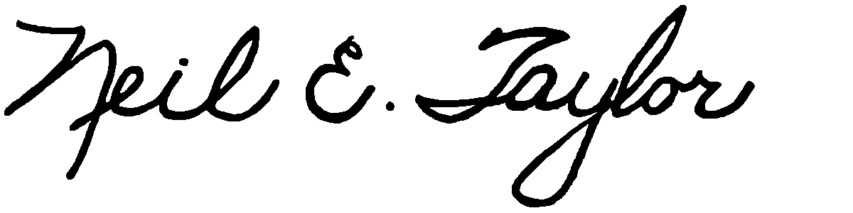

Neil E. Taylor

C.c.
Mrs. Jean Haalboom, Councillor, Region of Waterloo and Project Team Member
Mr. John Gazzola, Councillor, City of Kitchener and Project Team Member
Mr. Barry Vrbanovic, City of Kitchener and Project Team Member
Ms. Claudette Millar, Councillor, Region of Waterloo
Ms. Jane Mitchell, Councillor, Region of Waterloo
Mr. Les Armstrong, Councillor, Region of Waterloo
Mr. Jim Wideman, Councillor, Region of Waterloo
Mr. Carl Zehr, Councillor, Region of Waterloo
Mr. Geoff Lorentz, Councillor, Region of Waterloo
Mr. Doug Craig, Councillor, Region of Waterloo
Mr. Sean Strickland, Councillor, Region of Waterloo
Mr. Rob Deutschmann, Councillor, Region of Waterloo
Mr. Ross Kelterborn, Councillor, Region of Waterloo
Mr. Tom Galloway, Councillor, Region of Waterloo
Ms. Brenda Halloran, Councillor, Region of Waterloo
Mr. Ken Seiling, Chair, Region of Waterloo
Ms. Jane Brewer, Councillor, Region of Waterloo
Mr. Todd Cowan, Councillor, Region of Waterloo
Hon. Hon Kathleen O. Wynne, Premier of Ontario,

Hon Michael Gravelle, MPP, Minister of Natural Resources

Hon James J. Bradley , MPP, Minister of the Environment
Mr. Michael Harris, MPP

Hon. John Milloy, MPP

Ms. Virginia West, Deputy Minister
Mr. Gord Miller, Environmental Commissioner of Ontario
Mr. André Marin: The Ombudsman
Dr. Ann Cavoukian, Information and Privacy Commissioner of Ontario
Mr. Howard Hampton, MPP, Critic, Natural Resources
Mr. Jerry J. Ouellette, MPP, Critic, Natural Resources

Other interested and concerned citizens.

