Neil E. Taylor
1016 Wilson Avenue

Kitchener, Ontario

N2C 1J3

519-893-6469

November 21st, 2013

(Via e-mail)

Without Prejudice

Urgent Attention:

Wayne Cheater, P. Eng., Senior Project Manager
Regional Municipality of Waterloo, 150 Frederick Street,
Kitchener, Ontario, N2G 4J3.

Re. South Kitchener Transportation Corridor, and
Bleams Rd. Extension

Dear Mr. Cheater,

At the Public Consultation Centre , October 1, 2013, I became aware that various threatened species have been identified in the study area associated with the above cited project. Please provide me with a complete list of the Species At Risk identified in the area and their status. It would also be prudent to include all of the regulations pertinent to each of these species pursuant to the Endangered Species Act, 2007, ONTARIO REGULATION 242/08.

Respectfully requested,

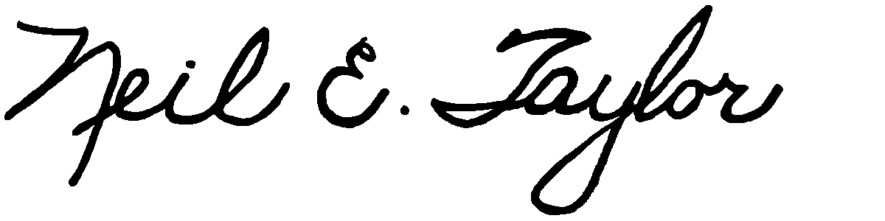

Neil E. Taylor

C.c.
Mrs. Jean Haalboom, Councillor, Region of Waterloo and Project Team Member
Mr. John Gazzola, Councillor, City of Kitchener and Project Team Member
Mr. Barry Vrbanovic, City of Kitchener and Project Team Member
Ms. Claudette Millar, Councillor, Region of Waterloo
Ms. Jane Mitchell, Councillor, Region of Waterloo
Mr. Les Armstrong, Councillor, Region of Waterloo
Mr. Jim Wideman, Councillor, Region of Waterloo
Mr. Carl Zehr, Councillor, Region of Waterloo
Mr. Geoff Lorentz, Councillor, Region of Waterloo
Mr. Doug Craig, Councillor, Region of Waterloo
Mr. Sean Strickland, Councillor, Region of Waterloo
Mr. Rob Deutschmann, Councillor, Region of Waterloo
Mr. Ross Kelterborn, Councillor, Region of Waterloo
Mr. Tom Galloway, Councillor, Region of Waterloo
Ms. Brenda Halloran, Councillor, Region of Waterloo
Mr. Ken Seiling, Chair, Region of Waterloo
Ms. Jane Brewer, Councillor, Region of Waterloo
Mr. Todd Cowan, Councillor, Region of Waterloo
Hon. Hon Kathleen O. Wynne, Premier of Ontario,

Hon Michael Gravelle, MPP, Minister of Natural Resources

Hon James J. Bradley , MPP, Minister of the Environment
Mr. Michael Harris, MPP

Hon. John Milloy, MPP

Mr. Ken Seiling, Regional Chair

Ms. Virginia West, Deputy Minister
Mr. Gord Miller, Environmental Commissioner of Ontario
Mr. André Marin: The Ombudsman
Dr. Ann Cavoukian, Information and Privacy Commissioner of Ontario
Mr. Howard Hampton, MPP, Critic, Natural Resources
Mr. Jerry J. Ouellette, MPP, Critic, Natural Resources

Other interested and concerned citizens.

