Neil E. Taylor
1016 Wilson Avenue

Kitchener, Ontario

N2C 1J3

519-893-6469

September 19th, 2013

(Via e-mail)

Without Prejudice

Urgent Attention:

Wayne Cheater, P. Eng., Senior Project Manager
Regional Municipality of Waterloo, 150 Frederick Street,
Kitchener, Ontario, N2G 4J3.

Re. South Kitchener Transportation Corridor,
Bleams Rd. Extension, and
River Road Extension Class EA

Dear Mr. Cheater,

Through the kindness of friends, I have learned that there is to be a Public Information Meeting re. the above in the near future.

On August 15th, 2012, you wrote me stating, “This message is copied to Don Drackley and Marianne Radue at IBI Group, who will compile all of the comments and who will also add your contact information to our mailing list for all Public Notices concerning this Study.” I have received no such notice.

As a long standing citizen who has considerable credibility re. this matter, I wish to have all information that will be divulged at that meeting made available to me immediately via fastest method to my summer address at: 1031 Hewitt Street, Gravenhurst, Ontario.

I also ask you to review seriously my letter of March 5th, 2012.

Please confirm receipt of this request a.s.a.p. My modem at the cottage has given me problems today. I may be reached at 705-687-1234.

Respectfully submitted,

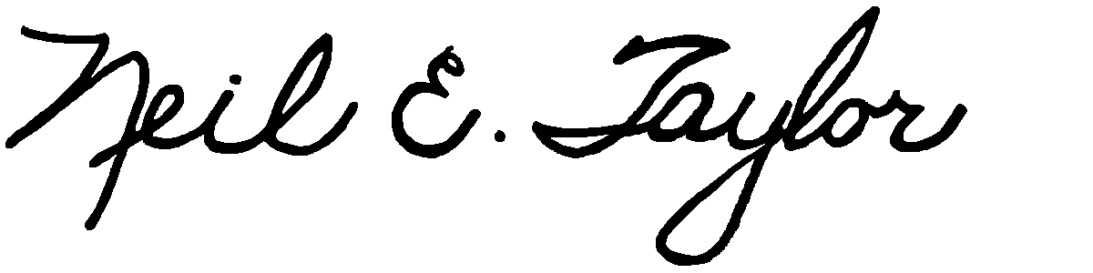

Neil E. Taylor

C.c.
Mrs. Jean Haalboom, Councillor, Region of Waterloo and Project Team Member
Mr. John Gazzola, Councillor, City of Kitchener and Project Team Member
Mr. Barry Vrbanovic, City of Kitchener and Project Team Member
Ms. Claudette Millar, Councillor, Region of Waterloo
Ms. Jane Mitchell, Councillor, Region of Waterloo
Mr. Les Armstrong, Councillor, Region of Waterloo
Mr. Jim Wideman, Councillor, Region of Waterloo
Mr. Carl Zehr, Councillor, Region of Waterloo
Mr. Geoff Lorentz, Councillor, Region of Waterloo
Mr. Doug Craig, Councillor, Region of Waterloo
Mr. Sean Strickland, Councillor, Region of Waterloo
Mr. Rob Deutschmann, Councillor, Region of Waterloo
Mr. Ross Kelterborn, Councillor, Region of Waterloo
Mr. Tom Galloway, Councillor, Region of Waterloo
Ms. Brenda Halloran, Councillor, Region of Waterloo
Mr. Ken Seiling, Chair, Region of Waterloo
Ms. Jane Brewer, Councillor, Region of Waterloo
Mr. Todd Cowan, Councillor, Region of Waterloo
Hon. Hon Kathleen O. Wynne, Premier of Ontario,

Hon Michael Gravelle, MPP, Minister of Natural Resources

Hon James J. Bradley , MPP, Minister of the Environment
Mr. Michael Harris, MPP

Hon. John Milloy, MPP

Mr. Ken Seiling, Regional Chair

Ms. Virginia West, Deputy Minister
Mr. Gord Miller, Environmental Commissioner of Ontario
Mr. André Marin: The Ombudsman
Dr. Ann Cavoukian, Information and Privacy Commissioner of Ontario
Mr. Howard Hampton, MPP, Critic, Natural Resources
Mr. Jerry J. Ouellette, MPP, Critic, Natural Resources
Ms. Elizabeth Witmer, MPP

Other interested and concerned citizens.

