**Concerns Regarding Potential Risks from Agrochemical Residues**

**and Aggregate Washing at Watts Pond Road Pit**

by N. Greenacre MSc (June 7th 2013)

**Pesticide Residues:** (The term "Pesticides" includes insecticides, fungicides and herbicides).

The land of the proposed pit has been in continuous agricultural use since before the licence was granted in 1974. The principal crops grown have been corn, soya beans, grains and hay. Standard farming practices have included the use of pesticides as recommended by OMAFRA. Whilst the control, use and application rates of herbicides have improved in recent years, some pesticides have considerable environmental persistence with residues remaining in the soil and sub-soils[1]. The residues can be the original chemical or its breakdown products, "metabolites", resulting from chemical or microbiological action. The metabolites can be non-toxic, as toxic, or more toxic than the parent chemical depending on the form of breakdown. Water supplies are monitored for the presence of pesticides with specified maximum acceptable concentrations (MACs). MACs were derived from testing the amount needed per kg of body weight to kill laboratory animals. In recent years endocrinology *(study of hormones)* methods have been used to measure at what concentration substances start to affect a living organism rather than the amount needed to kill. As a result some pesticides have been identified as probable endocrine disrupting substances (EDS) that can affect the hormone systems of people and wildlife at very low concentrations [2][3]. In consequence existing MACs are being revised or have been changed in several countries.[1][2]

To give an example, the most common herbicide used for corn has been atrazine, (a triazine herbicide), which is still in use in Ontario, often in combination with other herbicides. It is identified by Environment Canada as inherently toxic to humans and non-humans[4] and in the top 100 most persistent organic pollutants (POPs) [5].Atrazine is rankedhighest of 83 pesticides in the Agriculture Canada priority scheme for potential groundwater pollution[6]. With clear evidence ofendocrine disrupting activity it has been rated as a Category 1 substance of high exposure concern by the European Union.[7] Recent studies (2009) have documented persistence in soil and sub-soil of 22 years.[8][9]

Its use has been banned in Germany since 1994[8] and in the European Union since 2004[2][21].

The interim drinking water standard (MAC) in Canada and Ontario, currently under review, is 5.0ppb (parts per billion)[6]; in the European Union it is 0.1ppb for a single pesticide and 0.5ppb for total pesticides[10]. For aquatic life the Canadian guideline is 2.0ppb[11].

**...Chlorinated pesticides and triazine herbicides are the most resistant to biodegradation and may persist for years following application. ...**

**...Quite long half-lives can occur once pesticides leave the soil and reach less biologically active zones of aquifers (Lavu et al., 1996; Chilton et al., 2000). It should be noted that although many pesticide half-lives have been determined for soils (Table 4.3); use of such half-lives to predict aquifer behaviour may cause misleadingly optimistic estimates...**

***From "Protecting Groundwater for Health" : World Health Organization 2006***[1]

**Aggregate Washing: [12]**

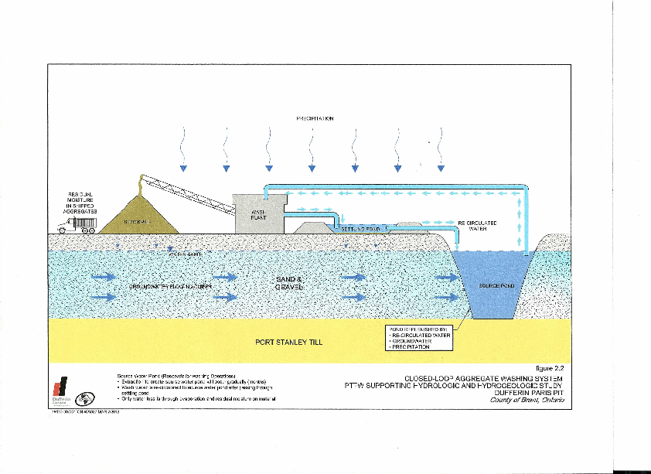

60% of the excavated aggregate will be washed in a "closed loop" system. A source pond will be excavated in the aquifer to provide water for washing.

The wash-water will flow through a settling pond to settle out the removed dirt before being returned to the source pond where it will mix with the groundwater flowing through the pond.

Washing rate: 598,000tonnes/annum,

700 tonnes/hour x12 hours, 8424tonne/day for 71 days

**The Concerns** ; The excavation of the source pond creates a direct access into the aquifer for any pollutants washed from the aggregate. Whilst aggregate extraction does not introduce pesticides, the washing of extracted aggregate in a closed loop system may release pesticide residues or other contaminants already in the aggregate which will then be carried in solution through the settling pond to the open aquifer in the excavated source pond. Compared to natural slow and diffuse leaching which may not be giving rise to elevated levels that exceed MACs, the washing of about 600,000 tonnes/year in a planned period of 71 days/year[12] clearly has the potential to both accelerate and concentrate residue levels at a single entry point in the aquifer. It has been stated that the removal of the top soil layer before excavation will prevent this risk. The World Health Organization warns against this assumption[1]; the warning is supported by recent scientific literature[8],[14]. The open source pond also exposes the aquifer to direct surface run-off and airborne pollution with no filtering protection[15][16]. Although just outside of the delineated wellhead protection areas, both the settling and source ponds are within an area designated as being of high intrinsic vulnerability[17]. The groundwater from the source pond will flow in time to the Grand River. Pesticide residues bond to soil particles[22 ][23] and those not released by the washing process are likely to accumulate in the sediment of the settling pond.[23] Whether likely differences in temperature between the groundwater and shallow exposed surface water of the settling pond and any acid rain effect on the pond pH, will cause release of any portion of the bonded residues is a further question. Any leachates from the settling pond will enter the aquifer upstream of the source pond.

The proposed use of sediment cleaned from the settling pond as top cover for the 1 metre of overburden to be left above the water table as part of the post-extraction rehabilitation would be unacceptable if it is contaminated. The average pH of rain in Ontario is 4.2-4.5; ten times more acidic than normal rain.[26] Again a question of whether this may release bonded residues from spread or stock-piled sediment in an highly vulnerable wellhead protection area needs answering.

**Well Head Protection Areas A, B & C and**

**Source Pond Location from Site Plan**[18]**.**

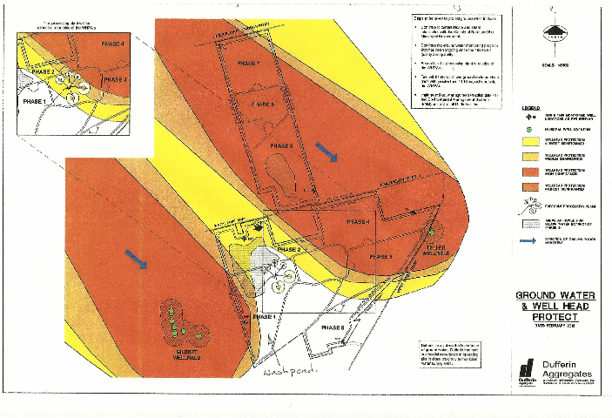The application of pesticidesis listed as a *prescribed* *significant threat*[19] that will be subject to control under the Source Protection Plan. However existing pesticide residues are not listed as a *significant threat*.The Ministry of the Environment has advised that the Clean Water Act addresses contamination from past activities rather than an activity that happens to be taking place on the site.[25] The potential role for the aggregate washing process to release residues from across the whole site directly into the aquifer through the source pond, appears not to be acknowledged or addressed.

Apparently the only study to date to determine the level of pesticide residues in the area of the pit was carried out in December 2012 to be part of the Permit To Take Water application, the permit required for the excavation of the source pond. To represent the whole 600acre site, only 3 sample points were used. For the soil samples, a detection limit of 0.05mg/kg (50ppb) was used for each of Atrazine and its metabolite, deethylatrazine. Residues were not detected at this high level [12]. Subsequent to CCOB querying this level, the 3 samples were re-examined at 0.02mg/kg and still returned a no detection result.[24] Given the farming history of the site, it is reasonable to assume residues will be present and would still be significant below this level. (Environment Canada pesticide residue monitoring at Turnbull Lake in the Paris wells catchment area detected 30 pesticide chemicals including atrazine.)[20]  Given the concentrating effect of the washing process combined with the toxicity of endocrine disrupters at very low concentrations, including a combination of chemicals sharing similar effects, the potential for contamination of the aquifer still remains a question.

These notes have focussed only on atrazine as one example of a pesticide. Other agrochemicals need to be considered. Amongst these nitrates are an existing problem that needs to be addressed equally.

*...****When pesticides do get into groundwater, cleanup of the contamination is usually prohibitively costly and often not practically feasible. The contamination can last many years and spread over a large area before dilution and degradation eventually reduce the pesticide concentrations.....***

***Protecting Groundwater for Health : World Health Organization 2006***

**Potential Risks from Agrochemical Residues and Aggregate Washing at Watts Pond Road Pit. (7th June 2013) Page 1**

**References :**

[1] WHO World Health Organization 2006 Protecting Groundwater for Health ; Managing the Quality of Drinking Water Sources, Ed. Schmoll O et al. , Chemicals Health relevance, transport and attenuation, 4.6 Pesticides pp125-128 Website access 8/14/12

[2] EU European Union, Directorate General Environment 2003 Endocrine Disruptors Website EU Strategy for Endocrine Disruptors. Website access 8/14/12

[3] EC (Environment Canada): Servos, M., Delorme, P., Fox,G., Sutcliffe, R.,and Wade, M. Threats to Sources of Drinking Water and Aquatic Ecosystem Health in Canada 5. Endocrine Disturbing Substances. Website access 8/14/12

[4] EC (Environment Canada) CEPA Environmental Registry, Substances Lists, Pesticides Draft Entry Characterization of trifluralin; atrazine; chlorothalonil; chlorophacinone; methoxychlor; and pentachlorophenol. P.2 Website access 8/12/12

[5} EC (Environment Canada): Servos, Muir D, Alaee M, Dube Danie, Lockhart L, Bidleman T.. Threats to Sources of Drinking Water and Aquatic Ecosystem Health in Canada . 4. Persistent Organic Pollutants and Mercury. Table 2. Website access 20/05/13.

[6] Health Canada: Environmental and Workplace Health Guidelines for Canadian Drinking Water Quality - Technical Documents: Chemical/Physical Parameters: Atrazine April 1993 (Edited September 1993) Website access 8/14/12

[7] EU European Union, Directorate General Environment 2003 Endocrine Disruptors Website ;EU Strategy for Endocrine Disruptors : Annex 13 List of 146 substances with endocrine disrupting classifications prepared in the Expert meeting : Annex 15 List of 66 Category 1 Substances with categorization high, medium or low exposure concern. Website access 8/14/12

[8] Jablonowski ND, Schaeffer A, Borauel P. 2010 Still present after all these years: persistence plus potential toxicity raise questions about the use of atrazine. Environ Sci Pollut Res (2011) 18:328-331. Website access 21/11/12

[9] Jablonowski ND, Koppchen S et al 2009 Persistence of 14C labeled atrazine and its residues in a field lysimeter soil after 22 years. *Environmental Pollution 2009 Jul: 157(7):2126-31* Website access 8/12/12

[10] EU European Union, Directorate General Health & Consumers, 2008, EU Pesticides Database. Atrazine Website access 8/14/12

[11 EC Environment Canada: Canadian Water Quality Guidelines for the Protection of Aquatic Life.1999 Table 1 Freshwater (CCME 1989).

[12] Conestoga-­Rovers & Associates March 2013 OWRA S34 Permit To Take Water Application and supporting hydrologic and hydrogeologic study; Dufferin Paris Pit. Prepared for Dufferin Aggregates, A Division of Holcim ( Canada) Inc.

**Potential Risks from Agrochemical Residues and Aggregate Washing at Watts Pond Road Pit.**

**(7th June 2013) Page 2**

[13] Lake Erie Region Source Protection Committee 2012 Grand River Source Protection Plan- Draft Website access 8/16/12

[14] Jablonowski ND, Modler J, Scaeffer A, Burauel P. 2012 Bioaccessability of environmentally aged 14C-atrazine residues in an agriculturally used soil and its particle-size aggregates. Forschungszentrum Julich GmbH. Website access 18/10/12

[15] EC Environment Canada, Water Science and Technology Directorate March 2011 Presence and Levels of Priority Pesticides in Selected Canadian Aquatic Ecosystems. Download 26/11/12

[16] Mueller R*, Berg Michael, Ulrich M M, Schwarzenbach 1997 Atrazine and its Primary Metabolites in Swiss Lakes: Input Characterisitics and Long-Term Behaviour in the Water Column. *Swiss Federal Institute for Environmental Science and Technology (EAWAG). Environ.Sci. Technol. 1997, 31, 2104-2113. Website access 1/12/12.

[17] Lake Erie Region Source Protection Committee 2012 Grand River Source Protection Area:

Proposed Amended Assessment Report April 2012 Map 14.5 Website access 04/05/2012.

[18] Dufferin Aggregates Site Plan.

[19] Clean Water Act 2006 : Table 1 Drinking Water Threats – Chemicals – The application of pesticides to land.

[20] EC Environment Canada, Water Science and Technology Directorate March 2013

Ref. [15] with personal communication email re Turnbull Lake detail.

[21] European Commission, Health & Consumer Protection Directorate-General ,

Decision 2004/248/EC OJ L78 16.3.2004 p.53

[22] Jablonowski N, Koeppchen S, Burauel P. 2008, Spatial distribution and characterization of long-term aged 14C-labeled atrazine residues in soil. J Agric Food Chem 56(20):9548-54 website access 21/11/12

[23] Stantec 2013 Review of Hyrogeology and Water Resources Dufferin Aggregates Paris Pit County of Brant : 6.0 Summary of Issues and Concerns. 8.

[24] Conestoga-­Rovers & Associates May 2013 Request for Information on the Atrazine Analytical Method and Detection Limits OWRA 534 Paris Pit : Letter Ref No 078410: G.I Lagos to B. Bardswick Director Ministry of the Environment May 22 2013

[25] Ministry of the Environment November 2012 Letter : L. Mark Director, to N. Greenacre ENV1283MC-2012-2939 November 6th 2012

[26] Ministry of the Environment 2009 Water Quality in Ontario 2008 Report, 4.0 Acid Rain p.25