Saturday April 16, 2006

I witnessed the following spills as I drove by the Laurentian Village Subdivision off Bleams to the West of Fisher-Hallman in the city of Kitchener Ontario at approximately 4pm. I called the Region of Waterloo’s Environmental Services and later returned to the scene with a camera to take photos at 8pm.

I witnessed both oil spills and diesel spills. Later on an article was written by Philip Jalsevac at the KW Record regarding this issue. In the article it states that Thomas Schmidt, the Region’s Commissioner of Transportation and Environmental Services said the Ministry of Environment was advised of the spill but said “They wouldn’t respond to something like this because it was relatively insignificant.” He went on to say, “Clearly, we want people to manage their site appropriately and to make sure they don’t spill these types of materials and to make sure they clean them up.” He also added, “We’re not out there all the time. If people see spills it’s absolutely appropriate to call in and get it dealt with.”

These are the photos I took that day. Please disregard the time as recorded by my camera. I didn’t set the time properly on it. The photos were all taken around 8pm.

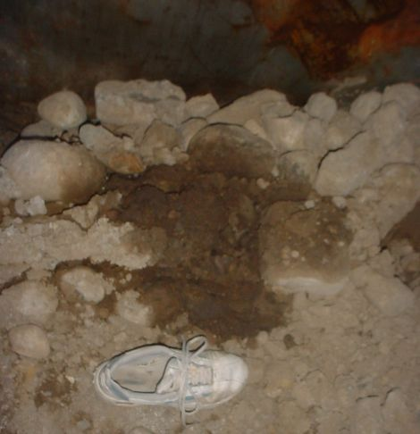
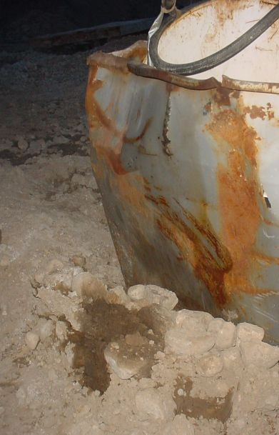

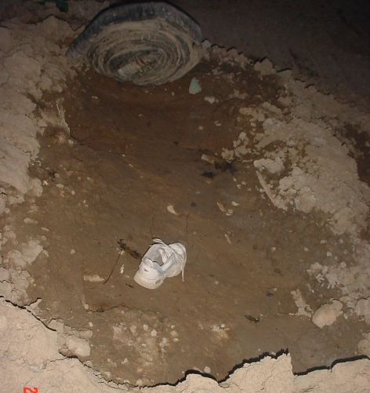

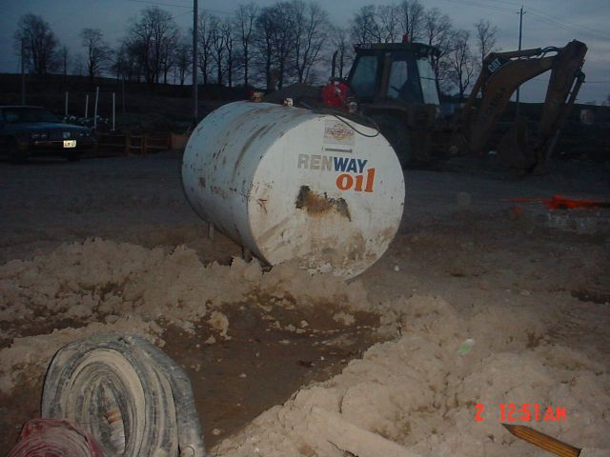

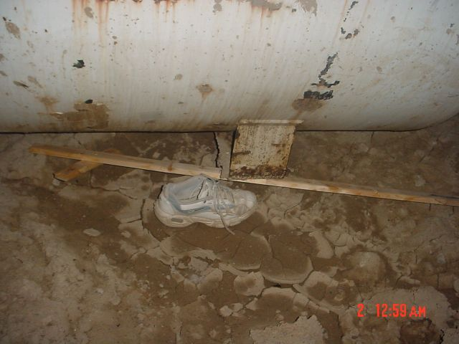
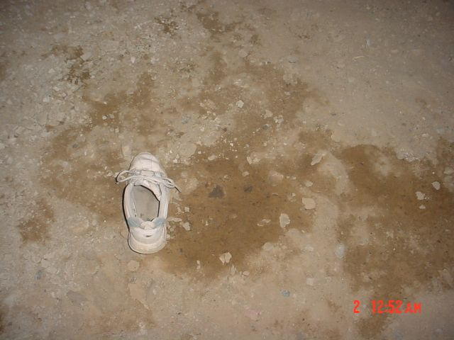

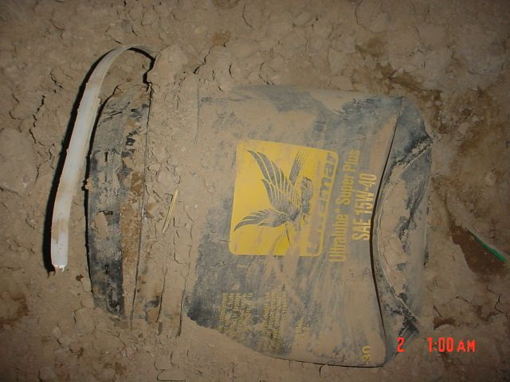
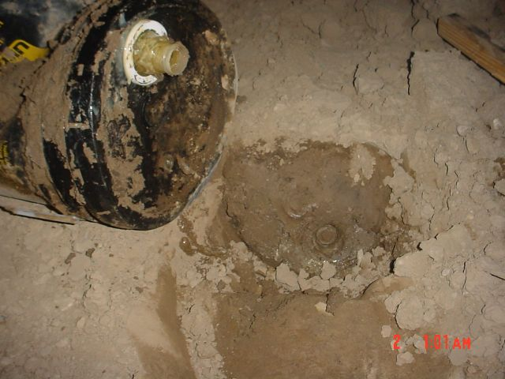

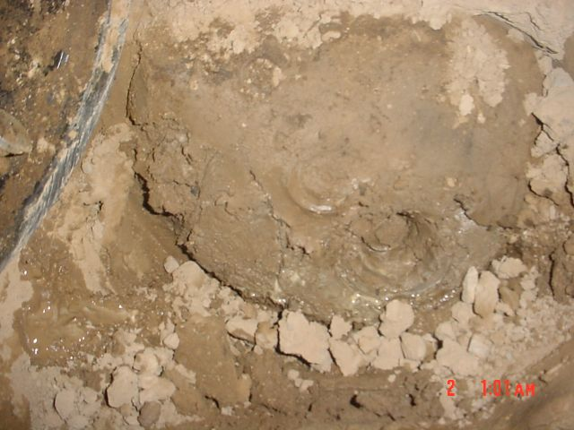
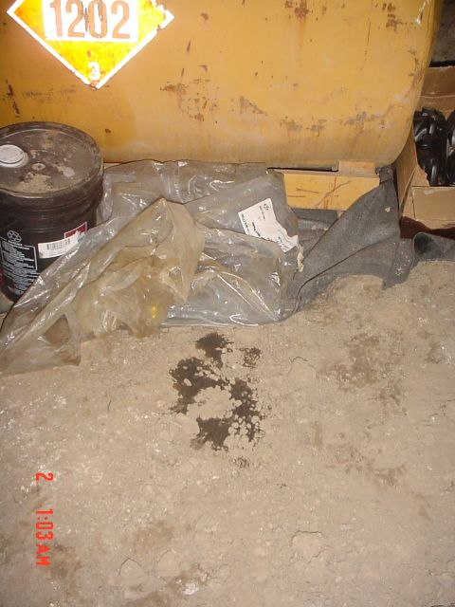

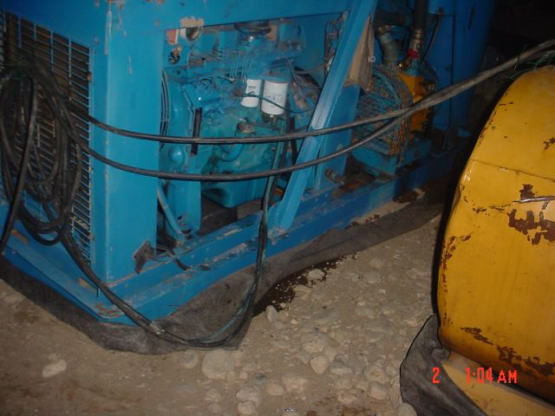

Housing inspector hurt on site June 24, 2005

There were unconfirmed reports of a Safety Inspector being beaten up at 146 Purple Sage in Laurentian Forest Subdivision. The incident involved an assault by a frame builder who was arrested by the Waterloo Regional Police. I have enquired with police services about this but they could not disclosed details.

August 22, Email from Susan

A person who identified themselves as Susan, (no last name given) using the email smschlot@rogers.com sent me an email on Wed, 13 Jul 2005 22:45:49. She wrote:

Hi Louisette Lanteigne. I hope I have found the correct email address, as your web site Environmental and Labor Law Infringements in Waterloo Region [http://ca.geocities.com/infringements@ROGERS.COM/ ] does not provide a contact email address. So if you are not the lady who maintains this geocities website, please disregard this email.

I am an environmental scientist, and moved into the Laurel Creek Subdivison November 2003. I have seen it all and am glad to see someone who has the time, energy and persistence to fight the bureaucrats. My fight against the builder (Decora Homes) has been exhausting, and mostly a losing battle.

Decora stored a leaky dozer in the foundation of my building prior to erecting the frame. I was unsuccessful at getting the spill cleaned up… as Decora poured cement over it to cover it up (I have pictures). So my house sits upon plume of gas and oil. I am sure the vapours escape into the air I breathe everyday.

I also have pictures of contractors drinking beer as they build the interior of my house.

But what caught my attention were your presentations to the Waterloo council, and more specifically, your argument re: the contamination of groundwater via roof run-off. I would like to make you aware that I presented my case against the Builder regarding my downspouts (leaders) to Tarion, the Ontario New Home Warranty Program (http://www.tarion.com/home), and lost. If you haven’t noticed, all the homes in the Laurel Creek Village subdivision (built by Decora Homes, Eastforest Homes, Deerfield Homes – all Umbrella Group of Activa?) run their downspouts (leaders) from the second storey roof onto the first storey roof. I was concerned that the concentrated flow of water draining directly onto the lower roof surface (rather than run directly to the ground or to another gutter below) would result in unnecessary early wear of the lower roof shingles, and void the warranty. My second argument to have the Builder re-direct the water away from the lower roof surface to avoid premature damage was the increased potential for pollution of our groundwater resources. After all, water is concentrated onto the shingles, causing them to wear quicker, and increasing the potential for contaminants to get into the water. Neither the Builder nor Home Warranty was concerned about this. Both argued that this is the standard design of the Builder, and it does not break any Building Code Standard.

Considering the new Source Water Protection Act that the Province is about to enforce, it is a shame that our Building Code Standards are not written with the Environment in mind, and in some cases, have a clear disregard for the environment. Case at hand.

I studied at the University of Waterloo back in the early 1990s and moved to the States for 10 years before moving back to the area. I was afraid to tell my colleagues I had bought a house on the Waterloo Moraine, especially since I had studied the areas water resources as a student at the University. Moreover, I was absolutely astonished when I read the Region’s vision for the Westside development as replicating the “Neo-Classical” subdivisions of the early 1950s, with the motto “More people, less cars”. I cannot image how a group of apparently educated people could possibly think that by squeezing as many houses into an area as possible and reducing the driveways to accommodate a single car would make people get rid of their second vehicle, especially when public transportation is poorly serviced in this area. The West Side is suburbia, and I live in a car-dependent neighbourhood. People park their cars on the grass.

One last point. Builders lay down cheap sod on an inch or less laid down top soil. The sod Builders use is cheap and stressed. And I do not believe the type of sod they laid is suitable for the area we live in. I lost my new sod tochince bugs, European Crane fly, and white grub with 2 months of being laid. No warranty. No Building Code. It cost me a fortune to have it reseeded and resodded in spots. I could not afford to lay more top soil. Final Result: I used pesticides. Because I cannot afford to lose my lawn again. Nemotoads take at least three years to establish, and service costs more. I had enough expenses, and the environment lost. Me. An environmental scientist. Using pesticides. Hmmm. I’m sure I’m not the only one.

Anyway. Just thought I would share these stories with you. Perhaps the downspout design issue will be a useful example in your future fights.

Fortunately, the last house on my street has been framed. I can hardly wait to see the builder leave, and take his junk and trash (which blows all over the street) with him. FYI. I never saw any harnesses being used for any siding or roof work. I did make the comment that OSHA (US Health and Safety Regulators) would have a hay day here with infringements! However, in the case of OSHA, the Builder would have to pay a hefty fine. I do not hear of large fines here. Perhaps that is why the Builders neglect to keep a close watch over their workers/contractors. After all, they are not being deterred by the threat of hefty fines.

Keep up the good work.

A supporting neighbour.
Susanne

October 4, 2005

On October 4, 2005 I was driving along Activa Avenue when I spotted an unusual looking diesel tank behind a storage trailer for Prosperity Homes. I took my camera with me and photographed the following photos of a diesel tank that was mounted on a pile of scrap wood. There was only a rubber hose on it to dispense fuel. No proper nozzel was attached. The air smelled heavily of diesel fuel and the ground was heavily saturated with fuel.

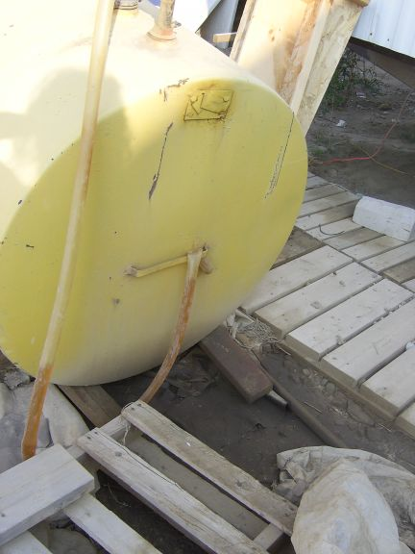
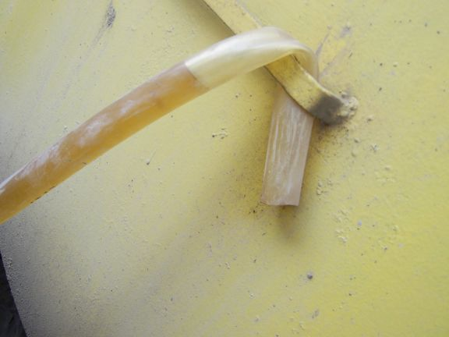
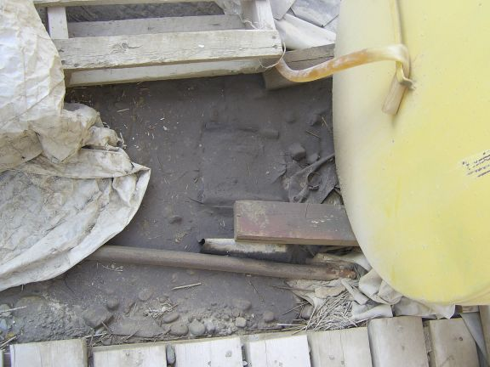
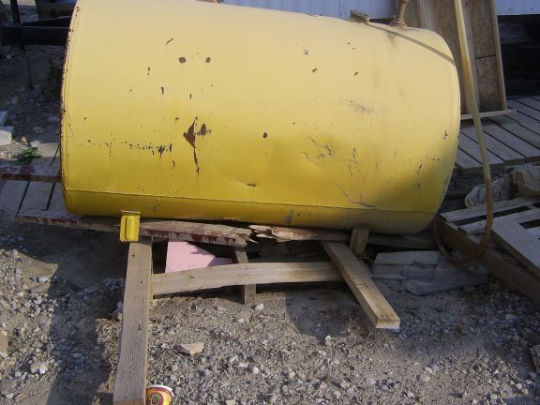

Beyond the oil and fuel spills I witnessed many unharnessed roofers working without hard hats. This one fella sat down and literally slid down the wood like a slide. Note: the yellow cable shown is the extension cord of the nail gun he used. This was at 23 Big Springs Court in Kitchener. Same day, same subdivision. Non compliance to labour laws was evident.

