Neil E. Taylor
1016 Wilson Avenue

Kitchener, Ontario

N2C 1J3

519-893-6469

August 14, 2012

(Via e-mail)

Without Prejudice

Urgent Attention:

Attention: Councillor Jean Haalboom and Project Team Member
Region of Waterloo

Re. South Kitchener Transportation Corridor,
Bleams Rd. Extension, and
River Road Extension Class EA

Dear Jean,

In response to your most recent email, this letter is intended to simplify the issue. In my June 18th letter to Karine Bériault, I stated the following:
“…In my letter, I posed some serious questions on one issue alone. This was that the study team, of which you were a part, observed a single Jefferson Salamander complex individual captured during the survey work of 2008 in an unexpected area, that is, within inches of the preferred alignment of the proposed 4 lane highway. …”
The response from her was as follows:
“You will note that the regulation is very clear as to the areas that are considered regulated habitat – in a nutshell, for the area in Hidden Valley, it’s the known breeding pond and 300 meters around it as long as the habitat is suitable for foraging, dispersal, migration or hibernation. If and when salamanders are found outside of regulated habitat, in an upland area and not in a breeding pond, their presence can be addressed via Section 9 of the ESA.”
I have scanned maps that indicate the location of salamanders found in different studies. Please take special note of the location of an arrow “2008” top right on the 1st map. This is where a Jefferson salamander was found. When I created this map for the presentation at Council, the tools I used were imprecise. I believe that the salamander was found within the 300m area. In fact, one may better see in the attached pdf file of the same map that 300m is delineated by the outside portion of the red area, precisely where the salamander was found. On close examination, one may see that the 300m intrudes into the preferred alignment.

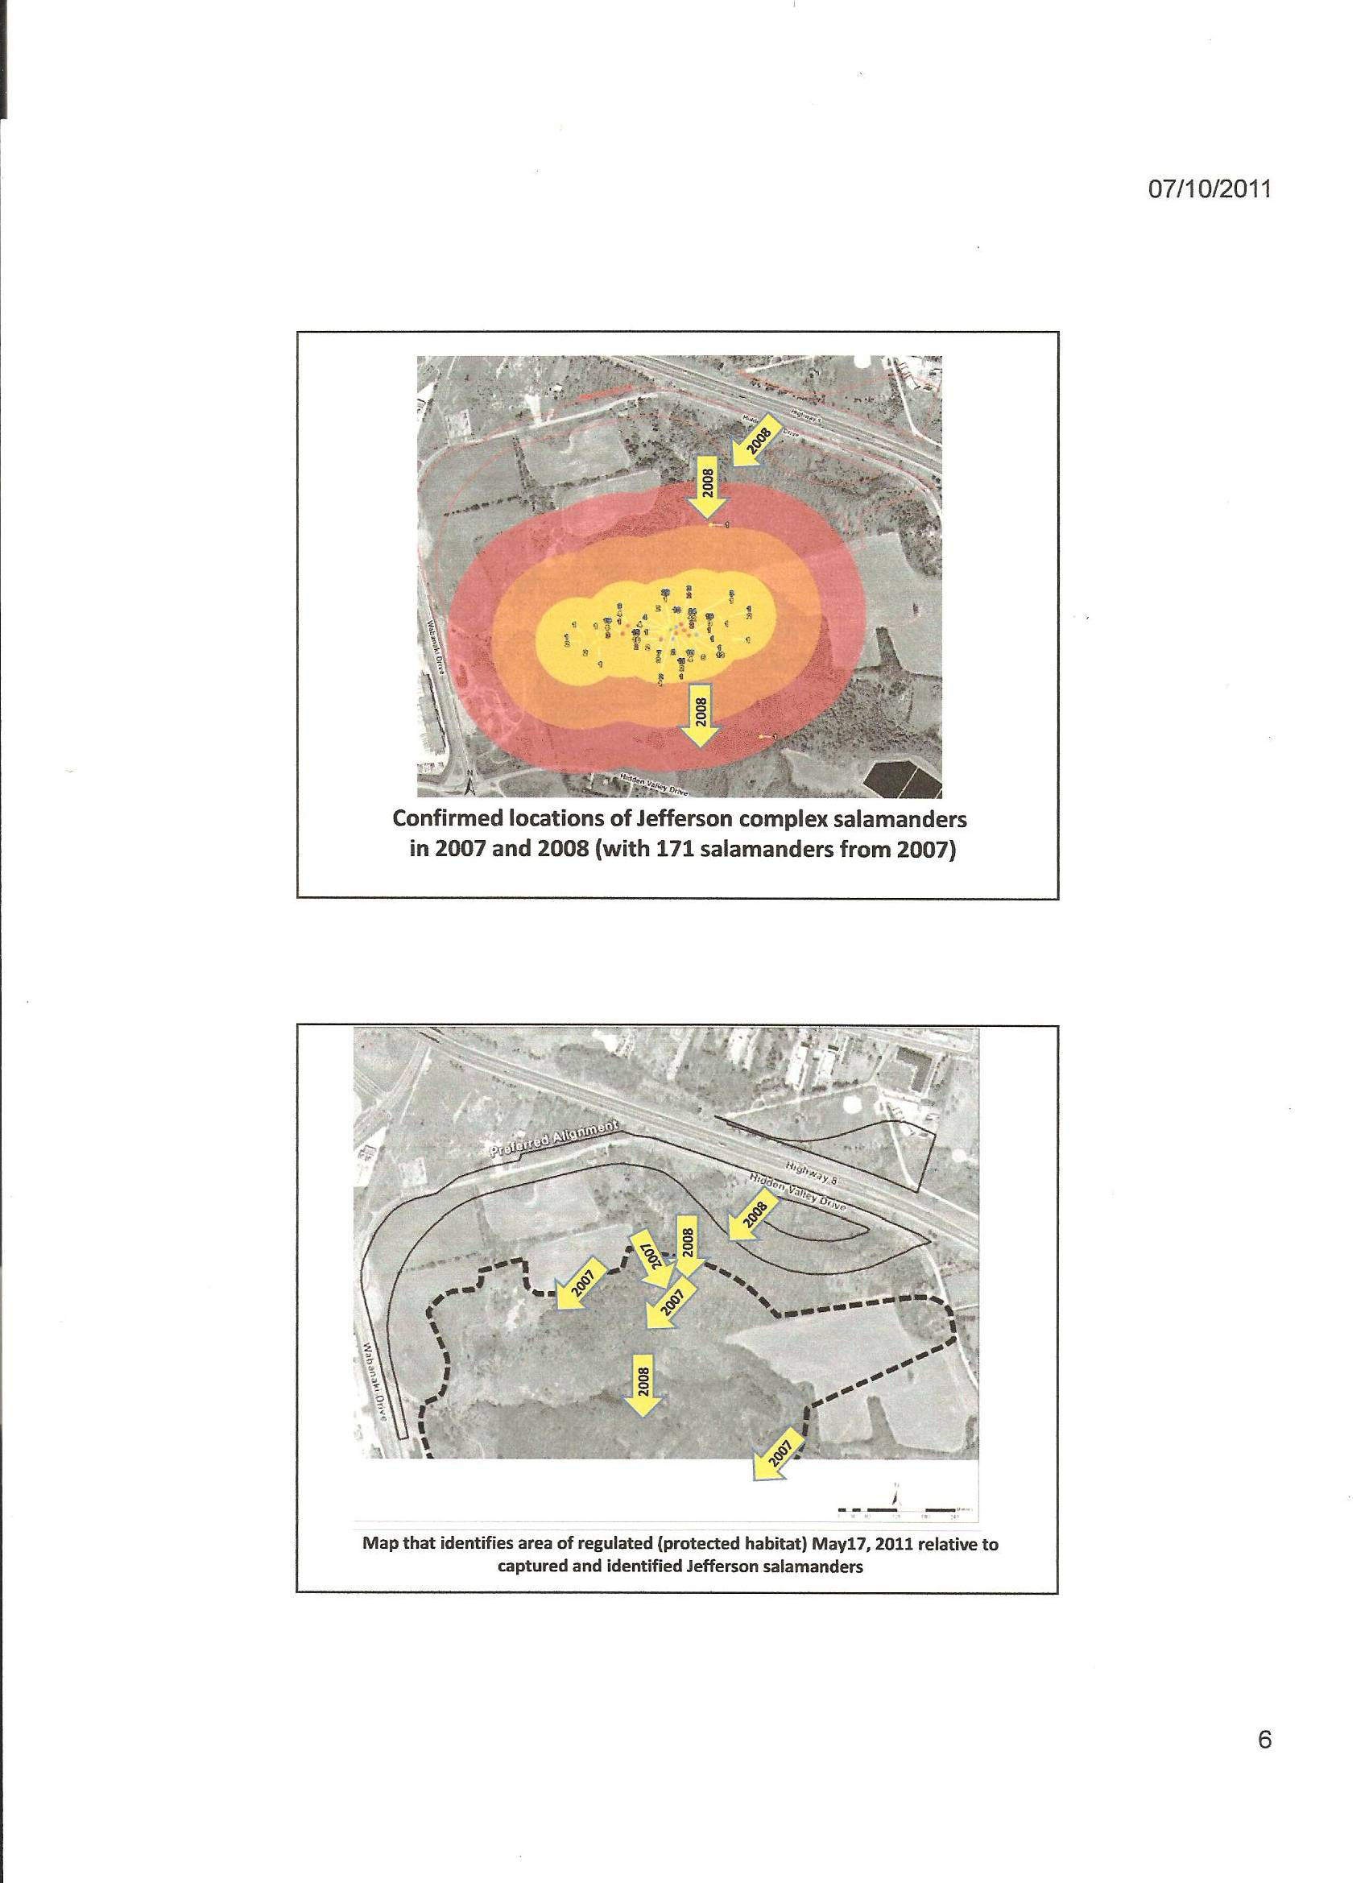
On the 2nd map, the 2008 arrow location is within inches of the preferred alignment. This is outside of the regulated area. However, this is in an upland habitat and is within 300 meters of the breeding pond area.

Ms. Bériault fails to recognize that 2 salamanders were found outside the regulated habitat in an upland area, one of which was a Jefferson salamander complex. She has never accounted for their presence. She has never explained where they might have come from.

Ms. Bériault was quick to quote part of the Endangered Species Act, but only the portion that purports to support the MNR delineation of the “regulated area”. The whole portion is stated as follows:
“The area that is within 300 metres of these wetlands, pools and ponds that provides suitable conditions for foraging, dispersal, migration or hibernation is also protected as habitat. In addition, areas that provide suitable conditions for dispersal to other suitable breeding areas, as well as the suitable breeding areas to which Jefferson Salamanders may disperse, up to 1 kilometre away from protected breeding ponds are protected.”
See: http://www.mnr.gov.on.ca/en/Business/Species/2ColumnSubPage/268554.html

Ms. Bériault never addresses the 1 kilometre issue. Why not?

I believe there are other breeding areas outside the regulated area. I believe that once again a new study is required to determine these facts.

Jean, I was right in 2007 and I am right again. This time neither the Region nor the MNR are willing or interested in doing the right thing. The points cited, in my letters of March 5th to the Region and June 28th to the MNR, have been ignored.

I ask you to seek full explanations as to how the MNR determined the regulated area, while ignoring related data. Further, I ask that you require staff to explain their apparent acceptance of the regulated area without questions. As a citizen of the province and of this region, I deserve to have my letters addressed fully and not treated to yet another exercise of obfuscation. I ask your assistance in this matter.

Respectfully submitted,

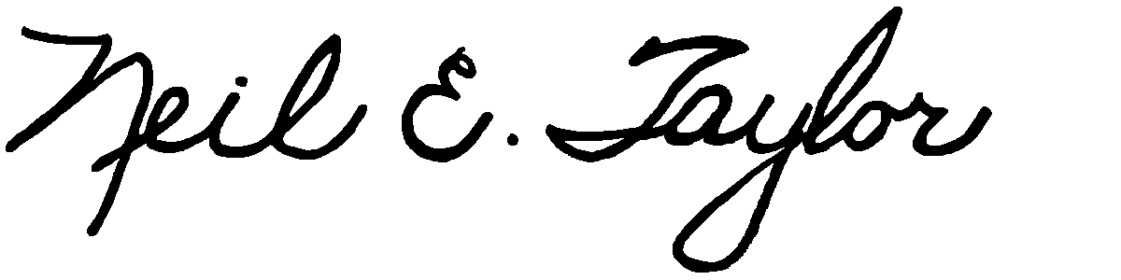
Neil E. Taylor

Attachment: Figure 4 from 2007 Field Investigations re. Class EA Phase 3-4

C.c.
Mr. John Gazzola, Councillor, City of Kitchener and Project Team Member
Mr. Barry Vrbanovic, City of Kitchener and Project Team Member
Ms. Claudette Millar, Councillor, Region of Waterloo
Ms. Jane Mitchell, Councillor, Region of Waterloo
Mr. Les Armstrong, Councillor, Region of Waterloo
Mr. Jim Wideman, Councillor, Region of Waterloo
Mr. Carl Zehr, Councillor, Region of Waterloo
Mr. Geoff Lorentz, Councillor, Region of Waterloo
Mr. Doug Craig, Councillor, Region of Waterloo
Mr. Sean Strickland, Councillor, Region of Waterloo
Mr. Rob Deutschmann, Councillor, Region of Waterloo
Mr. Ross Kelterborn, Councillor, Region of Waterloo
Mr. Tom Galloway, Councillor, Region of Waterloo
Ms. Brenda Halloran, Councillor, Region of Waterloo
Mr. Ken Seiling, Chair, Region of Waterloo
Ms. Jane Brewer, Councillor, Region of Waterloo
Mr. Todd Cowan, Councillor, Region of Waterloo

Hon. Dalton McGuinty, Premier of Ontario,

Hon Michael Gravelle, MPP, Minister of Natural Resources

Hon James J. Bradley , MPP, Minister of the Environment
Mr. Michael Harris, MPP

Hon. John Milloy, MPP

Mr. Ken Seiling, Regional Chair

Ms. Virginia West, Deputy Minister
Mr. Gord Miller, Environmental Commissioner of Ontario
Mr. André Marin: The Ombudsman
Dr. Ann Cavoukian, Information and Privacy Commissioner of Ontario
Mr. Howard Hampton, MPP, Critic, Natural Resources
Mr. Jerry J. Ouellette, MPP, Critic, Natural Resources

Ms. Bériault, MNR

Mr. Ian Hagman, MNR

Ms. Karolyne Pickett (MNR)

Other interested and concerned citizens.

