Neil E. Taylor
1016 Wilson Avenue

Kitchener, Ontario

N2C 1J3

519-893-6469

March 5th, 2012

(Via e-mail)

Without Prejudice

Urgent Attention:

Wayne Cheater, P. Eng., Senior Project Manager
Regional Municipality of Waterloo, 150 Frederick Street,
Kitchener, Ontario, N2G 4J3.

Re. South Kitchener Transportation Corridor,
Bleams Rd. Extension, and
River Road Extension Class EA

Dear Mr. Cheater,

I acknowledge receipt of your letter of February 23rd, in response to my letter dated February 8th.

I do not appreciate your references to a meeting that I chose not to attend because I was not provided data that I had requested for months that was necessary for my planned presentation.. Moreover, you are well aware that I had been seeking information and data for the best part of the year from the Region. Your office more than once denied me that information only to reluctantly provide it. Even so, questions and concerns I have raised could never have been answered in my presence when they have not been properly addressed since the meeting. In fact, you have discounted my concerns with weak arguments and rhetoric related only to my absence from the meeting.

Permit me to be direct. It must be obvious that the regulated area and range has been defined by the one Jefferson complex individual that I referred to in my letter of February 8th. If you wish to ignore this data point, then why were drift net fences placed in the area? By extension, why bother to sample if the data is to be ignored? extension, why bother to sample if the data that is collected is to be ignored? This data needs to be used to permit the survival of Jefferson salamander across Hidden Valley. In order to allow this population to survive, all three key habitats used in the life history need to be protected. These habitats include: overwinter den areas in forest, foraging areas in forest, and breeding areas in ponds.

Based on these letters, it is evident we both agree that a single Jefferson salamander complex individual was captured during the survey work of 2008 in an unexpected area, near the proposed 4 lane highway. In this regard, your letter of February 23rd stated:
“The observation of a single individual in that location illustrates an inconsistency that does not contradict the conclusions of the Region’s study. There were no other breeding pond locations found. The MNR has based their assessment of Regulated Habitat of Jefferson Salamanders in the Hidden Valley on Ontario data, some of which is obtained from the Regions studies.”
Based on these statements, it is evident the Region and MNR fails to acknowledge these past studies were designed to resolve the true identity of the salamanders (i.e., Jefferson complex or not) and to identify the breeding areas. Since these past studies were not designed to quantify migration pathways, the locations of the overwinter den areas, or foraging areas, each are still unknown. At this time, I posit that the single Jefferson salamander complex individual found near the proposed road represents the physical distribution of the salamander population in Hidden Valley. To state it more simply: the 2008 studies identified that Jefferson salamander complex individuals occur in close proximity and far away from the proposed road in Hidden Valley. Thus, your letter from February 23rd confirms that the Region and the MNR does not hold concern about den areas and foraging areas, but will readily protect the breeding ponds used by these same salamanders.

Mr. Cheater, I agree that you do not know the significance of the lone salamander. So why worry about this animal? Why worry about any of the 100s of Jefferson complex salamanders that occur in Hidden Valley? If you do not care about 1%, of the species in the area, why should we care about the other 99%? I strongly submit that each individual endangered species deserves as much protection as possible. If not, then why bother to document the one individual in the study? Why even bother to report when only one salamander is captured? It would be much easier for studies to ignore instances when data observations do not conform to our plans or perception of the natural environment.

Because no adult migration studies have been completed, the migration pathways, foraging areas, and den areas remain unknown. This is a major weakness of the data collected to date. If true concerns were expressed for the salamanders in the past, all of these facets along with the breeding ponds would have been studied. To date, since the Region does not understand adult migration and den sites, how on earth can you quantify the possible total effects on the population and possible losses from the proposed road itself? Is it possible to assess risk to the Jefferson complex in Hidden Valley if the den and forage areas are unknown? If you cannot identify and quantify possible losses for the entire life history, it is not possible to properly negotiate the benefit agreement required for the permit from MNR to destroy habitat or actual specimens of endangered species.

Following my criticism of other studies exactly 5 years ago, I note that the Region once again is using bad judgment. It is relying on only one year of data. Differences in climate may differ from one year to the next and thus migration patterns. It can be safely stated that the ROW, the proponent of this project, does not understand the migration patterns. This is a direct result of the study goal which was to identify the definitive identity of the salamanders and the location of breeding ponds. No adult migration or denning areas were determined.

The present approach used by the Region and MNR could potentially allow for the destruction of forest habitat where unknown numbers of salamander occurs and forages for 99% of its life. So the plan is to protect the breeding ponds (due to the basis of the present study), whereas the same level of protection is not afforded to the adult winter dens and foraging areas.

I seek explanations from the Region, the contracted environmental consultants, and the MNR to all matters raised in this letter. After I receive a response to this important matter, I will identify some of the other deficiencies that exist in the explanations noted in the February 23rd letter.

Respectfully submitted,

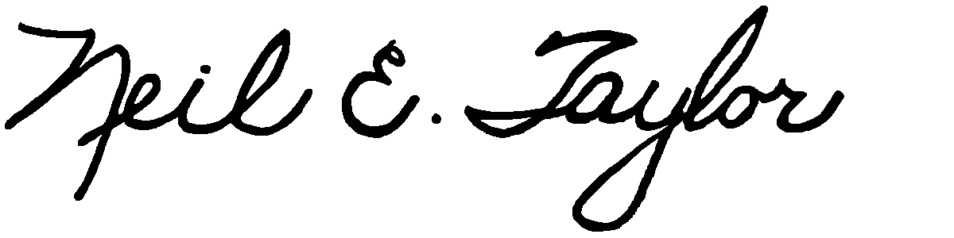

Neil E. Taylor

C.c.
Mrs. Jean Haalboom, Councillor, Region of Waterloo and Project Team Member
Mr. John Gazzola, Councillor, City of Kitchener and Project Team Member
Mr. Barry Vrbanovic, City of Kitchener and Project Team Member
Ms. Claudette Millar, Councillor, Region of Waterloo
Ms. Jane Mitchell, Councillor, Region of Waterloo
Mr. Les Armstrong, Councillor, Region of Waterloo
Mr. Jim Wideman, Councillor, Region of Waterloo
Mr. Carl Zehr, Councillor, Region of Waterloo
Mr. Geoff Lorentz, Councillor, Region of Waterloo
Mr. Doug Craig, Councillor, Region of Waterloo
Mr. Sean Strickland, Councillor, Region of Waterloo
Mr. Rob Deutschmann, Councillor, Region of Waterloo
Mr. Ross Kelterborn, Councillor, Region of Waterloo
Mr. Tom Galloway, Councillor, Region of Waterloo
Ms. Brenda Halloran, Councillor, Region of Waterloo
Mr. Ken Seiling, Chair, Region of Waterloo
Ms. Jane Brewer, Councillor, Region of Waterloo
Mr. Todd Cowan, Councillor, Region of Waterloo

Hon. Dalton McGuinty, Premier of Ontario,

Hon Michael Gravelle, MPP, Minister of Natural Resources

Hon James J. Bradley , MPP, Minister of the Environment
Mr. Michael Harris, MPP

Hon. John Milloy, MPP

Mr. Ken Seiling, Regional Chair

Ms. Virginia West, Deputy Minister
Mr. Gord Miller, Environmental Commissioner of Ontario
Mr. André Marin: The Ombudsman
Dr. Ann Cavoukian, Information and Privacy Commissioner of Ontario
Mr. Howard Hampton, MPP, Critic, Natural Resources
Mr. Jerry J. Ouellette, MPP, Critic, Natural Resources
Ms. Elizabeth Witmer, MPP

Other interested and concerned citizens.

