Neil E. Taylor
1016 Wilson Avenue

Kitchener, Ontario

N2C 1J3

519-893-6469 (Cottage 705-687-1234)

July 23, 2012

(Via e-mail)

Without Prejudice

Urgent Attention:

Mr. Gordon Miller
Environmental Commissioner of Ontario
1075 Bay Street, Suite 605
Toronto, ON
M5S 2B1

Re. South Kitchener Transportation Corridor, Bleams Rd. Extension, and River Road Extension Class EA

Dear Commissioner Miller:

I have met you a few times at the Latornell Conservation Symposium. I have also copied your office many items of correspondence re. the Class EA over several years. In fact I enclose a letter sent to you May 17, 2007. I have also attached the most recent correspondence between myself and the Region of Waterloo and with the MNR.

Mr. Miller, you should be aware that I challenged an earlier EA prepared for the Region in 2007. This was on basis that it was incomplete and incorrect with respect to the identification of various species. The most glaring was related to a species at risk, Jefferson Salamander. A Natural Heritage Study (August 2005) stated,
“Detailed field efforts concentrated on locating the presence of species at risk, and in 2004 LGL Limited did not locate any species designated as vulnerable, threatened or endangered by the MNR”.
To the credit of regional staff, they took my criticism seriously and undertook more studies in 2007 and 2008 and this revealed the presence of 366 individual salamanders in the Jefferson complex. Amazing! I suggest that there are more than that and that this habitat probably has the largest population anywhere in Canada.

Ms. Bériault, of the MNR, in a letter dated July 19, makes reference to a November 30th, 2011 meeting. What she does not admit is that I had volunteered to meet with all regional councilors and in particular with members of the project team. In preparation for the meeting, the MNR declined to permit me to use an electronic version of a map that I already possessed as a hard print copy. This denial was appealed to the Freedom of Information and Privacy Commissioner’s office. Some 5 months later, the MNR reversed itself without explanation, but this was much too late for the scheduled meeting.

Ms. Bériault seems to have satisfied herself in response to my concerns by stating that these points were covered in the November 30th meeting. Perhaps she is unaware that I have the minutes of that meeting as well as documents she relied upon. These were the basis of my letters of concern to Mr. Cheater, Region of Waterloo, and then to her.

In my letter to her dated June 28, 2012, I state,
“For example, locations with documented Jefferson salamander are excluded from regulated areas whereas locations with no documented Jefferson salamander are included as regulated area.”
I stated much more, but Ms. Bériault, responds only as follows:
“If and when salamanders are found outside of regulated habitat, in an upland area and not in a breeding pond, their presence can be addressed via Section 9 of the ESA.”
Ms. Bériault, fails to recognize that 2 salamanders were found outside the regulated habitat in an upland area, one of which was a Jefferson salamander complex. She has never accounted for their presence. She has never explained where they might have come from. I believe there are other breeding areas outside the regulated area.

Mr. Miller, I was right in 2007 and I am right again. This time neither the Region nor the MNR are willing or interested in doing the right thing. The points cited in my letters of March 5th to the Region and June 28th to the MNR have been ignored.

At this time, I once more request the office of the Environmental Commissioner to help resolve the information being used to justify the road through Hidden Valley of Kitchener. If your office is willing to consider this matter in detail, I will submit all relevant information as soon as possible.

Respectfully submitted,

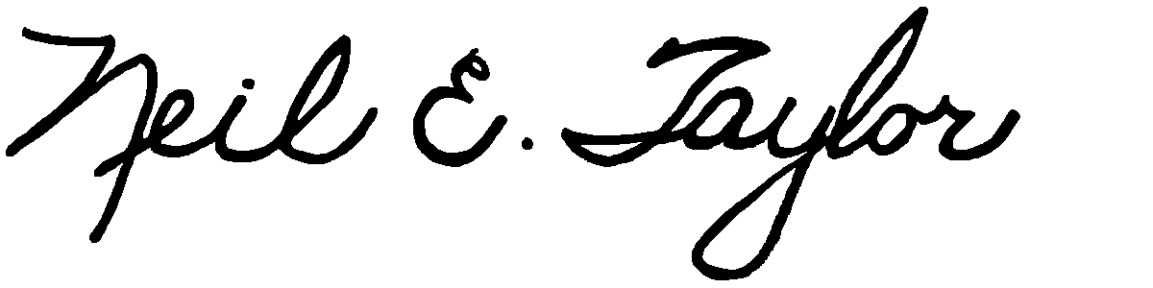

Neil E. Taylor

Attachments:

May 17, 2007 letter to G. Miller

March 5th, 2012 letter to W. Cheater, Region of Waterloo

March 15, 2012 letter from W. Cheater, Region of Waterloo

June 28, 2012 letter to K. Bériault, MNR

July 19, 2012 letter from K. Bériault, MNR

C.c.
Mrs. Jean Haalboom, Councillor, Region of Waterloo and Project Team Member
Mr. John Gazzola, Councillor, City of Kitchener and Project Team Member
Mr. Barry Vrbanovic, City of Kitchener and Project Team Member
Ms. Claudette Millar, Councillor, Region of Waterloo
Ms. Jane Mitchell, Councillor, Region of Waterloo
Mr. Les Armstrong, Councillor, Region of Waterloo
Mr. Jim Wideman, Councillor, Region of Waterloo
Mr. Carl Zehr, Councillor, Region of Waterloo
Mr. Geoff Lorentz, Councillor, Region of Waterloo
Mr. Doug Craig, Councillor, Region of Waterloo
Mr. Sean Strickland, Councillor, Region of Waterloo
Mr. Rob Deutschmann, Councillor, Region of Waterloo
Mr. Ross Kelterborn, Councillor, Region of Waterloo
Mr. Tom Galloway, Councillor, Region of Waterloo
Ms. Brenda Halloran, Councillor, Region of Waterloo
Mr. Ken Seiling, Chair, Region of Waterloo
Ms. Jane Brewer, Councillor, Region of Waterloo
Mr. Todd Cowan, Councillor, Region of Waterloo

Hon. Dalton McGuinty, Premier of Ontario,

Hon Michael Gravelle, MPP, Minister of Natural Resources

Hon James J. Bradley , MPP, Minister of the Environment
Mr. Michael Harris, MPP

Hon. John Milloy, MPP

Mr. Ken Seiling, Regional Chair

Ms. Virginia West, Deputy Minister
Mr. Gord Miller, Environmental Commissioner of Ontario
Mr. André Marin: The Ombudsman
Dr. Ann Cavoukian, Information and Privacy Commissioner of Ontario
Mr. Howard Hampton, MPP, Critic, Natural Resources
Mr. Jerry J. Ouellette, MPP, Critic, Natural Resources

Other interested and concerned citizens.

