-+

STRASBURG ROAD extension
from north of Stauffer drive to New Dundee road

Class Environmental Assessment

NOTICE OF PUBLIC INFORMATION CENTRE NO. 2

The Study
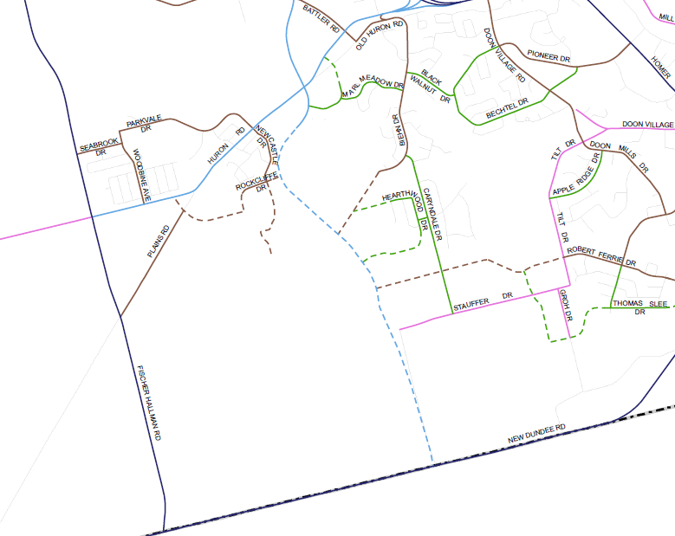
The City of Kitchener is progressing with the Class Environmental Assessment (EA) Study for the South Section of the Strasburg Road Extension from north of Stauffer Drive southerly to New Dundee Road. The accompanying Key Plan illustrates the conceptual alignment of the established Strasburg Road corridor, for which Detail Design is in progress (North Section), and the limits of the Strasburg Road Extension Class EA Study (South Section).
HURON
BRIGADOON
DOON SOUTH
Strasburg Road Extension
(North Section)
Detail Design
Strasburg Road Extension
(South Section)
Class EA Study

The Process
The City is conducting the Class EA study in accordance with Schedule ‘C’ of the Municipal Engineers Association Municipal Class Environmental Assessment, October 2000, as amended (2007), in compliance with the Ontario Environmental Assessment Act. The Class EA process includes public and government agency consultation, evaluation of project alternatives, an assessment of the impacts of the proposed improvements, and identification of measures to mitigate any adverse environmental impacts.

The first in a series of three Public Information Centres (PIC) was held in June 2010 to introduce the study and the scope of the EA investigations. The second PIC will be held as follows:

Date: Wednesday June 1, 2011
Time: 6:00 p.m. to 8:00 p.m.
Location: Brigadoon Public School
415 Caryndale Drive
Kitchener

The purpose of PIC No. 2 is to report on study progress, present the route alignment alternatives that have been developed and the short list of alignment options proposed for more detailed study, and provide an opportunity for public and government agency review and comment. Representatives from the City and the Consultant Team will be present at this drop-in information session to answer questions and discuss the next steps in the study.

At the June 2010 PIC, the Project Team received comments on the segment of the Strasburg Road Extension between Rush Meadow Street and north of Stauffer Drive (North Section). These comments have been considered as part of the Detail Design work, and the proposed plan for the North Section will be presented at a PIC scheduled for Fall 2011.

Comments
Stakeholder consultation is vital to the Class EA process. The City wishes to ensure that anyone with an interest in this study has the opportunity to get involved and provide input before a final decision is made on a preferred alignment for the South Section of the Strasburg Road Extension. With the exception of personal information, all comments will become part of the public record.

To provide your comments or to request additional information concerning this project, please contact either of the following Project Team members:

Mr. Binu J. Korah, P.Eng.  Manager, Development Engineering  City of Kitchener  200 King Street West  Kitchener, ON N2G 4G7  Phone: (519) 741-2974  Fax: (519) 741-2747  TTY: (519) 741-2385  Email: binu.korah@kitchener.ca | Mr. Ian K. Upjohn, MCIP, RPP  Principal Planner  Environment Division  SNC-Lavalin Inc.  195 The West Mall  Toronto, ON M9C 5K1  Phone: (416) 679-6289  Fax: (416) 231-5356  Email: ian.upjohn@snclavalin.com

