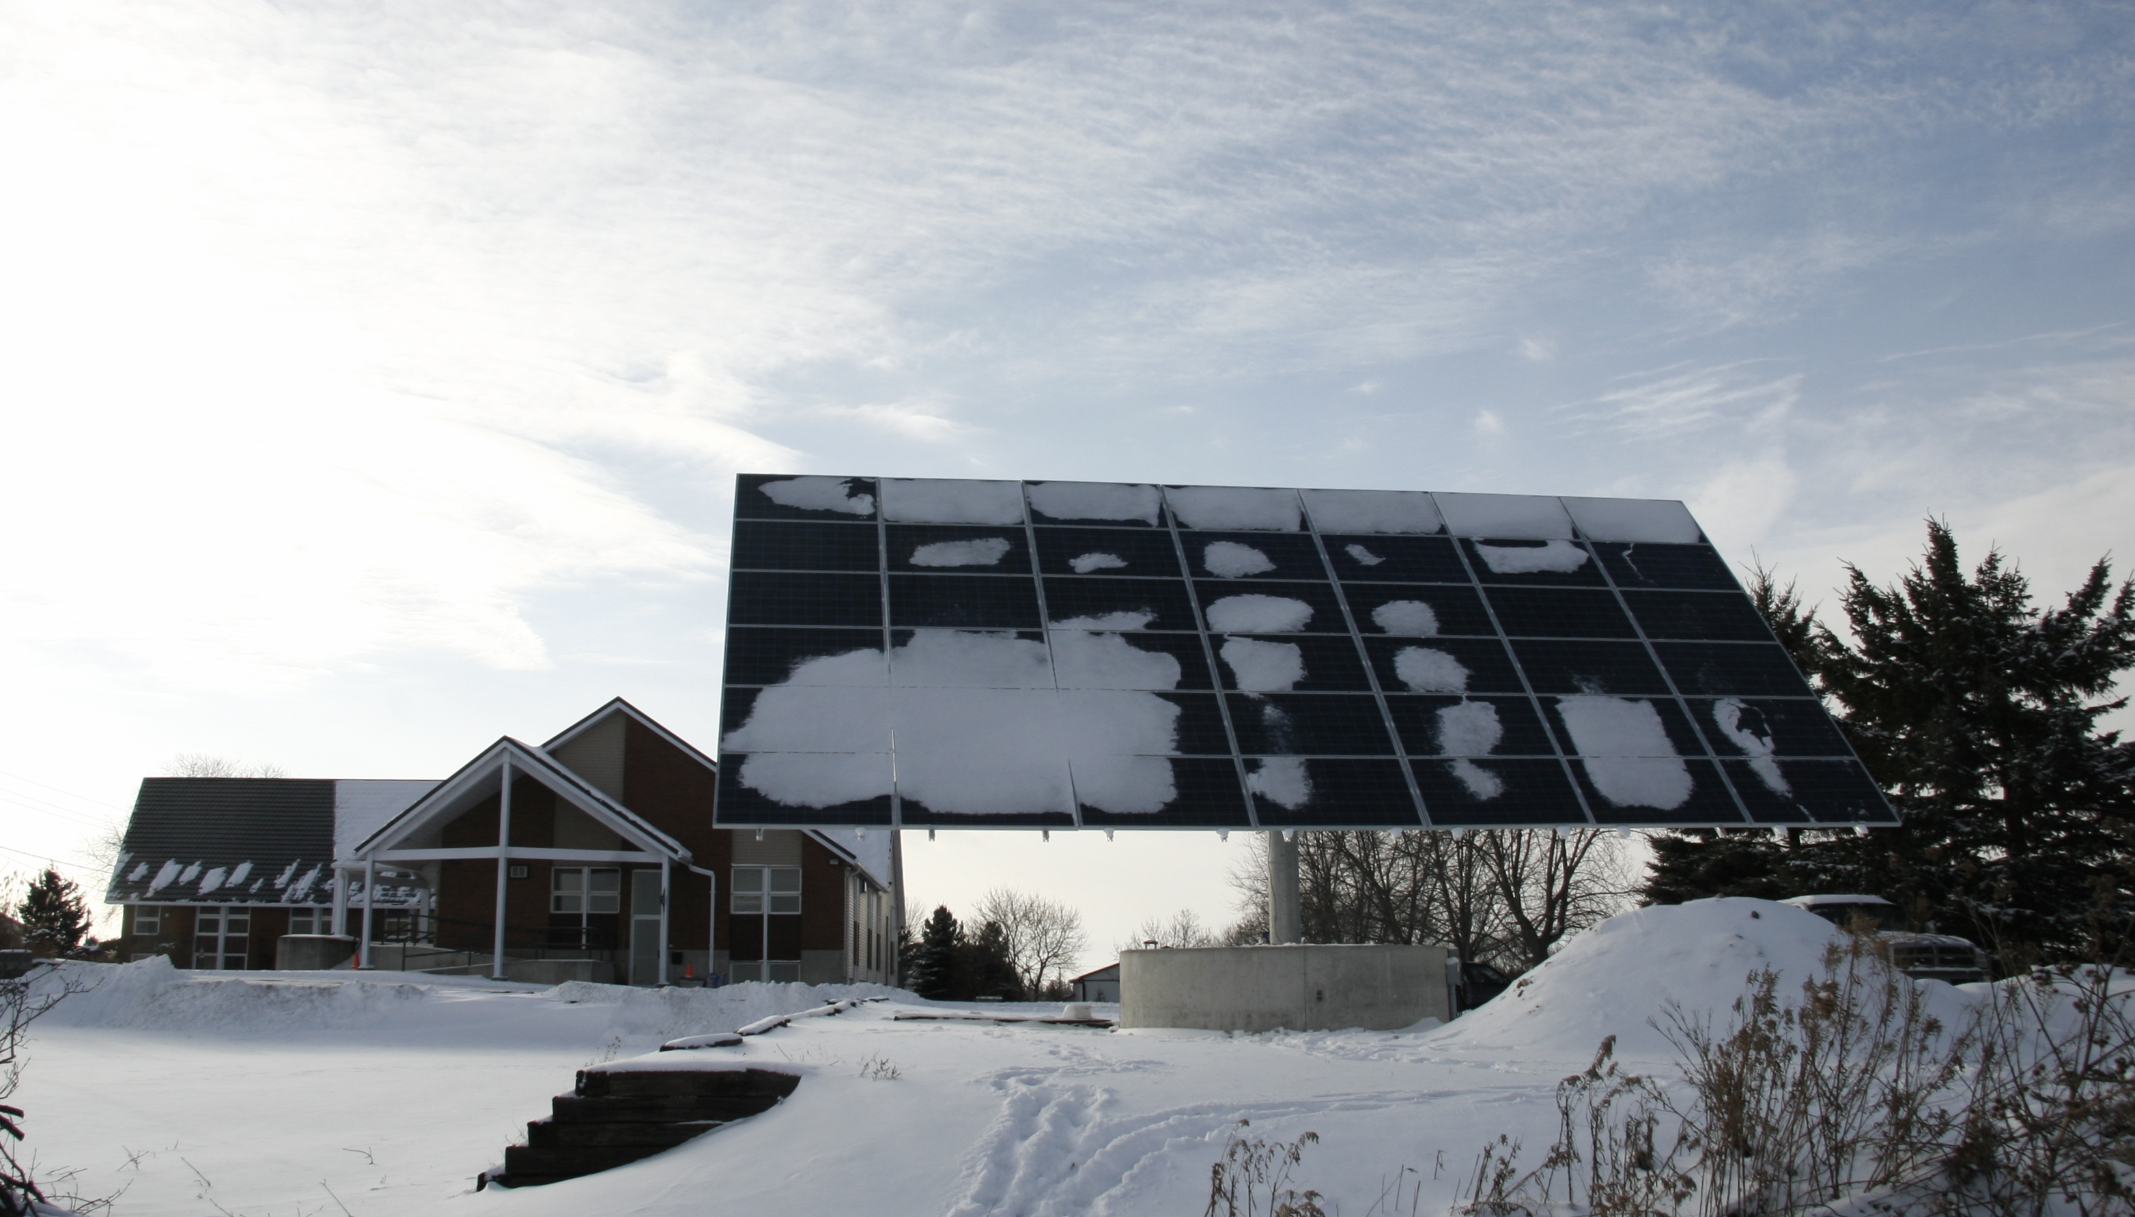
Saturday February 26, 2011
2-4 PM
Hillcrest Mennonite Church
1056 Huron St, New Hamburg

Self-guided tour featuring:
DEFINING ENERGY POVERTY and what we can do about it
PEACEFUL APPROACHES to creation’s resources
VIEW SOLAR PANELS installed at Hillcrest
FINANCING ENERGY PROJECTS through Creation Care Loans
DISPLAYS with solar energy organizations and vendors

ontario.mcc.org/mise




Hosted by:
In partnership with:
Hillcrest Mennonite Church

