Innovation Corridors for Region of Waterloo

Initial Draft, December 2009, Version 2.0 November 2010
Source - John Shortreed please ask for latest version shortree@uwaterloo.ca
An evolving document. Thanks to all those who have commented

Innovation Corridor is a Concept and Brand for Waterloo Region to achieve the objectives of:
reurbanization, economic development, cultural enhancement,
good jobs, quality of life, and innovation

OVERVIEW

The overarching objective is to support and celebrate innovation in Waterloo Region by creating a physical entity, a corridor, that would support ”innovating visitors” by providing a world class experience during their stay.

The desirable attributes for a visitor are also the desirable attributes for permanent residents and workers who desire a high quality ‘life-style experience’. Permanent workers and residents in the corridors will provide the base demand for the joint services such as shops, restaurants, parks and performances.

The corridor is focused and concentrated for success in two innovation corridors with the Universities, Research Park and UpTown-Kitchener residential corridor in the North and the Galt Grand River corridor in the South.

A modified iXpress and new iXdown transit service will reflect, integrate and link the corridors to the spirit of innovation and lifestyle experience throughout the Waterloo Region.

The corridors would be an outward and visible sign of an innovative spirit and culture
(Aside – are there any poets out there with a better replacement for’ inward and spiritual grace’ from the King James version?)

The corridor is an overlay on the existing urban fabric and uses existing governance structures.

Innovation Corridor – The idea and its elements

- The corridors would be both a brand and a physical ‘life style’ corridor in the cities of Kitchener -Waterloo and Cambridge.
- The corridors celebrate innovation in technology, the arts, education, manufacturing, society, and lifestyle in Waterloo Region. They promote innovation; international, state-of-the-art, world class innovation. The goal is a world brand, similar to RIM, Blackberry, ComDev and the University of Waterloo.
- The “innovation” objectives of the corridors are fully aligned to the mission and goals of Canada’s Technology Triangle and would represent a tangible expression of those goals as a physical presence that can be experienced day by day.
- The corridors are intended first and foremost to provide visitors and participants in innovation activities a quality live-work-play experience to enhance their work in Waterloo Region. All decisions about the corridors should be judged against this overarching goal.
- The corridors will also provide for a quality ‘life-style’ experience for others who move into the corridors (empty nesters, etc.) and other day visitors who come to experience the life style. These new residents and visitors will provide an economic base for quality-of-life/work/play activities, events and developments.
- Physically, Innovation Corridor are linear corridors – in the north starting in Kitchener and proceeding along King St. to Uptown Waterloo continuing north past the Balsillie Institute and Perimeter Institute to the Universities of Waterloo and then on to the Research and Technology Park. In the south the corridor encompasses the existing core of Galt and the adjacent Grand river area.
- Innovation corridor north is approximately 7 kilometers long starting at mileage 0.0 in Kitchener with mileage 7.0 at the Research and Technology Park. Innovation corridor south is 3-4 kilometers long and while the exact location of the corridor is to be determined it likely is along the Grand River, and on Coronation, Dundas, and Ainslie streets.
- Innovation corridors are ‘tight’, about 5 blocks wide. They are pedestrian scale. The corridors are also an integrated part of the regularly functioning urban area and infrastructure – both the corridors and regular urban life are superimposed, physically and functionally. You can move easily and seamlessly from one world to the other.
- The linearity of the corridors provides for simple wayfinding, for example in the north; UpTown Waterloo might be mileage 3.4, PI mileage 3.5, University of Waterloo 5.0, and so forth. Locations of destinations would be easy to relate to because of the linearity of the corridor and the unambiguous designation “mileage x.x”. Navigation is simple, clear and hard to get wrong. The mileage would also be linked to a common name for the area.
- Innovation corridors are supported both by walking and “fare-free” transit with high frequency hop-on hop-off service, making for pleasant, quick, and easy corridor movement. The corridors are a pedestrian destination that can be accessed from work, from home, from a hotel, from car park, from walking, on a bike, or from Grand River Transit (GRT) including the iXpress and proposed iXtown.
- Once on either the north or south corridors anywhere on the corridor is a maximum of about 15 minutes away, door to door, either by walking or fare free hop on hop off frequent transit service. The essence of the corridor is high connectivity for people to all corridor destinations. The link between north and south corridor is expected to be a little over a half an hour by transit traveling on its own ROW and fully integrated with the fare free transit and new iXtown routes.
- The corridors have many ‘theme’ layers and for each of these layers the initial “seeds” are already in place. For example in the north, consider the Prosperity Council’s objectives of culture – from the Center in the Square, to the Conrad center, to the Museum, to Sun Life auditorium, to the Waterloo Theater, to the UpTown Gallery district, to the Button Factory, to CIGI, to the PI, to Clay and Glass, to Humanities Theater, there is a string of locations along the corridor where cultural activities can take place. Similarly for educational institutions, starting with the Kitchener Library, the School of Social Work, the Image Factory, the Pharmacy school, to K-W High School, to International Policy Analysis, Waterloo Library, Clay and Glass museum, to University of Waterloo, etc. In the south existing features include the architecture school, the parks along the Grand River, attractive condominiums, etc. You can easily, along the corridors, identify elements for the themes of Restaurants, Pubs, Skating, Recreation, Spas, Green areas, Bicycle shops, Grocery shops, Student services, Student accommodation, Hotels, short stay housing, and so forth.
- Waterloo Park is a jewel of the north corridor. Centrally located and less than 10 minutes away from anywhere in the corridor via the free and frequent transit system, it is a place to go for lunch, for a walk, for contemplation, for meeting people, etc. Think of central parks in other metro areas. Again there is also an existing string of other green spaces that exist now along the corridors including the spectacular Grand River in the south corridor.
- The corridors are also proposed to be in cyberspace, on-line in real-time, with information on where your colleagues and friends are physically in the corridor, what restaurants have room for 12 people in 10 minutes (then book one), what is showing next at the Princess Cinema II, streaming video of talks open to your interests, apartments for rent (view rents, tour suites, contact information), what’s on this evening?, art show exhibits, current travel time to Toronto Airport, and so forth – all the things you need to know to take full advantage of living and/or visiting in the innovation corridors. All easily available on your wireless device.
- Corridor key gateways/nodes would include transportation terminals (North and South and GO/VIA stations) and many parking lots, hotels, workplaces, condos, and education and research institutions along the corridors. They should be weather proof.
- The corridors will be attractive for those outside the innovation sector who just want a ‘cool’ and pleasant place to live, eat meals, shop, and be entertained. Extensive condominium mixed use developments are expected to be attracted to the corridors. They will provide an expanded base to support all the corridor themes. The pensions of new empty-nester residents will be a significant addition to the Region’s economic base, a sort of collateral benefit.
- The corridors will become a unique kind of “research park”, one that is part traditional (i.e. that exists now) but partly one that is more open, less structured and responsive to independent initiatives for all sorts of products, tools, techniques, software, inventions, and other innovative ideas and concepts.

Practical details just for purposes of showing feasibility

These ideas and concepts would need detailed feasibility design and consensus utilizing traditional stakeholder processes involving; governments, key existing organizations, public, and so forth. For example determination of the extent of the south corridor that is most likely to realize innovation.

  - The governance of the corridor would be by existing governments of the cities of Kitchener, Waterloo, and Cambridge and the Region of Waterloo. There would be an independent advisory board that would be based initially on existing organizations with complementary objectives and close association with the corridor themes.
  - The vehicle movement system is likely bus, using regular GRT buses such as those already on King St. including iXpress, but on their own ROW including underpasses and overpasses as required.
  - The attached figure outlines a conceptual arrangement of transportation for the corridor illustrating;
    - Increased stops for iXpress to achieve land development objectives and improve access to the corridors. Stop spacing in the corridors would be similar to existing King St. bus routes.
    - Approximate fare free zones in the north and south corridors
    - Integration of iXpress rapid transit with the fare free transit in the corridor
    - Extension of the iXpress concept to iXtown, cross town service to extend exclusive ROW transit service to the whole Region not just the central corridor
    - iXpress and iXtown services as well as the King St. routes will, where possible be integrated into the transit service for the corridors to eliminate transfers and provide a seamless ride for corridor access. Ottawa has many similar examples. This may also reduce existing transit costs.
    - Electronic or honour fare systems will facilitate the interface with non ‘fare-free’ areas and the corridors and also increase speeds.
    - Extensions to outlying suburbs such as Elmira
  - Two lanes (one lane in each direction) on King and elsewhere on the corridor would be reserved rights of way (ROW) for the buses to keep them moving – one possibility would be middle of the street platforms (at each significant intersection or about 200 meters spacing between stops) with counter flow bus lanes to keep other traffic off the bus way and to keep clear of parking cars, unloading trucks, etc.. This would also allow for ROW without modifying the pavement so parades and other street closing events would have a smooth surface. It is expected that travel speeds for emergency vehicles would be improved since they could preempt the use of the ROW.
  - Besides exclusive ROW, traffic signals would be integrated and interconnected with the transit vehicles to improve speeds, see for example methods used in Edmonton and also in common use for emergency vehicles.
  - The capital costs of the corridors and the transit ROW would be staged (a key advantage of buses) but would be considerable both initially and on an ongoing basis. Capital costs for major structures will be needed for RR grade separations, river crossings, grade separation for major intersections, electronic modifications to traffic lights, and so forth both for the corridors and the iXpress and iXtown.
  - The regular traffic on King Street (and elsewhere on the corridors) is unrestricted. It is expected that traffic congestion along with pedestrian priority measures will slow traffic to be compatible with pedestrians. Cross corridor traffic, delivery vehicles, parking on street, etc. are as usual except there is only one lane instead of two in each direction. The counter flow bus lanes work to keep regular traffic operating without significant restrictions (some left turns might need to be turned into turn right and loop around the block turns)
  - Development will happen once the corridor is established, branded, and promoted. Special land use controls may, after an initial period, be needed to ensure;
    - There is sufficient provision for all the appropriate ‘themes’ and their land use requirements, particularly those with larger land requirements
    - Aesthetics for pedestrians and for destinations are continuously enhanced
    - Corridor Branding and Innovation are strengthened. This may include special incentives in terms of zoning, site plan controls, and perhaps financial
    - Innovation is celebrated in art, architecture, landscaping, permitted uses, public art, wayfinding signs etc.
    - Corridor incubation, similar to technological incubation, should be encouraged even for activities that may be considered strange. For example, day care experiments, new entertainment mediums, enhanced social services, unusual museums, and so forth.
  - The corridor would need working capital but should be expected to repay a reasonable portion of any costs. The “fare-free” transit zone and improvements to iXpress and iXtown as well as redesign of routes to eliminate transfers, should be the responsibility of GRT based on similar situations in other cities. The corridor investments should on balance be self-supporting which may involve special improvement area taxes similar to those for BIAs (existing BIA legislation might be used to create some of the funding for the corridor). There may need to be joint sharing of costs for the gateway/terminal/nodes between say the corridor, local municipalities and GRT. The proposed $170 million transit terminal in Vaughan, with retail and residential land uses is an expensive example.

What might the next steps be?

- Presentation to public forums and governments for consideration, optimization and approval in principle.
- Continue to explore the corridor concept through discussions to refine the proposal and assess probability of success. This step is about 50% completed and this document will be continuously modified to reflect the best available concepts and modify any show stoppers.
- Form a small ad hoc development team that has access to the resources such as: innovation needs, urban dynamics, research, design and presentation, planning policy options, how to organize charretts (a hands on stakeholder driven design exercise to develop and refine concepts and key elements of the corridors), etc.
- Develop some illustrative graphics and descriptive material to demonstrate the corridor concept as it is refined. These would include refinement of the brand, name, focus, themes, transportation, etc.
- Use of a “professional/key informant” charrette to develop options and common design elements for the corridor. Hopefully the charrette would lead directly to an Initial design and implementation policies at least in principle,
- Final design of corridor and implementation policies
- Development of an implementation plan including organizational arrangements
- Initial designation of the Innovative Corridor brand (or what ever the brand name is) and initial implementation;
  - GRT routes
  - Sidewalk upgrades by Waterloo, Kitchener and Cambridge
  - Formation of initial advisory committee
  - Development of planning, operating, and continuous improvement policies
  - Coordination of new BIA zone with existing BIA zones.
  - Arrange for initial and ongoing capital and operating costs
  - Promotion and launch
  - Work with existing organizations to expand their scope for international innovation

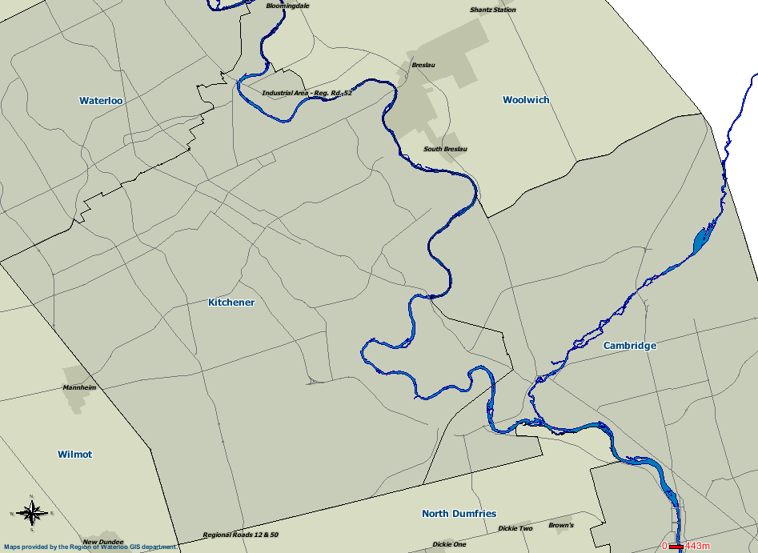
Innovation Corridor North
Innovation Corridor South
University
Tech Park
Mall
Mall
UpTown
DownTown
Galt
To Elmira
Schematic of Innovation Corridors and fare free zones
fare free
fare free
Park
iXtown and iXpress
Routes (illustrative)
Note iXpress and other iXtown routes integrated into Innovation Corridors

