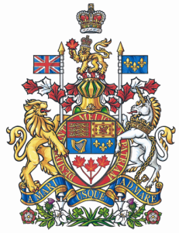

NEWS RELEASE

Scarpaleggia tables motion calling on the federal government
to create a “Council of the St. Lawrence River”

Ottawa, December 2, 2010 – Francis Scarpaleggia, Member of Parliament for Lac-Saint-Louis and Liberal Water Critic, has tabled a motion in the House of Commons calling on the Harper government to create a Council of the St. Lawrence River to better manage and protect this vital waterway.

“The need for a coordinating body to promote the integrated management of the St. Lawrence was clearly reinforced by the roundtable on water that I attended earlier this month in St-Flavie, a community on the St. Lawrence River in the federal electoral district of Haute-Gaspésie–La Mitis–Matane–Matapédia,” said the Montreal-area M.P. whose own riding also borders this vital North American waterway.

“Based on discussions at the roundtable, and separately with others interested in the future of the St. Lawrence, there is a present lack of vision, leadership and cohesion in addressing the challenges facing the river,” added Scarpaleggia.

The council, as envisaged in the Liberal M.P.’s motion, would include representatives from both the federal and Quebec governments, First Nations, river municipalities, industry, and environmental groups. The council would draw on the scientific expertise of various government departments as well as on the local knowledge of the 13 comités des Zones d’intervention prioritaires (ZIP), consultative committees funded under the current St. Lawrence Action Plan.

Scarpaleggia’s motion calls on the government to model the Council of the St. Lawrence on the Fraser Basin Council on Canada’s west coast. “Given the importance of the St. Lawrence for the environment, industry, and for the communities that border the river, it seems logical and reasonable to provide the river with a consultative governing structure similar to the Fraser River’s,” said the Montreal West Island M.P.

-30-

For further information contact Ludmilla von Hoyningen Huene, Special Assistant to Francis Scarpaleggia, at (613) 995-8281 or scarpf8@parl.gc.ca.

