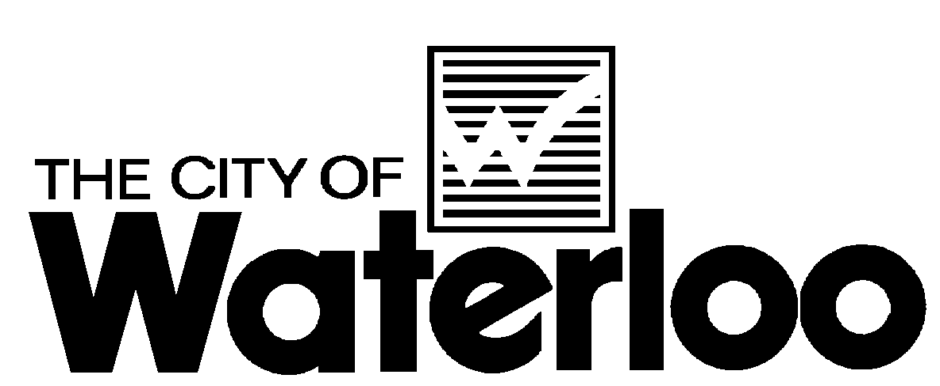 | Corporate Communications
Prepared For: Council  Copies To: CMT, Bill Garibaldi, Public Works  Prepared By: Janice Works, Corporate Communications  Email: janice.works@waterloo.ca  Date: September 8, 2010 | Status: For Information  Approval: Tim Anderson, CAO  Page 1 of 1

__________________________________________________________________
BRIEFING NOTE:
Public forums on the fluoride question.
_____________________________________________________________________________

On August 26, 2010, staff issued a media advisory stating that the City was looking for an impartial third party (media or a citizen voting group, for instance) to organize two additional public information forums – one in September and another in October on the topic of fluoridation. It would be the responsibility of this media organization or group to organize and ensure that balanced information on the issue of fluoride (both pro and con) is available to the public. Facility space would be made available for the event, if needed, as well as assistance in communicating the event to the public.

Last week, staff spoke with a representative from a community group known as Wonderful Waterloo. This group has offered to provide assistance in organizing the remaining two forums on the topic of fluoride for the community. Wonderful Waterloo is an online community that discusses urban development, transportation projects, heritage issues, business and other issues throughout all of Kitchener, Waterloo, Cambridge and the four Townships - North Dumfries, Wellesley, Wilmot, and Woolwich. This group has organized public forums, the most recent on the topic of livable communities, which are videotaped and later posted to their website as an online forum. For more information, please visit www.wonderfulwaterloo.com.

At present, we are hoping to have the fluoride forums on the following dates:

Thursday, September 16 – 7:00 p.m.
Thursday, October 7 – 7:00 p.m.

Space has been allocated at the Hauser Haus, Waterloo Memorial Recreation Complex for these dates and times. If both the pro and con sides of the panel can’t be orchestrated for these two events, then these forums can’t happen.

Having said that, it’s important to note that these public information sessions do not preclude proponents of either side from organizing their own information sessions and ensuring that information that supports their view on this subject reaches our community. In fact, this will be an important part of the community dialogue, and we would encourage them to do this.

When we receive confirmation that these forums are ready to move forward, staff will begin a media blitz to communicate this information to the community.

Staff will also keep Council informed as we move forward.

