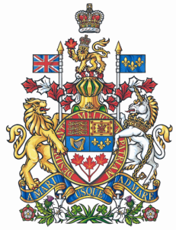

NEWS RELEASE

Scarpaleggia introduces legislation to stop Canada’s lakes from being used as dumping grounds for toxic mining refuse

Ottawa, June 17, 2010 – Francis Scarpaleggia, Member of Parliament for Lac-Saint-Louis and Chair of the National Liberal Water Caucus, today introduced a private member’s bill to prohibit Canada’s lakes from being used as low-cost disposal sites for tailings waste from mining operations.

“More and more, the federal Fisheries Act’s Metal Mining Effluent Regulations (MMERs) are being used as an easy loophole for allowing mining companies to avoid the costs of building safe impoundment areas for their mine wastes. Instead of having to build proper impoundment sites on land for mine tailings, the MMERs allow mining companies to use healthy freshwater lakes as dumping grounds for their mine tailings. This growing practice clearly goes against the original intent of the regulations which were meant as a way to normalize, through grandfathering, lakes that had already been destroyed by being used as tailings disposal areas in contravention of the Fisheries Act,” said the Lac-Saint-Louis M.P.

The Montreal West Island M.P. believes it is more urgent than ever to close this Fisheries Act loophole given that the recent federal budget weakens the federal environmental assessment process by giving the environment minister the power to exclude projects from having to go through comprehensive reviews of their overall impact on ecosystems—including proposals that envisage using lakes as dumping grounds for mining wastes. Since coming to power, the Conservative government has used the MMERs to approve the destruction of four lakes. At the moment, there are at least eleven more lakes across Canada on the list to be approved for use as disposal sites for toxic mining refuse.

- 30 -

For more information contact Gweneth M. Thirlwell, Legislative Assistant to Francis Scarpaleggia, at (613) 995-8281 or scarpf0@parl.gc.ca.

