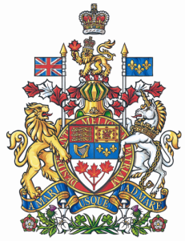

NEWS RELEASE

National Liberal Water Caucus meets during prorogation

Ottawa, January 25, 2010 – Francis Scarpaleggia, Member of Parliament for Lac-Saint-Louis and Chair of the National Liberal Water Caucus, will be holding a meeting of the caucus as part of the “Liberals are working agenda” during the prorogation of Parliament.

The water caucus will meet Tuesday, January 26 at 9am in 112-N Centre Block to discuss the impact of mining tailings on Canada’s lakes. The invited panellists are:

Celeste Côté – National Water Campaigner (Sierra Club Canada)
Meera Karunananthan – National Water Campaigner (Council of Canadians)
Brent Patterson – Director of Campaigns and Organizing (Council of Canadians)
Kristin Stark – Research Analyst (Assembly of First Nations)
Catherine Coumans – Research Coordinator (MiningWatch Canada)
Ramsey Hart – Coordinator of Canada Program (MiningWatch Canada)

“Liberals are determined to use the prorogation period to explore important policy issues like those involving our most precious national resource,” said the West Island of Montreal M.P. “The dynamics and needs of our nation’s natural environment do not wait for the government to ‘recalibrate.’ The environment does not wait on the Prime Minister,” added Mr. Scarpaleggia.

-30-

For further information contact Ludmilla von Hoyningen Huene, Special Assistant to Francis Scarpaleggia, at (613) 995-8281 or scarpf8@parl.gc.ca.

