Neil E. Taylor
1016 Wilson Avenue
Kitchener, Ontario
N2C 1J3

January 4th, 2010

(Via email)

Attention:

Hon. Donna Cansfield MPP
Minister of Natural Resources
6630- 99 Wellesley St W, 6th Flr., Whitney Block
Toronto ON M7A 1W3

Re. COURT FILE NO.: 636/09
Ontario Superior Court Of Justice
JUDGMENT of J. GRAY
August 13, 2009,

And the

Endangered Species Act (ACT)

And

Letters dated August 28th, September 10th, October 23, and November 17

Dear Minister:

I have patiently waited for a complete response to the letters of August 28th, September 10th, and November 17, 2009. I now ask for the following:

- a hard copy of the letter purported to have originated from you dated October 23, 2009. It should show your full and proper signature as well as the letterhead of the Ministry,
- an explanation of what “the reasonable grounds necessary for the issuance of such an order were present with respect to either the culvert or the road leading up to it,…”,
- the criteria that you require to take action commensurate with the requirements of provincial legislation.

Further, I request an explanation of;
- why my letter of November 17th has never been acknowledged or responded to as of this date,
- why you did not act, but trusted the City of Guelph to enact responsibilities that are delegated to you as Minister,
- why you did not exercise your “power to determine the very matter in issue in the defendants’ motion for an injunction, namely, whether work on the project should be stopped, and if so, to what degree and for how long, because of some anticipated negative impact on the habitat of the Jefferson Salamander.”
- why you abandoned your responsibility to invoke the ‘precautionary principle” in this matter.

As I have heard you say on more than one occasion, habitat protection is paramount to implementation of the Endangered Species Act. Once again, I respectfully request that you provide criteria by which you could be persuaded for the issuance of such an injunction to stop work action pursuant to the ACT in the interest of “habitat protection”.

Finally I request a full response to this letter as well as those of August 28th, September 10th, and November 17, 2009

I look forward to acknowledgement of this letter by return mail and responses to these letters.

Respectfully submitted,
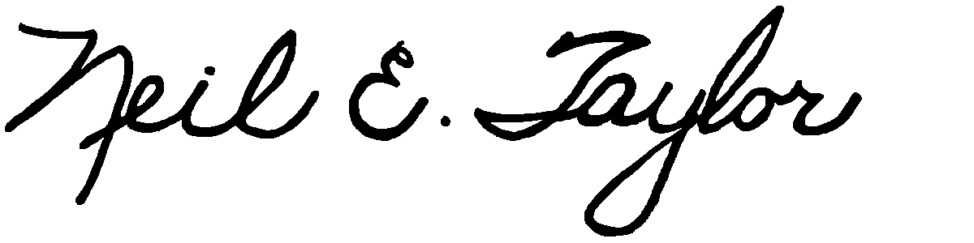
Neil E. Taylor

C.c.
Premier Dalton McGuinty
Gordon Miller, Environmental Commissioner of Ontario
The Office of the Ombudsman Ontario, André Marin
Leeanna Pendergast, MPP
Other interested parties

