Neil E. Taylor
1016 Wilson Avenue
Kitchener, Ontario
N2C 1J3

January 4th, 2010

(Via email)

Attention:

Leeanna Pendergast MPP - Kitchener--Conestoga
Unit 624, 2nd Floor
1187 Fischer-Hallman Road
Kitchener, Ontario N2E 4H9

Re. COURT FILE NO.: 636/09
Ontario Superior Court Of Justice
JUDGMENT of J. GRAY
August 13, 2009,

And the

Endangered Species Act (ACT)

And

Letters dated August 28th, September 10th, October 23, and November 17

Dear Ms. Pendergast:

As my MPP and representative to the Legislature for the Province of Ontario, I request your immediate attention and assistance in obtaining responses from the Minister of Natural Resources pursuant to the letters cited above.
I note that you are one of only a few MPPs for which an email address is not posted on the Legislature web site.
I look forward to acknowledgement of this letter by return mail and responses to these letters.

Respectfully requested,
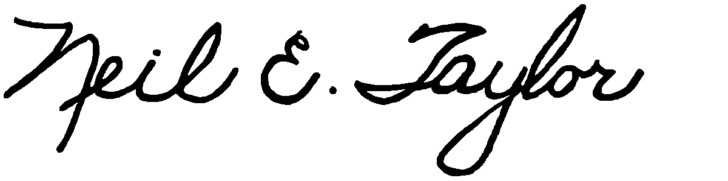
Neil E. Taylor

C.c.
Premier Dalton McGuinty
Gordon Miller, Environmental Commissioner of Ontario
The Office of the Ombudsman Ontario, André Marin
Leeanna Pendergast, MPP
Other interested parties

