
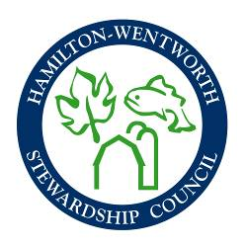
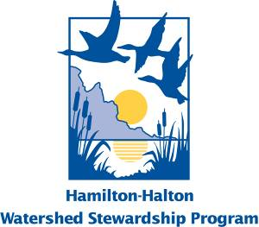
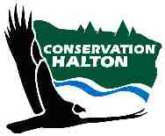
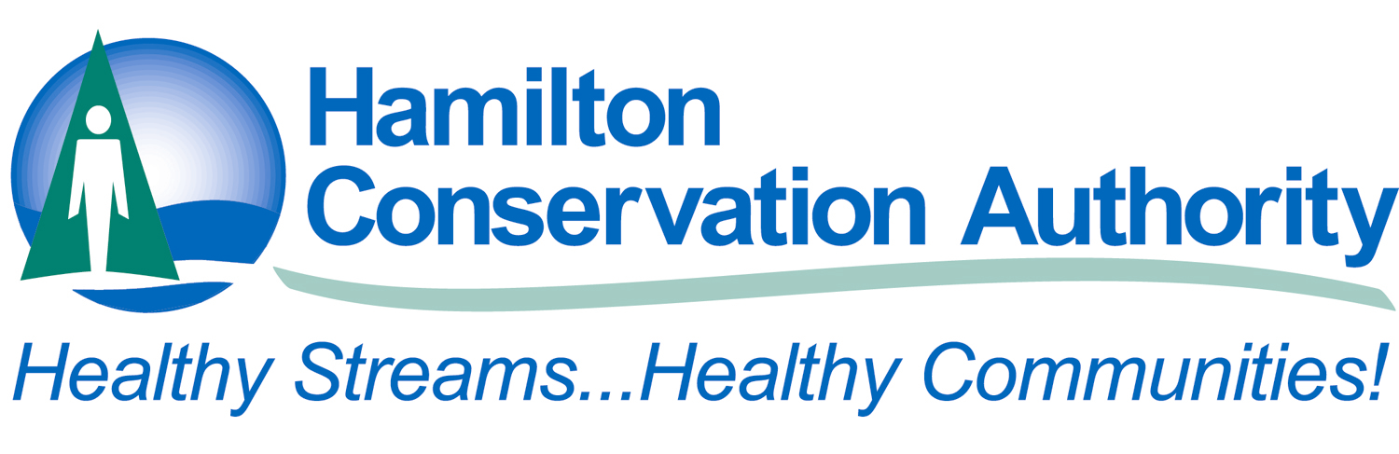



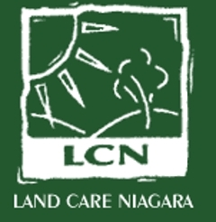

Friends of Mill Creek

Sharing Experiences Workshop – Organizing Committee
Dec 2nd, 10-noon
Meeting 3 - Minutes
Hamilton Conservation Authority Main Office

- Responses to Promotion – 32 people have already pre-registered for the workshop as a result of the call for interest. 41% are returning from last year. 59% are new to sharing experiences this year. We received 14 offers to present. 36% were made by people who had attended last year, 64% are new to the workshop.

- Review of Responses to Call for Interest – The media releases and flyer were sent out by all Organizing Committee members in November. Attached are the responses to the call for interest. Discussion around a common theme and coherent program structure led to the development of the following theme and presentations selected. Committee members unable to attend the Dec 2nd meeting to review the responses to the call for interest and comment on and/or approve the theme and presentations selected by the end of December so that presenters can be notified in early January and the workshop flyer can be drafted and release in mid to late January.

Theme – “Issues, Big and Small”
Presenters:
Land Protection Ken Woodruff – Save General Brock Parklands Committee
Community Michelle Albanese – Orland Conservation
Level
Engaging Youth Alice Casselman – ACER
Teresa Sauren – Reduce the Juice

Global Biodiversity Leslie Adams – P.O.W.E.R.
Climate Change Vicki Beard – Pollination Guelph

- Note all presenters will be instructed to ensure that their presentations focus on how their group or agency developed the capacity to undertake the projects that they have offered to present on.
- Each presenter will be assigned an organizing committee member to assist with guiding their presentation content. (see responses to promotion spreadsheet) The committee member will report back to the committee regarding their presenters’ presentation content. It was also suggested that the presenters might benefit from meeting with one another and the organizing committee. Jaime to ask the presenters if they would like to come to the February OC meeting.

- Keynote Speaker – Having someone high profile address the groups at the beginning of the workshop to inspire people and set the tone for the day was suggested following last year’s workshop. Some potential keynote speakers discussed included Brian McHattie, City of Hamilton Councilor and Environmentalist and Local Youth Delegates for the Copenhagen Climate Change Conference. Committee members unable to attend the Dec 2nd meeting to submit suggestions for potential keynote speakers. Jaime to send around the list of possible speakers for vote by the organizing committee once all suggestions have been received.

- Promotion – the flyer advertising the workshop will be circulated in late January. Jaime to design the flyer and circulate to Committee members for comment once the presenters are finalized.

- Displays – It was suggested that presenters from last year on fundamental subjects like, liability and insurance, fund raising and grant writing and building volunteer capacity could be offered the opportunity to bring displays to the workshop to fill the request of many respondents to the call for interest to cover much of the same material as last year. It was also suggested that funders also be invited to have displays at the workshop.

- On-line Registration – Committee members unable to attend the Dec 2nd meeting to comment on and/or approve the Questions for the on-line registration form.

- Date – date of the workshop to be moved to April 10th, 2010 to accommodate the new Maplewood venue. Jaime will ensure that all respondents to the current promotion and all subsequent promotional material will adequately highlight the date change. Committee members unable to attend the Dec 2nd meeting to comment on and/or approve the date change.

- Budget – Because of the change of venue, the per partner contribution is back down to 300$. Sheila O’Neal of HHWSP has offered to serve as treasurer for the workshop. Please make cheques payable to the “Hamilton Region Conservation Authority”. Committee members to mail or bring their cheque to our next meeting.

- Venue – Jaime investigated numerous alternate venues, all were either booked already or were out of our budget range due to in-house catering requirements. Other venues investigated included: Burlington Convention Centre, Liuna Station, Bishop Tonnos High School, Westdale High School, Hamilton War Plane Museum, etc. Maplewood in Ancaster is the new location. It has multiple breakout rooms, is carpeted for better acoustics, central to all partner jurisdictions, etc. Committee members unable to attend the Dec 2nd meeting to comment on and/or approve the new venue.

- Catering – Jaime secured Pierre’s catering for the same price and menu as last year as much positive feedback was received following last year’s workshop. Committee members unable to attend the Dec 2nd meeting to comment on and/or approve the caterer.

- Toolkit – Committee members to review the content of last year’s toolkit, make suggestions and compile updated content for the 2010 toolkit.

- Next Meeting – February 2nd, 2010 – HCA Main Office

