Neil E. Taylor
1016 Wilson Avenue
Kitchener, Ontario
N2C 1J3

November 17th, 2009

(Via email)

Attention:

Hon. Donna Cansfield MPP
Minister of Natural Resources
6630- 99 Wellesley St W, 6th Flr., Whitney Block
Toronto ON M7A 1W3

Re. COURT FILE NO.: 636/09
Ontario Superior Court Of Justice
JUDGMENT of J. GRAY
August 13, 2009,

And the

Endangered Species Act (ACT)

Dear Minister:

I have received a letter purported to have come from you dated October 23, 2009. I state purported for it neither has your full and proper signature nor does it contain the usual letterhead of the Ministry. That I have no hard copy of the same, I cannot accept that this represents a credible response from you in response to my letters dated. August 28th and September 10th. Accordingly, I request a proper response from you to those letters and to this one.

The letter of October contains the following amazing statement, “I was not persuaded that the reasonable grounds necessary for the issuance of such an order were present with respect to either the culvert or the road leading up to it, provided the city fulfills its commitments by limiting construction activities to the culvert and water main, and by implementing their proposed Jefferson salamander protection measures.” Minister, if this indeed is your letter, you are engaging in a dialogue of obfuscation. Just exactly what would persuade you? Let me hear the criteria that you require to take action commensurate with the requirements of provincial legislation.

Again, if this indeed is your letter, your fall back excuse seems to be the rationale that, “As you may be aware, on September 3, 2009, the City of Guelph postponed the culvert and water main works at the HCBP creek crossing for the remainder of 2009.” I submit that this is pitiful attempt to “pass the buck” while feebly pretending that you are doing the right thing.

Minister, you had a responsibility quite unique as cited by Judge Gray in his judgment. He stated that you have the,
“power to determine the very matter in issue in the defendants’ motion for an injunction, namely, whether work on the project should be stopped, and if so, to what degree and for how long, because of some anticipated negative impact on the habitat of the Jefferson Salamander.”
You shamefully abandoned that responsibility. Unlike Judge Gray, who recognized the primacy of the ‘precautionary principle’ when he wrote,
“…which, simply put, contemplates that where there is a threat of a significant reduction or loss of biological diversity, lack of full scientific certainty should not be used as a reason for postponing measures to avoid or minimize such a threat…”,
you have either have been poorly advised or deliberately rendered a decision without sound reasons. Minister, you or your minions simply do not get it. Habitat protection is paramount to implementation of the Endangered Species Act.

Once again, I respectfully request that you provide criteria by which you could be persuaded for the issuance of such an injunction to stop work action pursuant to the ACT.

I look forward to acknowledgement and a response to this letter.

Respectfully submitted,
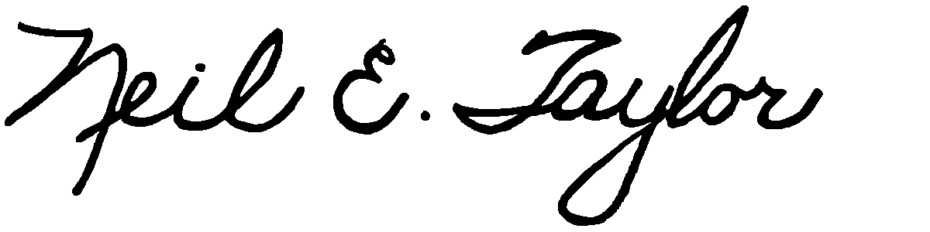
Neil E. Taylor

C.c.
Premier Dalton McGuinty
Gordon Miller, Environmental Commissioner of Ontario
Leeanna Pendergast, MPP
Other interested parties

