Neil E. Taylor
1016 Wilson Avenue
Kitchener, Ontario
N2C 1J3

September 16th, 2009

(Via email)

Attention:

Gordon Miller
Environmental Commissioner of Ontario

1075 Bay Street, Suite 605
Toronto, ON M5S 2B1

Dear Commissioner Miller:

Re. COURT FILE NO.: 636/09
Ontario Superior Court Of Justice
JUDGMENT of J. GRAY
August 13, 2009
and,
Construction/destruction activity at Hanlon Creek in Guelph at a location identified as a Threatened species Habitat,
and
Letters to the Minister of Natural resources dated August 28th and September 10th, 2009

Today I respectfully request that you and your staff investigate the Minister and Ministry of Natural resources with respect to a decision of the Ontario Superior Court, the Endangered Species Act, 2007 and the unacknowledged and unanswered letters cited above.

It is my submission that the Minister has failed to take the advice delivered in a court decision by Justice J. Gray and has failed to exercise her power pursuant to Section 28 of the Endangered Species Act, 2007.

It is widely understood and known that the Ministers of the Environment and Natural Resources seldom apply due diligence in the issuance of orders with respect to Environmental Assessment (EA) via ‘Part II Order’ or Section 28 of the Endangered Species Act, 2007.

In a recent letter dated September 14, 2009 to L. Lonteigne, the Minister of Natural Resources wrote,
“As I have indicated to you in previous correspondence, you may wish to address your concerns about the potential impacts of development in northwest area to the City of Waterloo ’s Planning and Development Department at (519) 747-8752 or the Region of Waterloo’s Community Planning Department at (519) 575-4533.

Please note that I have previously responded to you about avian and amphibian species at risk in the northwest area of the City of Waterloo . The significant habitat of endangered and threatened species is protected from development through the Provincial Policy Statement under the Planning Act. Municipal planning decisions must be consistent with the Provincial Policy Statement.
The Endangered Species Act, 2007 (ESA), which came into force on June 30, 2008, identifies species at risk and protects them and their habitat. As well, the ESA promotes the recovery of the species and stewardship activities that assist in the protection and recovery of species that are at risk. It is the responsibility of the proponent to be compliant with the ESA or they may be subject to prosecution under the act.

If you require further information on any of the issues raised in your correspondence, please contact Ken Cornelisse, Acting Planning and Information Management Supervisor in our Guelph District Office, at (519) 826-6849.”

The stated objective of the PPS is that:
“Wetlands are essential ecosystems that contain important ecological, hydrological and socio-economic values. The Province of Ontario is committed to the protection and conservation of all provincially significant wetlands (Classes I, II, and III), and encourages and supports the protection and conservation of all other wetlands within the province. The goal of this Policy Statement is to ensure that wetlands are properly identified and adequately protected through the land use planning process.”

The Minister’s response in her September 14th letter is an unjustified dismissal of a citizen’s concerns and represents defiance of the PPS. Once again, the buck was passed.

In the case of the decision rendered in a Superior Court last month and letters submitted by the undersigned, the Minister has failed to exercise the power vested in her position as a Minister of the Crown through various sections of Legislative Acts that were placed in her trust.

Accordingly, I request the Commissioner to investigate this matter and render an order or any such remedy as is deemed appropriate given the information that I have provided.

I look forward to acknowledgement and a response to this letter.

Respectfully submitted,
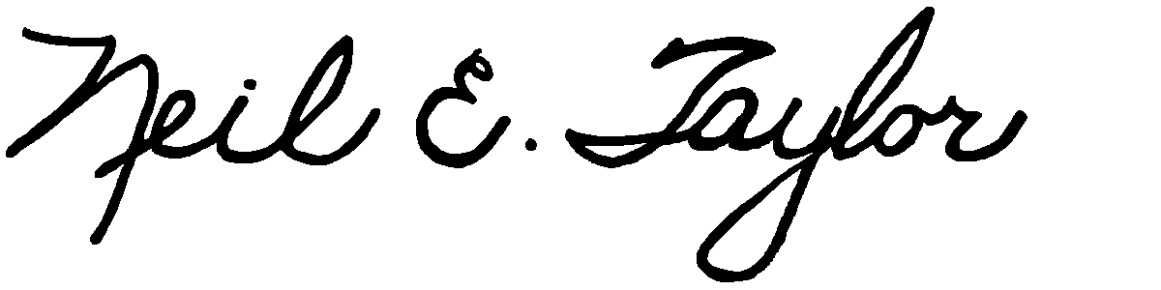
Neil E. Taylor

Attachments:
Decision, Gray J. August 13, 2009 (pdf)
Letters to the Minister of Natural Resources, August 28th and September 10th

