Neil E. Taylor
1016 Wilson Avenue
Kitchener, Ontario
N2C 1J3

September 10th, 2009

(Via email)

Attention:

Hon. Donna Cansfield MPP
Minister of Natural Resources
6630- 99 Wellesley St W, 6th Flr., Whitney Block
Toronto ON M7A 1W3

Re. COURT FILE NO.: 636/09
Ontario Superior Court Of Justice
JUDGMENT of J. GRAY
August 13, 2009

Dear Minister:

As of this date, I have not received any communication from you with respect to my letter of August 28th, 2009. Not only did I ask for acknowledgement of the letter, but a response to it. Be assured that this is most disturbing and disappointing.

Since that date, I have been advised that an article appearing in the media has indicated that you have declined to issue an order to stop any further construction/destruction activity at Hanlon Creek in Guelph. This too is most disturbing and disappointing.

In as much as I have not had a response from you from my earlier letter, I must conclude that my assertions and concerns have merit and that you are unable to defend the indefensible.

Minister, I respectfully request you to reconsider and reverse this decision. This may be a precedent action, but one worth pursuing. There is ample reason for such an action. I quote from my earlier letter as follows:
- There is evidence Jefferson Salamanders were located on the property, including the discovery of a Jefferson Salamander hybrid just outside the construction zone. The presence of a cross-breed means a Jefferson Salamander could be nearby.
- Doctor Jim Bogart, chair of the provincially-mandated Jefferson Salamander recovery team, recommended that more research be done to identify possible breeding ponds for Jefferson Salamanders on the property before proceeding with construction.
- The court also heard testimony from Ian Hagman, the Guelph District Manager for the Ministry of Natural Resources, who on cross-examination admitted his staff had recommended halting development of the HCBP in the interim, while measures were taken to determine whether Jefferson Salamanders or their habitats were present. He said under oath,
“My recommendation, and that of my staff, as not to proceed with construction at this time,”
- Judge Gray’s decision recognizes the primacy of the ‘precautionary principle’. He wrote,
“which, simply put, contemplates that where there is a threat of a significant reduction or loss of biological diversity, lack of full scientific certainty should not be used as a reason for postponing measures to avoid or minimize such a threat.”

Once again, I invite you to do the right thing pursuant to the Act and issue an order to stop further work until all necessary studies are completed.

I look forward to acknowledgement and a response to this letter.

Respectfully submitted,
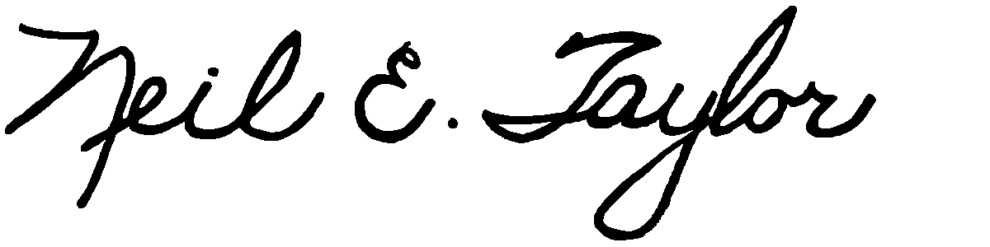
Neil E. Taylor

Attachment:
Decision, Gray J. August 13, 2009 (pdf)

C.c.
Premier Dalton McGuinty
Gordon Miller, Environmental Commissioner of Ontario
Leeanna Pendergast, MPP
Other interested parties

