Neil E. Taylor
1016 Wilson Avenue
Kitchener, Ontario
N2C 1J3

August 28th, 2009

(Via email)

Attention:

Hon. Donna Cansfield MPP
Minister of Natural Resources
6630- 99 Wellesley St W, 6th Flr., Whitney Block
Toronto ON M7A 1W3

Re. COURT FILE NO.: 636/09
Ontario Superior Court Of Justice
JUDGMENT of J. GRAY
August 13, 2009

Dear Minister:

I have reviewed the above cited judgment and attach it for convenience.

I have had the pleasure of hearing you speak at the 2007 and 2008 A. D. Latornell Conservation Symposium. Your sincerity with respect to your role as a minister of the crown was most apparent. I invite you to review the document and my reasons for my appeal to you re. this matter.

Your government has brought forth the much touted Endangered Species Act. Many of us have expressed much concern re. the protection of habitat of these species. I have provided comment supported by papers developed by qualified experts to MNR staff.

He noted that the Ministry of Natural Resources (MNR) is powerless to act because protocols for the Jefferson Salamander and its habitat are recommendations rather than regulations (embodied in statute law) at the moment. As Minister, you have a responsibility quite unique and this is cited by Judge Gray in his judgment. He stated that you have the,
“power to determine the very matter in issue in the defendants’ motion for an injunction, namely, whether work on the project should be stopped, and if so, to what degree and for how long, because of some anticipated negative impact on the habitat of the Jefferson Salamander.”
Further, Justice Gray noted that there was no evidence before him that the Minister had considered the matter and,
“if construction activity commences immediately, it may prevent, or at lest seriously limit, any opportunity for the Minister to consider making such an order.” Describing this as “irreparable harm” the decision grants the applicants standing, and grants “an injunction to prevent further work on the culvert and the road leading up to it for a period of up to 30 days.”
I recognize that political decisions are at times whimsical, or so it seems. However in this instance, precedent could be set by you and your government. You could put some real teeth into the Act and exercise the power entrusted to you pursuant Section 28 of the Act.
There is abundant evidence for such an action.
- There is evidence Jefferson Salamanders were located on the property, including the discovery of a Jefferson Salamander hybrid just outside the construction zone. The presence of a cross-breed means a Jefferson Salamander could be nearby.
- Doctor Jim Bogart, chair of the provincially-mandated Jefferson Salamander recovery team, recommended that more research be done to identify possible breeding ponds for Jefferson Salamanders on the property before proceeding with construction.
- The court also heard testimony from Ian Hagman, the Guelph District Manager for the Ministry of Natural Resources, who on cross-examination admitted his staff had recommended halting development of the HCBP in the interim, while measures were taken to determine whether Jefferson Salamanders or their habitats were present. He said under oath,
“My recommendation, and that of my staff, as not to proceed with construction at this time,”
- Judge Gray’s decision recognizes the primacy of the ‘precautionary principle’. He wrote,
“which, simply put, contemplates that where there is a threat of a significant reduction or loss of biological diversity, lack of full scientific certainty should not be used as a reason for postponing measures to avoid or minimize such a threat.”

I invite you to do the right thing pursuant to the Act and issue an order to stop further work until all necessary studies are completed.

I look forward to a response at your earliest convenience.

Respectfully submitted,
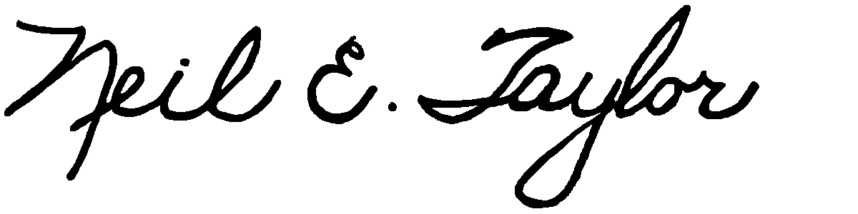
Neil E. Taylor

Attachment:
Decision, Gray J. August 13, 2009 (pdf)

C.c.
Gordon Miller, Environmental Commissioner of Ontario
Leeanna Pendergast, MPP

